Experiment 1
1. Experiment Title
Demonstrate Inline, Internal, and External JavaScript; Use Console Methods; Create a Webpage Showing User Information and a Welcome Message.

2. Software/Tools Required
- Visual Studio Code (VS Code)
- Google Chrome / Mozilla Firefox / Microsoft Edge
- HTML5
- CSS3
- JavaScript
- Windows Operating System

3. Experiment Program Code
The experiment consists of the following files:
- index.html
- styles.css
- script.js

index.html
<!DOCTYPE html>
<html lang="en">

<head>
<meta charset="UTF-8">
<meta name="viewport" content="width=device-width, initial-scale=1.0">
<title>Experiment No: 1 - JavaScript Methods Demo</title>

<style>
body {
font-family: Arial, sans-serif;
padding: 25px;
margin: 0;
}

.container {
max-width: 1000px;
margin: 0 auto;
}

h1 {
text-align: center;
font-size: 32px;
margin-bottom: 10px;
}

.subtitle {
text-align: center;
color: #666;
margin-bottom: 25px;
font-size: 17px;
}

.section {
padding: 20px;
border: 2px solid black;
margin: 15px 0;
}

.section h2 {
font-size: 22px;
margin-bottom: 12px;
}

.section p {
font-size: 16px;
margin: 10px 0;
}

button {
padding: 12px 20px;
border: 2px solid black;
cursor: pointer;
font-size: 16px;
margin: 10px 5px;
}

button:hover {
background-color: #f0f0f0;
}

#userInfo,
#welcomeMessage {
padding: 15px;
border: 1px solid black;
margin-top: 12px;
font-size: 16px;
}
</style>

<!-- Internal JavaScript -->
<script>
console.log("=== Internal JavaScript ===");
console.log("Internal JavaScript loaded successfully");

// Function using Internal JavaScript
function showUserInfo() {
var name = "Jash Chauhan";
var prn = "24070521242";
var course = "Computer Science & Engineering";

document.getElementById("userInfo").innerHTML =
"<strong>Name:</strong> " + name + "<br>" +
"<strong>PRN:</strong> " + prn + "<br>" +
"<strong>Course:</strong> " + course;

console.log("User Info displayed using Internal JavaScript");
console.log("Name: " + name);
console.log("PRN: " + prn);
}

// Function to demonstrate console methods
function demonstrateConsole() {
console.log("=== Console Methods Demo ===");
console.log("This is console.log()");
console.info("This is console.info()");
console.warn("This is console.warn()");
console.error("This is console.error()");
alert("Check the browser console (F12) to see different console methods!");
}
</script>
</head>

<body>
<div class="container">
<h1>Experiment No: 1</h1>
<p class="subtitle">Demonstrate inline, internal, and external JavaScript</p>

<!-- Section 1: Inline JavaScript -->
<div class="section">
<h2>1️⃣ Inline JavaScript</h2>
<p>JavaScript code written directly inside HTML element using event attributes.</p>
<button onclick="alert('Hello from Inline JavaScript!'); console.log('Inline JavaScript executed');">
Click Me (Inline JS)
</button>
</div>

<!-- Section 2: Internal JavaScript -->
<div class="section">
<h2>2️⃣ Internal JavaScript</h2>
<p>JavaScript code written inside &lt;script&gt; tag within the HTML document.</p>
<button onclick="showUserInfo();">Show User Info (Internal JS)</button>
<button onclick="demonstrateConsole();">Console Methods Demo</button>
<div id="userInfo"></div>
</div>

<!-- Section 3: External JavaScript -->
<div class="section">
<h2>3️⃣ External JavaScript</h2>
<p>JavaScript code stored in a separate .js file and linked using &lt;script src=""&gt; tag.</p>
<button onclick="showWelcomeMessage();">Show Welcome Message (External JS)</button>
<div id="welcomeMessage"></div>
</div>
</div>

<!-- External JavaScript -->
<script src="script.js"></script>
</body>

</html>

script.js
// External JavaScript File

console.log("=== External JavaScript ===");
console.log("External JavaScript file (script.js) loaded successfully");

// Function using External JavaScript
function showWelcomeMessage() {
var studentName = "Jash Chauhan";
var currentDate = new Date();
var hours = currentDate.getHours();
var greeting;

if (hours < 12) {
greeting = "Good Morning";
} else if (hours < 18) {
greeting = "Good Afternoon";
} else {
greeting = "Good Evening";
}

var welcomeText = greeting + ", " + studentName + "! Welcome to JavaScript Programming.";

document.getElementById("welcomeMessage").innerHTML =
"<strong>Welcome Message:</strong><br>" + welcomeText;

console.log("Welcome message displayed using External JavaScript");
console.log("Message: " + welcomeText);
console.info("Current time: " + currentDate.toLocaleTimeString());
}

console.log("All JavaScript functions are ready!");

styles.css
/* External CSS */

.external-section {
padding: 30px;
border: 1px solid black;
margin: 20px 0;
}

.external-section h2 {
font-size: 24px;
}

.external-section p {
font-size: 18px;
}

.external-section button {
padding: 10px 20px;
border: 1px solid black;
cursor: pointer;
font-size: 16px;
}

Output:
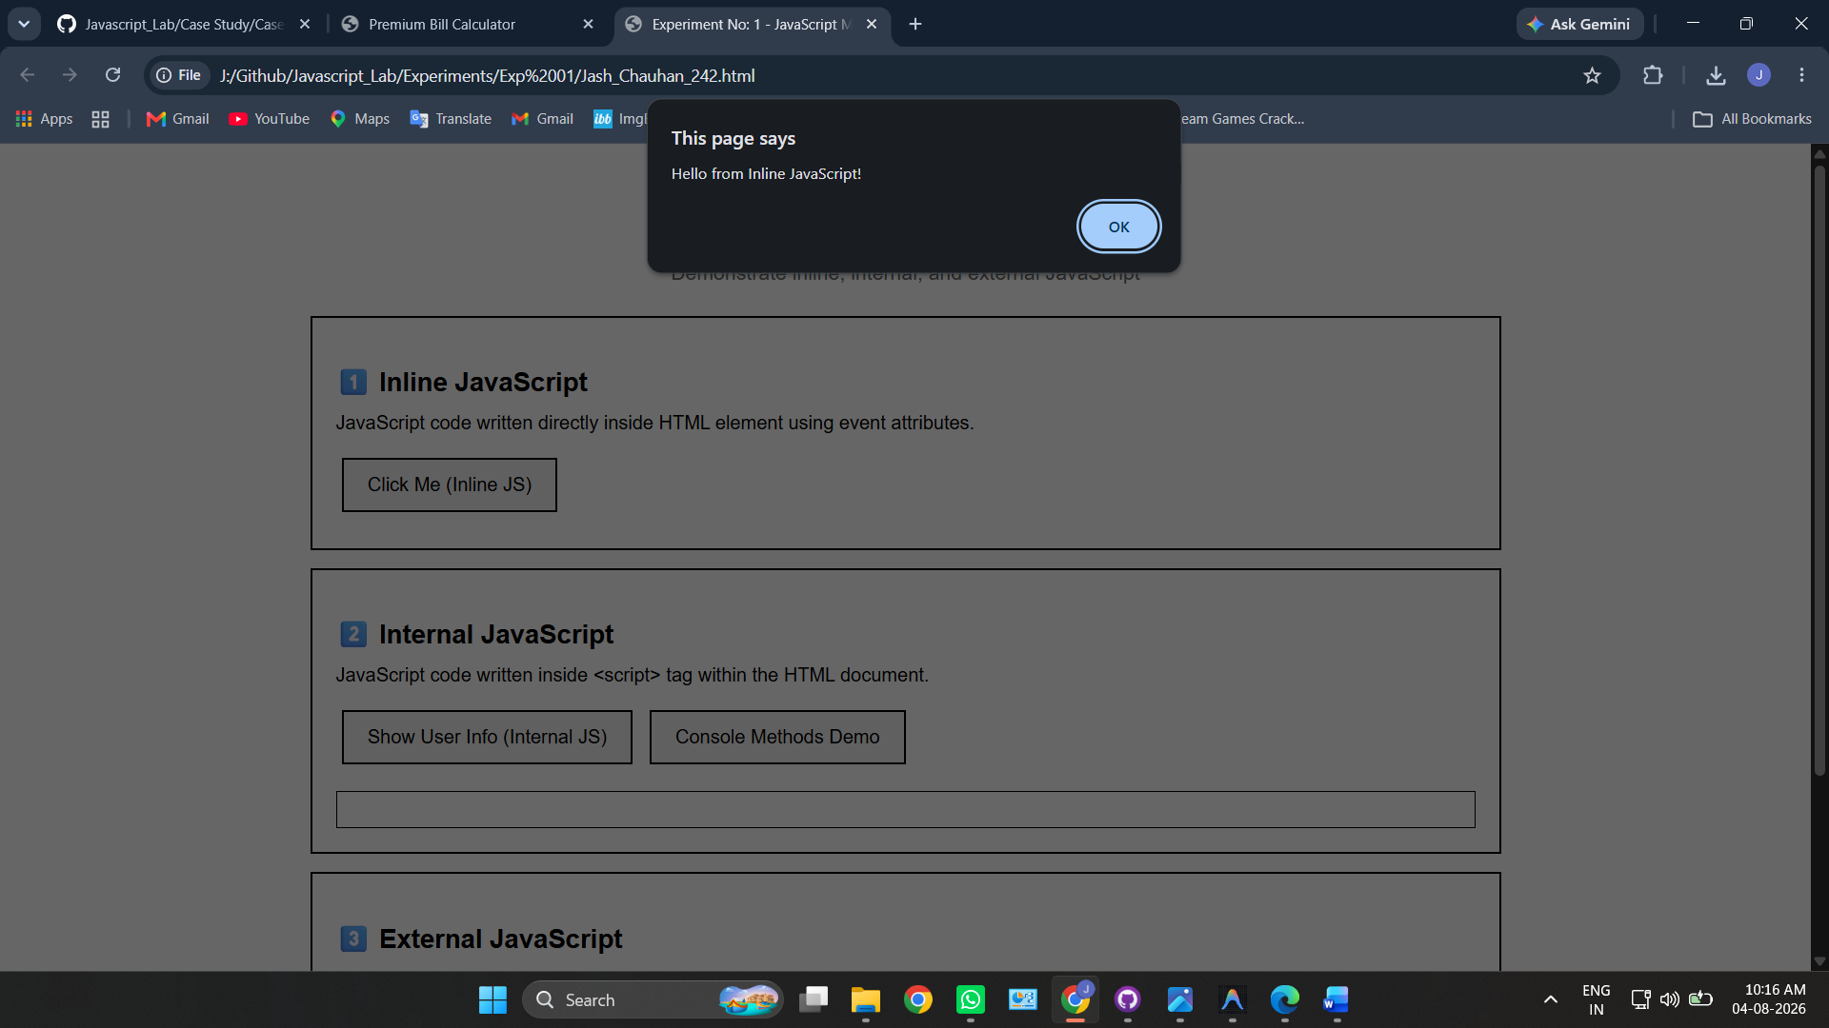
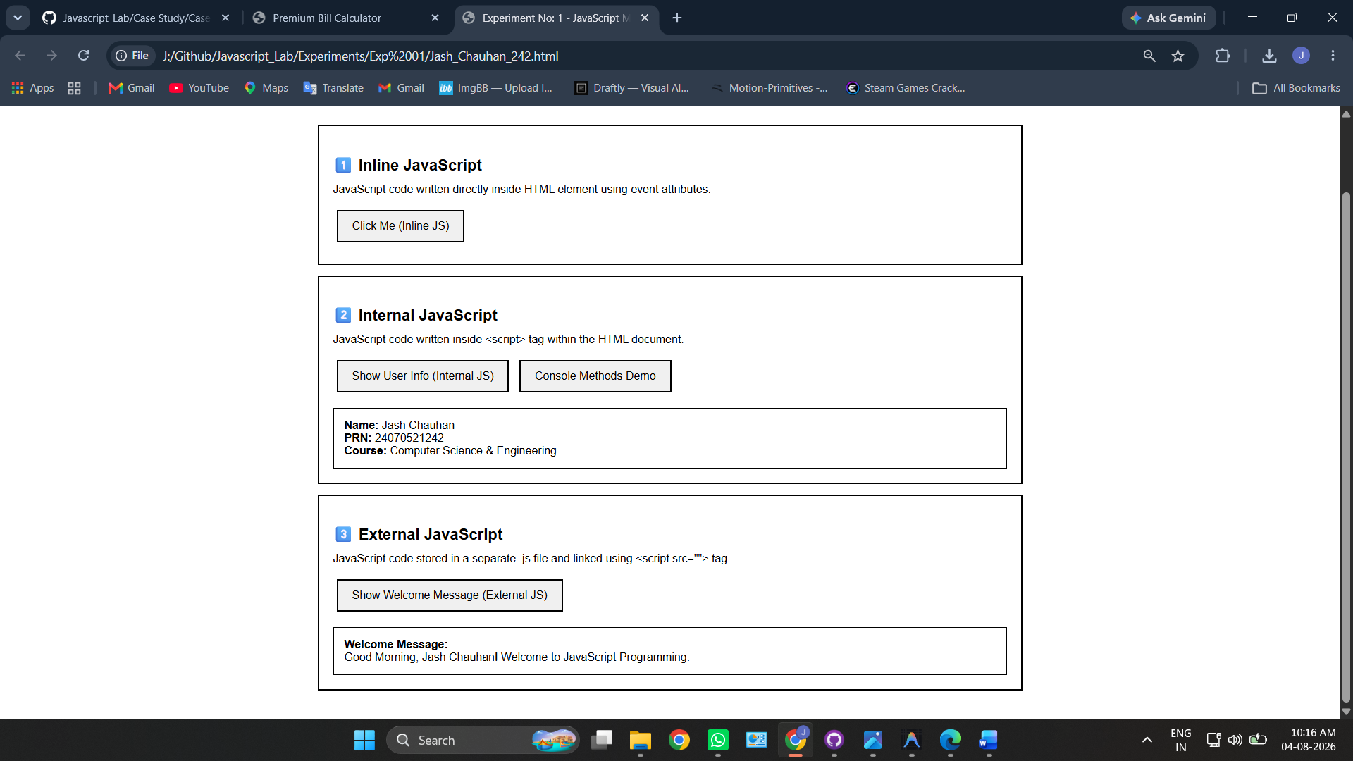

Case Study 1
1. Case Study Title
Create a Webpage for College Department and Link the Student Information Page with It and Write a JavaScript Program to Display "Welcome to SIT Nagpur" in an Alert Box.

2. Case Study Program Code
The case study consists of the following files:
- index.html – Displays the college department information and shows the alert message "Welcome to SIT Nagpur" using JavaScript.
- students.html – Displays the student information page linked from the department webpage.

index.html
<!DOCTYPE html>
<html lang="en">
<head>
<meta charset="UTF-8" />
<meta name="viewport" content="width=device-width, initial-scale=1.0" />
<meta name="description" content="SIT Nagpur - Department of Computer Science & Engineering. Explore our programs, faculty, and student resources." />
<title>SIT Nagpur | Department of Computer Science</title>
<link rel="preconnect" href="https://fonts.googleapis.com" />
<link rel="preconnect" href="https://fonts.gstatic.com" crossorigin />
<link href="https://fonts.googleapis.com/css2?family=Outfit:wght@300;400;500;600;700;800;900&family=Inter:wght@300;400;500;600&display=swap" rel="stylesheet" />
<style>
*, *::before, *::after { margin: 0; padding: 0; box-sizing: border-box; }

:root {
--primary: #2563eb;
--primary-dark: #1d4ed8;
--accent: #0ea5e9;
--gold: #d97706;
--bg-dark: #ffffff;
--bg-card: #ffffff;
--bg-card2: #f8fafc;
--text-main: #0f172a;
--text-muted: #475569;
--border: #e2e8f0;
--shadow: 0 8px 40px rgba(0,0,0,0.05);
--radius: 16px;
--transition: 0.35s cubic-bezier(0.4,0,0.2,1);
}

html { scroll-behavior: smooth; }

body {
font-family: 'Inter', sans-serif;
background: var(--bg-dark);
color: var(--text-main);
overflow-x: hidden;
}

body::before {
content: '';
position: fixed;
inset: 0;
background:
radial-gradient(ellipse 80% 60% at 20% 10%, rgba(59,130,246,0.18) 0%, transparent 60%),
radial-gradient(ellipse 60% 50% at 80% 80%, rgba(56,189,248,0.12) 0%, transparent 60%),
radial-gradient(ellipse 50% 40% at 50% 50%, rgba(244,63,94,0.07) 0%, transparent 70%);
pointer-events: none;
z-index: 0;
}

/* NAVBAR */
nav {
position: sticky; top: 0; z-index: 100;
backdrop-filter: blur(20px);
background: rgba(255,255,255,0.9);
border-bottom: 1px solid var(--border);
padding: 0 5%;
display: flex; align-items: center; justify-content: space-between;
height: 70px;
animation: slideDown 0.6s ease;
}

@keyframes slideDown {
from { transform: translateY(-100%); opacity: 0; }
to { transform: translateY(0); opacity: 1; }
}

.nav-logo {
display: flex; align-items: center; gap: 12px;
text-decoration: none;
}

.logo-icon {
width: 42px; height: 42px;
background: linear-gradient(135deg, var(--primary), var(--accent));
border-radius: 10px;
display: grid; place-items: center;
font-size: 20px; font-family: 'Outfit', sans-serif; font-weight: 800; color: #fff;
box-shadow: 0 4px 18px rgba(59,130,246,0.5);
}

.nav-logo span {
font-family: 'Outfit', sans-serif; font-weight: 700; font-size: 1.1rem;
}

.nav-links { display: flex; gap: 6px; list-style: none; }

.nav-links a {
color: var(--text-muted); text-decoration: none;
font-size: 0.9rem; font-weight: 500;
padding: 8px 16px; border-radius: 8px;
transition: var(--transition);
}

.nav-links a:hover { color: var(--text-main); background: rgba(59,130,246,0.15); }
.nav-links a.active { color: var(--primary); background: rgba(59,130,246,0.12); }

.nav-cta {
background: linear-gradient(135deg, var(--primary), var(--primary-dark)) !important;
color: #fff !important;
border-radius: 10px !important;
box-shadow: 0 4px 16px rgba(59,130,246,0.4);
}

/* HERO */
.hero {
position: relative; z-index: 1;
min-height: calc(100vh - 70px);
display: flex; flex-direction: column; align-items: center; justify-content: center;
text-align: center; padding: 80px 5% 60px;
}

.hero-badge {
display: inline-flex; align-items: center; gap: 8px;
background: rgba(59,130,246,0.15);
border: 1px solid rgba(59,130,246,0.35);
border-radius: 50px; padding: 8px 20px;
font-size: 0.82rem; font-weight: 600;
color: var(--accent); letter-spacing: 0.06em; text-transform: uppercase;
margin-bottom: 28px;
animation: fadeUp 0.8s ease 0.2s both;
}

.hero-badge::before {
content: '●'; font-size: 8px; color: var(--accent);
animation: pulse 2s infinite;
}

@keyframes pulse { 0%,100%{opacity:1} 50%{opacity:0.3} }

.hero h1 {
font-family: 'Outfit', sans-serif;
font-size: clamp(2.4rem, 6vw, 4.8rem);
font-weight: 900; line-height: 1.1;
margin-bottom: 24px;
animation: fadeUp 0.8s ease 0.35s both;
}

.highlight {
color: var(--primary);
}

.hero p {
max-width: 620px; color: var(--text-muted);
font-size: 1.08rem; line-height: 1.8;
margin-bottom: 44px;
animation: fadeUp 0.8s ease 0.5s both;
}

.hero-btns {
display: flex; gap: 16px; flex-wrap: wrap; justify-content: center;
animation: fadeUp 0.8s ease 0.65s both;
}

@keyframes fadeUp {
from { opacity:0; transform:translateY(30px); }
to { opacity:1; transform:translateY(0); }
}

.btn-primary {
background: linear-gradient(135deg, var(--primary), var(--primary-dark));
color: #fff; border: none;
padding: 16px 36px; border-radius: 14px;
font-size: 1rem; font-weight: 600; cursor: pointer;
text-decoration: none; display: inline-flex; align-items: center; gap: 10px;
box-shadow: 0 6px 28px rgba(59,130,246,0.45);
transition: var(--transition); font-family: 'Inter', sans-serif;
}

.btn-primary:hover { transform: translateY(-3px); box-shadow: 0 12px 40px rgba(59,130,246,0.6); }

.btn-secondary {
background: rgba(0,0,0,0.03);
color: var(--text-main);
border: 1px solid var(--border);
padding: 16px 36px; border-radius: 14px;
font-size: 1rem; font-weight: 600; cursor: pointer;
text-decoration: none; display: inline-flex; align-items: center; gap: 10px;
backdrop-filter: blur(10px);
transition: var(--transition); font-family: 'Inter', sans-serif;
}

.btn-secondary:hover { background: rgba(59,130,246,0.12); border-color: var(--primary); transform: translateY(-3px); }

/* STATS */
.stats-strip {
position: relative; z-index: 1;
display: flex; justify-content: center; flex-wrap: wrap;
background: rgba(248,250,252,0.8);
border-top: 1px solid var(--border);
border-bottom: 1px solid var(--border);
backdrop-filter: blur(12px);
}

.stat-item {
flex: 1; min-width: 160px;
padding: 32px 20px; text-align: center;
border-right: 1px solid var(--border);
transition: var(--transition);
}

.stat-item:last-child { border-right: none; }
.stat-item:hover { background: rgba(59,130,246,0.07); }

.stat-num {
font-family: 'Outfit', sans-serif;
font-size: 2.4rem; font-weight: 800;
color: var(--primary);
display: block;
}

.stat-label { font-size: 0.85rem; color: var(--text-muted); font-weight: 500; margin-top: 4px; }

/* SECTION COMMON */
section { position: relative; z-index: 1; padding: 90px 5%; }

.section-tag {
display: inline-block;
background: rgba(59,130,246,0.12);
border: 1px solid rgba(59,130,246,0.3);
color: var(--primary);
font-size: 0.78rem; font-weight: 700;
letter-spacing: 0.1em; text-transform: uppercase;
padding: 6px 16px; border-radius: 50px; margin-bottom: 18px;
}

.section-title {
font-family: 'Outfit', sans-serif;
font-size: clamp(1.8rem, 3.5vw, 2.8rem);
font-weight: 800; margin-bottom: 14px;
}

.section-sub {
color: var(--text-muted); font-size: 1rem;
line-height: 1.7; max-width: 560px; margin-bottom: 56px;
}

/* ABOUT */
#about {
display: grid; grid-template-columns: 1fr 1fr;
gap: 64px; align-items: center;
}

.about-visual { position: relative; }

.about-card-main {
background: linear-gradient(135deg, var(--bg-card), var(--bg-card2));
border: 1px solid var(--border);
border-radius: 24px; padding: 40px;
box-shadow: var(--shadow);
}

.about-icon {
width: 60px; height: 60px;
background: linear-gradient(135deg, var(--primary), var(--accent));
border-radius: 14px;
display: grid; place-items: center;
font-size: 28px; margin-bottom: 20px;
box-shadow: 0 8px 24px rgba(59,130,246,0.4);
}

.about-card-main h3 { font-family: 'Outfit', sans-serif; font-size: 1.4rem; font-weight: 700; margin-bottom: 12px; }
.about-card-main p { color: var(--text-muted); line-height: 1.7; font-size: 0.95rem; }

.floating-badge {
position: absolute;
background: linear-gradient(135deg, var(--gold), #f59e0b);
color: #1a1400; font-weight: 700; font-size: 0.82rem;
padding: 10px 18px; border-radius: 50px;
box-shadow: 0 8px 24px rgba(251,191,36,0.4);
}

.floating-badge.top-right { top: -18px; right: -18px; }
.floating-badge.bot-left { bottom: -18px; left: -18px; }

.feature-list { list-style: none; display: flex; flex-direction: column; gap: 14px; }

.feature-list li {
display: flex; align-items: center; gap: 12px;
font-size: 0.95rem; color: var(--text-muted);
}

.feature-list li::before {
content: '✓';
width: 26px; height: 26px;
background: rgba(56,189,248,0.15);
border: 1px solid rgba(56,189,248,0.35);
color: var(--accent); border-radius: 50%;
display: grid; place-items: center;
font-size: 0.7rem; font-weight: 800; flex-shrink: 0;
}

/* PROGRAMS */
#programs { background: #f8fafc; }

.programs-list {
display: flex;
flex-direction: column;
gap: 16px;
max-width: 1000px;
margin: 0 auto;
}

.program-row {
display: grid;
grid-template-columns: auto 1fr auto;
gap: 40px;
align-items: center;
padding: 32px 40px;
background: var(--bg-card);
border: 1px solid var(--border);
border-radius: 16px;
transition: var(--transition);
cursor: pointer;
}

.program-row:hover {
border-color: var(--primary);
box-shadow: 0 12px 30px rgba(0,0,0,0.04);
transform: translateX(4px);
}

.prog-number {
font-family: 'Outfit', sans-serif;
font-size: 2.5rem;
font-weight: 800;
color: var(--border);
transition: var(--transition);
}

.program-row:hover .prog-number {
color: var(--primary);
}

.prog-content h3 {
font-family: 'Outfit', sans-serif;
font-size: 1.3rem;
font-weight: 700;
margin-bottom: 8px;
color: var(--text-main);
}

.prog-content p {
color: var(--text-muted);
font-size: 0.95rem;
line-height: 1.6;
max-width: 600px;
}

.prog-meta {
text-align: right;
}

.prog-duration {
display: block;
color: var(--primary);
font-size: 0.95rem;
font-weight: 700;
margin-bottom: 4px;
}

.prog-seats {
color: var(--text-muted);
font-size: 0.85rem;
font-weight: 500;
}

@media (max-width: 768px) {
.program-row {
grid-template-columns: 1fr;
gap: 16px;
padding: 24px;
}
.prog-meta { text-align: left; }
.prog-number { display: none; }
}

/* FACULTY */
.faculty-list {
display: flex;
flex-direction: column;
gap: 16px;
max-width: 900px;
margin: 0 auto;
}

.faculty-row {
display: flex;
align-items: center;
gap: 24px;
padding: 24px 32px;
background: var(--bg-card);
border: 1px solid var(--border);
border-radius: 16px;
transition: var(--transition);
cursor: pointer;
}

.faculty-row:hover {
border-color: var(--primary);
transform: translateX(4px);
box-shadow: 0 12px 30px rgba(0,0,0,0.04);
}

.faculty-avatar {
width: 56px; height: 56px; border-radius: 50%;
display: grid; place-items: center;
font-size: 1.1rem; font-weight: 700; font-family: 'Outfit', sans-serif;
flex-shrink: 0;
color: #fff;
}

.faculty-info {
flex: 1;
display: flex;
flex-direction: column;
gap: 4px;
}

.faculty-row h4 { font-family: 'Outfit', sans-serif; font-weight: 700; font-size: 1.15rem; color: var(--text-main); margin: 0; }

.faculty-meta {
display: flex;
justify-content: space-between;
align-items: center;
width: 100%;
}

.designation { color: var(--primary); font-size: 0.9rem; font-weight: 600; margin: 0; }
.specialization { color: var(--text-muted); font-size: 0.85rem; font-weight: 500; }

@media (max-width: 600px) {
.faculty-row {
flex-direction: column;
align-items: flex-start;
gap: 16px;
}
.faculty-meta {
flex-direction: column;
align-items: flex-start;
gap: 8px;
}
}

/* STUDENT BANNER */
.student-banner {
position: relative; z-index: 1;
margin: 0 5% 80px;
background: linear-gradient(135deg, rgba(59,130,246,0.18), rgba(56,189,248,0.1));
border: 1px solid rgba(59,130,246,0.35);
border-radius: 24px; padding: 56px 60px;
display: flex; align-items: center; justify-content: space-between;
gap: 40px; overflow: hidden;
}

.student-banner::before {
content: '🎓'; position: absolute; right: 60px;
top: 50%; transform: translateY(-50%);
font-size: 140px; opacity: 0.07; pointer-events: none;
}

.banner-content h2 {
font-family: 'Outfit', sans-serif;
font-size: clamp(1.4rem, 3vw, 2rem); font-weight: 800; margin-bottom: 12px;
}

.banner-content p { color: var(--text-muted); font-size: 0.95rem; line-height: 1.7; max-width: 500px; }

/* FOOTER */
footer {
position: relative; z-index: 1;
background: #f8fafc;
border-top: 1px solid var(--border);
padding: 56px 5% 28px;
}

.footer-grid {
display: grid; grid-template-columns: 2fr 1fr 1fr 1fr;
gap: 48px; margin-bottom: 48px;
}

.footer-brand p { color: var(--text-muted); font-size: 0.88rem; line-height: 1.7; margin-top: 14px; max-width: 280px; }

.footer-col h5 { font-family: 'Outfit', sans-serif; font-weight: 700; font-size: 0.95rem; margin-bottom: 16px; }
.footer-col ul { list-style: none; display: flex; flex-direction: column; gap: 10px; }
.footer-col ul a { color: var(--text-muted); text-decoration: none; font-size: 0.88rem; transition: var(--transition); }
.footer-col ul a:hover { color: var(--primary); }

.footer-bottom {
border-top: 1px solid var(--border); padding-top: 24px;
display: flex; align-items: center; justify-content: space-between;
color: var(--text-muted); font-size: 0.82rem;
}

/* REVEAL */
.reveal { opacity: 0; transform: translateY(40px); transition: opacity 0.7s ease, transform 0.7s ease; }
.reveal.visible { opacity: 1; transform: translateY(0); }

@media (max-width: 900px) {
#about { grid-template-columns: 1fr; }
.footer-grid { grid-template-columns: 1fr 1fr; }
.student-banner { flex-direction: column; text-align: center; }
}

@media (max-width: 600px) {
.nav-links { display: none; }
.footer-grid { grid-template-columns: 1fr; }
.hero-btns { flex-direction: column; align-items: center; }
}
</style>
<script src="https://unpkg.com/lucide@latest"></script>
<style>
i[data-lucide] {
width: 1.2em;
height: 1.2em;
vertical-align: text-bottom;
display: inline-block;
}
</style>
</head>
<body>

<!-- NAVBAR -->
<nav id="main-nav">
<a href="index.html" class="nav-logo">
<div class="logo-icon">S</div>
<span>SIT Nagpur</span>
</a>
<ul class="nav-links">
<li><a href="#about" class="active">About</a></li>
<li><a href="#programs">Programs</a></li>
<li><a href="#faculty">Faculty</a></li>
<li><a href="students.html" class="nav-cta">Student Info</a></li>
</ul>
</nav>

<!-- HERO -->
<section class="hero">
<div class="hero-badge">Affiliated to RTMNU &middot; AICTE Approved</div>
<h1>
Department of<br>
<span class="highlight">Computer Science</span><br>
&amp; Engineering
</h1>
<p>
Empowering the next generation of innovators at
<strong>Symbiosis Institute of Technology, Nagpur</strong>.
Excellence in education, research, and industry collaboration.
</p>
<div class="hero-btns">
<a href="students.html" class="btn-primary" id="student-info-btn"><i data-lucide="graduation-cap"></i> Student Information</a>
<a href="#programs" class="btn-secondary"><i data-lucide="book-open"></i> Explore Programs</a>
</div>
</section>

<!-- STATS -->
<div class="stats-strip">
<div class="stat-item">
<span class="stat-num">1200+</span>
<span class="stat-label">Students Enrolled</span>
</div>
<div class="stat-item">
<span class="stat-num">48</span>
<span class="stat-label">Expert Faculty</span>
</div>
<div class="stat-item">
<span class="stat-num">95%</span>
<span class="stat-label">Placement Rate</span>
</div>
<div class="stat-item">
<span class="stat-num">25+</span>
<span class="stat-label">Years of Excellence</span>
</div>
<div class="stat-item">
<span class="stat-num">150+</span>
<span class="stat-label">Research Papers</span>
</div>
</div>

<!-- ABOUT -->
<section id="about">
<div class="about-visual reveal">
<div class="about-card-main">
<div class="about-icon"><i data-lucide="lightbulb"></i></div>
<h3>Vision of the Department</h3>
<p>
To be a globally recognized centre of excellence in Computer Science
&amp; Engineering education, producing competent graduates who contribute
meaningfully to society through innovation and ethical practice.
</p>
</div>
<div class="floating-badge top-right"><i data-lucide="trophy"></i> NAAC Accredited</div>
<div class="floating-badge bot-left"><i data-lucide="star"></i> NBA Approved</div>
</div>

<div class="about-text reveal">
<div class="section-tag">About Us</div>
<h2 class="section-title">Shaping Tomorrow's<br>Tech Leaders</h2>
<p class="section-sub" style="max-width:100%; margin-bottom:28px;">
The Department of Computer Science &amp; Engineering at SIT Nagpur has been
at the forefront of technological education since its establishment. We foster
a culture of learning, research, and innovation.
</p>
<ul class="feature-list">
<li>State-of-the-art Computing Laboratories</li>
<li>Industry-integrated Curriculum &amp; Live Projects</li>
<li>Research Collaborations with IITs &amp; NITs</li>
<li>Active Placement Cell with 200+ Company Tie-ups</li>
<li>Student Clubs: Coding, AI/ML, Robotics, Cybersecurity</li>
<li>Merit Scholarships &amp; Financial Aid Programs</li>
</ul>
</div>
</section>

<!-- PROGRAMS -->
<section id="programs">
<div style="text-align:center; margin-bottom:56px;">
<div class="section-tag">Academics</div>
<h2 class="section-title">Our Programs</h2>
<p class="section-sub" style="margin:0 auto;">
Choose from a diverse range of undergraduate and postgraduate programs
designed to meet global industry standards.
</p>
</div>
<div class="programs-list">
<div class="program-row reveal">
<div class="prog-number">01</div>
<div class="prog-content">
<h3>B.E. Computer Science &amp; Engineering</h3>
<p>Comprehensive 4-year program covering algorithms, OS, networks, databases, AI/ML, and software engineering.</p>
</div>
<div class="prog-meta">
<span class="prog-duration">4 Years</span>
<span class="prog-seats">60 Seats</span>
</div>
</div>
<div class="program-row reveal">
<div class="prog-number">02</div>
<div class="prog-content">
<h3>B.E. AI &amp; Machine Learning</h3>
<p>Specialized program focusing on deep learning, data science, computer vision, and intelligent systems.</p>
</div>
<div class="prog-meta">
<span class="prog-duration">4 Years</span>
<span class="prog-seats">60 Seats</span>
</div>
</div>
<div class="program-row reveal">
<div class="prog-number">03</div>
<div class="prog-content">
<h3>B.E. Cybersecurity</h3>
<p>Modern curriculum covering ethical hacking, network security, cryptography, and digital forensics.</p>
</div>
<div class="prog-meta">
<span class="prog-duration">4 Years</span>
<span class="prog-seats">30 Seats</span>
</div>
</div>
<div class="program-row reveal">
<div class="prog-number">04</div>
<div class="prog-content">
<h3>B.E. Information Technology</h3>
<p>Broad-based program in software development, web technologies, cloud computing, and enterprise systems.</p>
</div>
<div class="prog-meta">
<span class="prog-duration">4 Years</span>
<span class="prog-seats">60 Seats</span>
</div>
</div>
<div class="program-row reveal">
<div class="prog-number">05</div>
<div class="prog-content">
<h3>M.Tech Computer Science</h3>
<p>Advanced 2-year postgraduate program with research opportunities and specializations in cutting-edge areas.</p>
</div>
<div class="prog-meta">
<span class="prog-duration">2 Years</span>
<span class="prog-seats">24 Seats</span>
</div>
</div>
<div class="program-row reveal">
<div class="prog-number">06</div>
<div class="prog-content">
<h3>M.Tech Data Science</h3>
<p>Data-driven postgraduate program with hands-on industry projects, big data, and analytics specialization.</p>
</div>
<div class="prog-meta">
<span class="prog-duration">2 Years</span>
<span class="prog-seats">24 Seats</span>
</div>
</div>
</div>
</section>

<!-- FACULTY -->
<section id="faculty">
<div style="text-align:center; margin-bottom:56px;">
<div class="section-tag">Our Team</div>
<h2 class="section-title">Meet the Faculty</h2>
<p class="section-sub" style="margin:0 auto;">
Learn from experienced academicians and industry experts who are passionate
about shaping your future.
</p>
</div>
<div class="faculty-list">
<div class="faculty-row reveal">
<div class="faculty-avatar" style="background:linear-gradient(135deg,#3b82f6,#2563eb); color:#fff;">DR</div>
<div class="faculty-info">
<h4>Dr. Rajesh Sharma</h4>
<div class="faculty-meta">
<span class="designation">Head of Department</span>
<span class="specialization">Ph.D &middot; AI &amp; Machine Learning</span>
</div>
</div>
</div>
<div class="faculty-row reveal">
<div class="faculty-avatar" style="background:linear-gradient(135deg,#38bdf8,#0284c7); color:#fff;">PM</div>
<div class="faculty-info">
<h4>Prof. Priya Mehta</h4>
<div class="faculty-meta">
<span class="designation">Associate Professor</span>
<span class="specialization">M.Tech &middot; Data Science</span>
</div>
</div>
</div>
<div class="faculty-row reveal">
<div class="faculty-avatar" style="background:linear-gradient(135deg,#f43f5e,#e11d48); color:#fff;">AK</div>
<div class="faculty-info">
<h4>Prof. Amit Kumar</h4>
<div class="faculty-meta">
<span class="designation">Assistant Professor</span>
<span class="specialization">Ph.D &middot; Cybersecurity</span>
</div>
</div>
</div>
<div class="faculty-row reveal">
<div class="faculty-avatar" style="background:linear-gradient(135deg,#fbbf24,#f59e0b); color:#1a1400;">SP</div>
<div class="faculty-info">
<h4>Dr. Sneha Patil</h4>
<div class="faculty-meta">
<span class="designation">Associate Professor</span>
<span class="specialization">Ph.D &middot; Cloud Computing</span>
</div>
</div>
</div>
</div>
</section>

<!-- STUDENT BANNER -->
<div class="student-banner reveal">
<div class="banner-content">
<h2><i data-lucide="graduation-cap"></i> Access Student Information Portal</h2>
<p>
View student profiles, academic records, attendance, results, and
important notices — all in one place. Click below to explore the
student information dashboard.
</p>
</div>
<a href="students.html" class="btn-primary" id="goto-students-btn" style="flex-shrink:0;">
View Students <i data-lucide="arrow-right"></i>
</a>
</div>

<!-- FOOTER -->
<footer>
<div class="footer-grid">
<div class="footer-brand">
<a href="index.html" class="nav-logo" style="display:inline-flex; margin-bottom:8px;">
<div class="logo-icon">S</div>
<span>SIT Nagpur</span>
</a>
<p>Symbiosis Institute of Technology, Nagpur.<br>
Department of Computer Science &amp; Engineering.<br>
Committed to excellence in technical education.</p>
</div>
<div class="footer-col">
<h5>Quick Links</h5>
<ul>
<li><a href="#about">About Us</a></li>
<li><a href="#programs">Programs</a></li>
<li><a href="#faculty">Faculty</a></li>
<li><a href="students.html">Student Info</a></li>
</ul>
</div>
<div class="footer-col">
<h5>Resources</h5>
<ul>
<li><a href="#">Library</a></li>
<li><a href="#">E-Learning</a></li>
<li><a href="#">Research Lab</a></li>
<li><a href="#">Placement Cell</a></li>
</ul>
</div>
<div class="footer-col">
<h5>Contact</h5>
<ul>
<li><a href="#"><i data-lucide="map-pin"></i> Nagpur, Maharashtra</a></li>
<li><a href="#"><i data-lucide="phone"></i> +91 712 000 0000</a></li>
<li><a href="#"><i data-lucide="mail"></i> cse@sitnagpur.edu.in</a></li>
</ul>
</div>
</div>
<div class="footer-bottom">
<span>&copy; 2026 SIT Nagpur &mdash; Department of CSE. All rights reserved.</span>
<span>Designed with <i data-lucide="heart"></i> for excellence</span>
</div>
</footer>

<script>
// ===============================================
// JAVASCRIPT — Welcome Alert
// ===============================================
window.addEventListener('load', function () {
alert('Welcome to SIT Nagpur');
});

// ===============================================
// Scroll Reveal Animation
// ===============================================
const revealObserver = new IntersectionObserver(
(entries) => {
entries.forEach((entry) => {
if (entry.isIntersecting) {
entry.target.classList.add('visible');
revealObserver.unobserve(entry.target);
}
});
},
{ threshold: 0.12 }
);
document.querySelectorAll('.reveal').forEach((el) => revealObserver.observe(el));

// ===============================================
// Active Nav on Scroll
// ===============================================
const navLinks = document.querySelectorAll('.nav-links a');
const navObserver = new IntersectionObserver(
(entries) => {
entries.forEach((entry) => {
if (entry.isIntersecting) {
navLinks.forEach((link) => {
link.classList.remove('active');
if (link.getAttribute('href') === '#' + entry.target.id) {
link.classList.add('active');
}
});
}
});
},
{ threshold: 0.4 }
);
document.querySelectorAll('section[id]').forEach((sec) => navObserver.observe(sec));

// ===============================================
// Smooth Scroll for Anchor Links
// ===============================================
document.querySelectorAll('a[href^="#"]').forEach((anchor) => {
anchor.addEventListener('click', function (e) {
const target = document.querySelector(this.getAttribute('href'));
if (target) {
e.preventDefault();
target.scrollIntoView({ behavior: 'smooth', block: 'start' });
}
});
});
</script>
<script>
lucide.createIcons();
</script>
</body>
</html>

students.html
<!DOCTYPE html>
<html lang="en">
<head>
<meta charset="UTF-8" />
<meta name="viewport" content="width=device-width, initial-scale=1.0" />
<meta name="description" content="SIT Nagpur CSE - Student Information Portal. View student profiles, academic records, and performance data." />
<title>SIT Nagpur | Student Information Portal</title>
<link rel="preconnect" href="https://fonts.googleapis.com" />
<link rel="preconnect" href="https://fonts.gstatic.com" crossorigin />
<link href="https://fonts.googleapis.com/css2?family=Outfit:wght@300;400;500;600;700;800;900&family=Inter:wght@300;400;500;600&display=swap" rel="stylesheet" />
<style>
*, *::before, *::after { margin: 0; padding: 0; box-sizing: border-box; }

:root {
--primary: #2563eb;
--primary-dark: #1d4ed8;
--accent: #0ea5e9;
--secondary: #f43f5e;
--gold: #d97706;
--green: #10b981;
--orange: #f97316;
--bg-dark: #ffffff;
--bg-card: #ffffff;
--bg-card2: #f8fafc;
--text-main: #0f172a;
--text-muted: #475569;
--border: #e2e8f0;
--radius: 16px;
--transition: 0.35s cubic-bezier(0.4,0,0.2,1);
}

html { scroll-behavior: smooth; }

body {
font-family: 'Inter', sans-serif;
background: var(--bg-dark);
color: var(--text-main);
min-height: 100vh;
overflow-x: hidden;
}

body::before {
content: '';
position: fixed; inset: 0;
background:
radial-gradient(ellipse 70% 50% at 10% 20%, rgba(59,130,246,0.2) 0%, transparent 60%),
radial-gradient(ellipse 60% 50% at 90% 70%, rgba(56,189,248,0.14) 0%, transparent 60%),
radial-gradient(ellipse 40% 40% at 50% 90%, rgba(244,63,94,0.08) 0%, transparent 60%);
pointer-events: none; z-index: 0;
}

/* ===== NAVBAR ===== */
nav {
position: sticky; top: 0; z-index: 100;
backdrop-filter: blur(20px);
background: rgba(255,255,255,0.9);
border-bottom: 1px solid var(--border);
padding: 0 5%;
display: flex; align-items: center; justify-content: space-between;
height: 70px;
animation: slideDown 0.5s ease;
}

@keyframes slideDown {
from { transform: translateY(-100%); opacity: 0; }
to { transform: translateY(0); opacity: 1; }
}

.nav-logo {
display: flex; align-items: center; gap: 12px;
text-decoration: none;
}

.logo-icon {
width: 42px; height: 42px;
background: linear-gradient(135deg, var(--primary), var(--accent));
border-radius: 10px;
display: grid; place-items: center;
font-size: 20px; font-family: 'Outfit', sans-serif; font-weight: 800; color: #fff;
box-shadow: 0 4px 18px rgba(59,130,246,0.5);
}

.nav-logo span { font-family: 'Outfit', sans-serif; font-weight: 700; font-size: 1.1rem; }

.nav-links { display: flex; gap: 6px; list-style: none; }

.nav-links a {
color: var(--text-muted); text-decoration: none;
font-size: 0.9rem; font-weight: 500;
padding: 8px 16px; border-radius: 8px;
transition: var(--transition);
}

.nav-links a:hover { color: var(--text-main); background: rgba(59,130,246,0.15); }
.nav-links a.active { color: var(--primary); background: rgba(59,130,246,0.12); }

.nav-back {
background: rgba(0,0,0,0.04) !important;
border: 1px solid var(--border) !important;
border-radius: 10px !important;
color: var(--text-main) !important;
}

/* ===== PAGE HEADER ===== */
.page-header {
position: relative; z-index: 1;
background: linear-gradient(135deg, rgba(59,130,246,0.18), rgba(56,189,248,0.1));
border-bottom: 1px solid var(--border);
padding: 60px 5% 48px;
text-align: center;
}

.page-header .section-tag {
display: inline-block;
background: rgba(59,130,246,0.15);
border: 1px solid rgba(59,130,246,0.35);
color: var(--accent); font-size: 0.78rem;
font-weight: 700; letter-spacing: 0.1em; text-transform: uppercase;
padding: 6px 18px; border-radius: 50px; margin-bottom: 20px;
animation: fadeUp 0.7s ease 0.1s both;
}

.page-header h1 {
font-family: 'Outfit', sans-serif;
font-size: clamp(2rem, 5vw, 3.5rem);
font-weight: 900; margin-bottom: 14px;
animation: fadeUp 0.7s ease 0.25s both;
}

.page-header h1 span {
color: var(--primary);
}

.page-header p {
color: var(--text-muted); font-size: 1rem; max-width: 520px;
margin: 0 auto; line-height: 1.7;
animation: fadeUp 0.7s ease 0.4s both;
}

@keyframes fadeUp {
from { opacity:0; transform:translateY(20px); }
to { opacity:1; transform:translateY(0); }
}

/* ===== SEARCH & FILTER ===== */
.search-bar-wrap {
position: relative; z-index: 1;
padding: 32px 5%;
display: flex; gap: 16px; flex-wrap: wrap;
align-items: center; justify-content: center;
}

.search-input-wrap {
position: relative; flex: 1; max-width: 480px; min-width: 240px;
}

.search-input-wrap input {
width: 100%;
background: rgba(0,0,0,0.03);
border: 1px solid var(--border);
border-radius: 12px;
padding: 14px 20px 14px 48px;
color: var(--text-main); font-size: 0.95rem;
font-family: 'Inter', sans-serif;
outline: none; transition: var(--transition);
}

.search-input-wrap input:focus {
border-color: var(--primary);
background: rgba(59,130,246,0.07);
box-shadow: 0 0 0 3px rgba(59,130,246,0.15);
}

.search-input-wrap input::placeholder { color: var(--text-muted); }

.search-icon {
position: absolute; left: 16px; top: 50%; transform: translateY(-50%);
font-size: 1rem; pointer-events: none; color: var(--text-muted);
}

.filter-select {
background: rgba(0,0,0,0.03);
border: 1px solid var(--border);
border-radius: 12px;
padding: 14px 20px; color: var(--text-main);
font-size: 0.9rem; font-family: 'Inter', sans-serif;
outline: none; cursor: pointer; transition: var(--transition);
appearance: none; min-width: 160px;
}

.filter-select:focus { border-color: var(--primary); }

/* ===== STATS ROW ===== */
.stats-row {
position: relative; z-index: 1;
display: grid; grid-template-columns: repeat(auto-fit, minmax(180px, 1fr));
gap: 20px; padding: 0 5% 48px;
}

.mini-stat {
background: var(--bg-card);
border: 1px solid var(--border);
border-radius: var(--radius);
padding: 24px 20px;
display: flex; align-items: center; gap: 16px;
transition: var(--transition);
}

.mini-stat:hover { border-color: var(--primary); transform: translateY(-3px); }

.mini-stat-icon {
width: 48px; height: 48px; border-radius: 12px;
display: grid; place-items: center; font-size: 1.4rem; flex-shrink: 0;
}

.mini-stat-data strong {
font-family: 'Outfit', sans-serif;
font-size: 1.6rem; font-weight: 800;
display: block;
color: var(--primary);
}

.mini-stat-data span { color: var(--text-muted); font-size: 0.82rem; font-weight: 500; }

/* ===== STUDENT TABLE ===== */
.table-section {
position: relative; z-index: 1;
padding: 0 5% 80px;
}

.table-wrap {
background: var(--bg-card);
border: 1px solid var(--border);
border-radius: 20px;
overflow: hidden;
box-shadow: 0 8px 40px rgba(0,0,0,0.08);
}

.table-header-row {
padding: 20px 28px;
display: flex; align-items: center; justify-content: space-between;
border-bottom: 1px solid var(--border);
background: rgba(59,130,246,0.05);
}

.table-header-row h3 {
font-family: 'Outfit', sans-serif; font-weight: 700; font-size: 1.1rem;
}

.table-header-row span {
color: var(--text-muted); font-size: 0.85rem;
}

table {
width: 100%; border-collapse: collapse;
}

thead tr {
background: rgba(59,130,246,0.08);
}

thead th {
padding: 14px 20px;
text-align: left;
font-size: 0.78rem; font-weight: 700;
color: var(--text-muted);
letter-spacing: 0.06em; text-transform: uppercase;
border-bottom: 1px solid var(--border);
}

tbody tr {
border-bottom: 1px solid rgba(59,130,246,0.1);
transition: var(--transition);
}

tbody tr:last-child { border-bottom: none; }

tbody tr:hover {
background: rgba(59,130,246,0.06);
}

tbody td {
padding: 16px 20px;
font-size: 0.9rem;
vertical-align: middle;
}

.student-avatar {
width: 38px; height: 38px; border-radius: 50%;
display: inline-grid; place-items: center;
font-size: 0.85rem; font-weight: 700;
font-family: 'Outfit', sans-serif;
color: #fff; margin-right: 10px;
vertical-align: middle;
}

.student-name { font-weight: 600; color: var(--text-main); }
.student-id { color: var(--text-muted); font-size: 0.8rem; }

.badge {
display: inline-block;
padding: 4px 12px; border-radius: 50px;
font-size: 0.76rem; font-weight: 700;
}

.badge-blue { background: rgba(59,130,246,0.15); color: var(--primary); }
.badge-green { background: rgba(74,222,128,0.15); color: var(--green); }
.badge-orange { background: rgba(251,146,60,0.15); color: var(--orange); }
.badge-red { background: rgba(244,63,94,0.15); color: var(--secondary); }
.badge-teal { background: rgba(56,189,248,0.15); color: var(--accent); }

.progress-bar-wrap {
background: rgba(0,0,0,0.08);
border-radius: 50px; height: 8px;
width: 100px; overflow: hidden;
}

.progress-bar {
height: 100%; border-radius: 50px;
background: linear-gradient(90deg, var(--primary), var(--accent));
transition: width 1s ease;
}

.cgpa-val { font-weight: 700; color: var(--accent); font-size: 0.9rem; }

/* ===== PAGINATION ===== */
.pagination {
padding: 24px 28px;
display: flex; align-items: center; justify-content: center; gap: 8px;
border-top: 1px solid var(--border);
}

.page-btn {
width: 38px; height: 38px; border-radius: 10px;
display: grid; place-items: center;
background: none; border: 1px solid var(--border);
color: var(--text-muted); cursor: pointer;
font-size: 0.88rem; font-family: 'Inter', sans-serif;
transition: var(--transition);
}

.page-btn:hover, .page-btn.active {
background: var(--primary); border-color: var(--primary); color: #fff;
}

/* ===== PROFILE CARDS ===== */
.profile-section {
position: relative; z-index: 1;
padding: 0 5% 80px;
}

.profile-section-title {
font-family: 'Outfit', sans-serif;
font-size: 1.5rem; font-weight: 800;
margin-bottom: 28px;
}

.profile-list {
display: flex;
flex-direction: column;
gap: 16px;
max-width: 1000px;
margin: 0 auto;
}

.profile-row {
display: flex;
align-items: center;
gap: 32px;
padding: 24px 32px;
background: var(--bg-card);
border: 1px solid var(--border);
border-radius: 16px;
transition: var(--transition);
cursor: pointer;
}

.profile-row:hover {
border-color: var(--primary);
transform: translateX(4px);
box-shadow: 0 12px 30px rgba(0,0,0,0.04);
}

.profile-ava {
width: 64px; height: 64px; border-radius: 50%;
display: grid; place-items: center;
font-size: 1.2rem; font-weight: 800;
font-family: 'Outfit', sans-serif; color: #fff;
flex-shrink: 0;
}

.profile-info {
flex: 1;
display: flex;
flex-direction: column;
gap: 4px;
}

.profile-row h4 {
font-family: 'Outfit', sans-serif; font-weight: 700; font-size: 1.15rem; margin: 0; color: var(--text-main);
}

.profile-row .roll { color: var(--text-muted); font-size: 0.85rem; }

.profile-tags { display: flex; gap: 6px; flex-wrap: wrap; margin-top: 4px; }

.profile-stats {
display: flex; gap: 32px;
text-align: right;
}

.pstat {
display: flex; flex-direction: column; align-items: flex-end;
}

.pstat strong {
font-family: 'Outfit', sans-serif; font-size: 1.15rem; font-weight: 800;
color: var(--primary);
}

.pstat span { color: var(--text-muted); font-size: 0.75rem; font-weight: 600; text-transform: uppercase; letter-spacing: 0.05em; }

@media (max-width: 768px) {
.profile-row { flex-direction: column; align-items: flex-start; gap: 16px; }
.profile-stats { justify-content: space-between; width: 100%; text-align: left; }
.pstat { align-items: flex-start; }
}

/* ===== NOTICES ===== */
.notices-section {
position: relative; z-index: 1;
padding: 0 5% 80px;
}

.notices-list { display: flex; flex-direction: column; gap: 16px; max-width: 1000px; margin: 0 auto; }

.notice-card {
display: flex;
align-items: center;
gap: 24px;
background: var(--bg-card);
border: 1px solid var(--border);
border-left: 4px solid var(--primary);
border-radius: 12px;
padding: 24px 32px;
transition: var(--transition);
}

.notice-card:hover { transform: translateX(4px); box-shadow: 0 8px 30px rgba(0,0,0,0.04); }
.notice-card.urgent { border-left-color: var(--secondary); }
.notice-card.success { border-left-color: var(--green); }
.notice-card.info { border-left-color: var(--accent); }

.notice-content {
flex: 1;
}

.notice-head { display: flex; align-items: center; gap: 10px; margin-bottom: 8px; }
.notice-head .tag { font-size: 0.72rem; font-weight: 700; text-transform: uppercase; padding: 4px 12px; border-radius: 50px; }

.notice-card h4 {
font-family: 'Outfit', sans-serif; font-weight: 700; font-size: 1.1rem; margin-bottom: 6px; color: var(--text-main);
}

.notice-card p { color: var(--text-muted); font-size: 0.9rem; line-height: 1.6; max-width: 800px; margin: 0; }

.notice-date-container {
text-align: right;
min-width: 100px;
}

.notice-date { color: var(--text-muted); font-size: 0.85rem; font-weight: 500; }

/* FOOTER */
footer {
position: relative; z-index: 1;
background: #f8fafc;
border-top: 1px solid var(--border);
padding: 28px 5%;
display: flex; align-items: center; justify-content: space-between;
flex-wrap: wrap; gap: 16px;
}

footer p { color: var(--text-muted); font-size: 0.85rem; }

.footer-links { display: flex; gap: 20px; }
.footer-links a { color: var(--text-muted); text-decoration: none; font-size: 0.85rem; transition: var(--transition); }
.footer-links a:hover { color: var(--primary); }

/* REVEAL */
.reveal { opacity: 0; transform: translateY(30px); transition: opacity 0.7s ease, transform 0.7s ease; }
.reveal.visible { opacity: 1; transform: translateY(0); }

/* HIDDEN row */
.student-row.hidden { display: none; }

@media (max-width: 900px) { .notices-grid { grid-template-columns: 1fr; } }
@media (max-width: 700px) { .nav-links { display: none; } table thead { display: none; } tbody td { display: block; } }
</style>
<script src="https://unpkg.com/lucide@latest"></script>
<style>
i[data-lucide] {
width: 1.2em;
height: 1.2em;
vertical-align: text-bottom;
display: inline-block;
}
</style>
</head>
<body>

<!-- NAVBAR -->
<nav>
<a href="index.html" class="nav-logo">
<div class="logo-icon">S</div>
<span>SIT Nagpur</span>
</a>
<ul class="nav-links">
<li><a href="index.html">Department</a></li>
<li><a href="index.html#programs">Programs</a></li>
<li><a href="index.html#faculty">Faculty</a></li>
<li><a href="students.html" class="active">Student Info</a></li>
</ul>
</nav>

<!-- PAGE HEADER -->
<div class="page-header">
<div class="section-tag"><i data-lucide="graduation-cap"></i> Student Portal</div>
<h1>Student <span>Information</span> Dashboard</h1>
<p>
Access comprehensive academic profiles, performance records, attendance data,
and important notices for all enrolled students.
</p>
</div>

<!-- SEARCH & FILTER -->
<div class="search-bar-wrap">
<div class="search-input-wrap">
<span class="search-icon"><i data-lucide="search"></i></span>
<input
type="text"
id="student-search"
placeholder="Search by name, roll number, or branch..."
/>
</div>
<select class="filter-select" id="branch-filter">
<option value="">All Branches</option>
<option value="CSE">CSE</option>
<option value="AI/ML">AI/ML</option>
<option value="IT">IT</option>
<option value="Cyber">Cybersecurity</option>
</select>
<select class="filter-select" id="year-filter">
<option value="">All Years</option>
<option value="1st">1st Year</option>
<option value="2nd">2nd Year</option>
<option value="3rd">3rd Year</option>
<option value="4th">4th Year</option>
</select>
</div>

<!-- MINI STATS -->
<div class="stats-row reveal">
<div class="mini-stat">
<div class="mini-stat-icon" style="background:rgba(59,130,246,0.15);"><i data-lucide="users"></i></div>
<div class="mini-stat-data">
<strong>1,247</strong>
<span>Total Students</span>
</div>
</div>
<div class="mini-stat">
<div class="mini-stat-icon" style="background:rgba(74,222,128,0.15);"><i data-lucide="check-circle"></i></div>
<div class="mini-stat-data">
<strong>87.3%</strong>
<span>Avg. Attendance</span>
</div>
</div>
<div class="mini-stat">
<div class="mini-stat-icon" style="background:rgba(56,189,248,0.15);"><i data-lucide="star"></i></div>
<div class="mini-stat-data">
<strong>7.94</strong>
<span>Average CGPA</span>
</div>
</div>
<div class="mini-stat">
<div class="mini-stat-icon" style="background:rgba(251,191,36,0.15);"><i data-lucide="trophy"></i></div>
<div class="mini-stat-data">
<strong>342</strong>
<span>Placed This Year</span>
</div>
</div>
<div class="mini-stat">
<div class="mini-stat-icon" style="background:rgba(251,146,60,0.15);"><i data-lucide="book-open"></i></div>
<div class="mini-stat-data">
<strong>96</strong>
<span>Backlogs Active</span>
</div>
</div>
</div>

<!-- STUDENT TABLE -->
<div class="table-section reveal">
<div class="table-wrap">
<div class="table-header-row">
<h3><i data-lucide="clipboard-list"></i> All Student Records</h3>
<span id="record-count">Showing 12 records</span>
</div>
<div style="overflow-x:auto;">
<table id="student-table">
<thead>
<tr>
<th>Student</th>
<th>Roll No.</th>
<th>Branch</th>
<th>Year</th>
<th>Attendance</th>
<th>CGPA</th>
<th>Status</th>
</tr>
</thead>
<tbody id="student-tbody">
<!-- Rows injected by JS -->
</tbody>
</table>
</div>
<div class="pagination">
<button class="page-btn active" id="page-1">1</button>
<button class="page-btn" id="page-2">2</button>
<button class="page-btn" id="page-3">3</button>
<button class="page-btn"><i data-lucide="chevron-right"></i></button>
</div>
</div>
</div>

<!-- PROFILE CARDS -->
<div class="profile-section">
<h3 class="profile-section-title reveal"><i data-lucide="star"></i> Top Performers</h3>
<div class="profile-list">
<div class="profile-row reveal">
<div class="profile-ava" style="background:linear-gradient(135deg,#3b82f6,#2563eb); border-color:rgba(59,130,246,0.4);">AM</div>
<div class="profile-info">
<h4>Aarav Mishra</h4>
<div class="roll">SIT/CSE/2022/001</div>
<div class="profile-tags"><span class="badge badge-blue">CSE</span>
<span class="badge badge-teal">4th Year</span>
<span class="badge badge-green">Gold</span></div>
</div>
<div class="profile-stats">
<div class="pstat"><strong>9.7</strong><span>CGPA</span></div>
<div class="pstat"><strong>98%</strong><span>Attend.</span></div>
<div class="pstat"><strong>5</strong><span>Awards</span></div>
</div>
</div>

<div class="profile-row reveal">
<div class="profile-ava" style="background:linear-gradient(135deg,#38bdf8,#0284c7); border-color:rgba(56,189,248,0.4);">PR</div>
<div class="profile-info">
<h4>Priya Raut</h4>
<div class="roll">SIT/AI/2022/012</div>
<div class="profile-tags"><span class="badge badge-teal">AI/ML</span>
<span class="badge badge-teal">4th Year</span>
<span class="badge badge-green">Silver</span></div>
</div>
<div class="profile-stats">
<div class="pstat"><strong>9.5</strong><span>CGPA</span></div>
<div class="pstat"><strong>95%</strong><span>Attend.</span></div>
<div class="pstat"><strong>3</strong><span>Awards</span></div>
</div>
</div>

<div class="profile-row reveal">
<div class="profile-ava" style="background:linear-gradient(135deg,#fbbf24,#f59e0b); border-color:rgba(251,191,36,0.4);">RK</div>
<div class="profile-info">
<h4>Rahul Kamble</h4>
<div class="roll">SIT/CSE/2023/031</div>
<div class="profile-tags"><span class="badge badge-blue">CSE</span>
<span class="badge badge-orange">3rd Year</span>
<span class="badge badge-green">Bronze</span></div>
</div>
<div class="profile-stats">
<div class="pstat"><strong>9.2</strong><span>CGPA</span></div>
<div class="pstat"><strong>91%</strong><span>Attend.</span></div>
<div class="pstat"><strong>2</strong><span>Awards</span></div>
</div>
</div>

<div class="profile-row reveal">
<div class="profile-ava" style="background:linear-gradient(135deg,#f43f5e,#e11d48); border-color:rgba(244,63,94,0.4);">SN</div>
<div class="profile-info">
<h4>Sanvi Naik</h4>
<div class="roll">SIT/IT/2023/044</div>
<div class="profile-tags"><span class="badge badge-blue">IT</span>
<span class="badge badge-orange">3rd Year</span></div>
</div>
<div class="profile-stats">
<div class="pstat"><strong>9.0</strong><span>CGPA</span></div>
<div class="pstat"><strong>93%</strong><span>Attend.</span></div>
<div class="pstat"><strong>1</strong><span>Awards</span></div>
</div>
</div>
</div>
</div>

<!-- NOTICES -->
<div class="notices-section">
<h3 class="profile-section-title reveal"><i data-lucide="bell"></i> Important Notices</h3>
<div class="notices-list">
<div class="notice-card reveal">
<div class="notice-content">
<div class="notice-head"><span class="tag badge badge-blue">Academic</span></div>
<h4>End Semester Examination Schedule — Nov 2026</h4>
<p>The end-semester examination timetable for all programmes has been released. Students are advised to check their hall tickets on the portal.</p>
</div>
<div class="notice-date-container">
<div class="notice-date"><i data-lucide="calendar"></i> 05 Jul 2026</div>
</div>
</div>

<div class="notice-card urgent reveal">
<div class="notice-content">
<div class="notice-head"><span class="tag badge badge-red">Urgent</span></div>
<h4>Last Date for Fee Payment — 15 July 2026</h4>
<p>All students with pending dues are requested to clear their fees before 15th July to avoid de-barring from examinations.</p>
</div>
<div class="notice-date-container">
<div class="notice-date"><i data-lucide="calendar"></i> 01 Jul 2026</div>
</div>
</div>

<div class="notice-card success reveal">
<div class="notice-content">
<div class="notice-head"><span class="tag badge badge-green">Placement</span></div>
<h4>TCS &amp; Infosys Campus Drive — 20 July 2026</h4>
<p>Eligible final year students may register for the upcoming campus placement drive by TCS and Infosys. Registration closes on 12th July.</p>
</div>
<div class="notice-date-container">
<div class="notice-date"><i data-lucide="calendar"></i> 28 Jun 2026</div>
</div>
</div>

<div class="notice-card info reveal">
<div class="notice-content">
<div class="notice-head"><span class="tag badge badge-teal">Event</span></div>
<h4>TechFest 2026 — Annual National Technical Fest</h4>
<p>SIT TechFest 2026 is scheduled for 25–27 July. Students can participate in hackathons, robotics, paper presentations, and more.</p>
</div>
<div class="notice-date-container">
<div class="notice-date"><i data-lucide="calendar"></i> 25 Jun 2026</div>
</div>
</div>
</div>
</div>

<!-- FOOTER -->
<footer>
<p>&copy; 2026 SIT Nagpur &mdash; Student Information Portal</p>
<div class="footer-links">
<a href="index.html"><i data-lucide="arrow-left"></i> Back to Department</a>
<a href="#">Privacy Policy</a>
<a href="#">Support</a>
</div>
</footer>

<!-- JAVASCRIPT -->
<script>
// ============================================================
// STUDENT DATA
// ============================================================
const students = [
{ name:'Aarav Mishra', roll:'SIT/CSE/22/001', branch:'CSE', year:'4th', attend:98, cgpa:9.7, status:'Active' },
{ name:'Priya Raut', roll:'SIT/AI/22/012', branch:'AI/ML', year:'4th', attend:95, cgpa:9.5, status:'Active' },
{ name:'Rahul Kamble', roll:'SIT/CSE/23/031', branch:'CSE', year:'3rd', attend:91, cgpa:9.2, status:'Active' },
{ name:'Sanvi Naik', roll:'SIT/IT/23/044', branch:'IT', year:'3rd', attend:93, cgpa:9.0, status:'Active' },
{ name:'Karan Deshmukh', roll:'SIT/CY/24/008', branch:'Cyber', year:'2nd', attend:85, cgpa:8.4, status:'Active' },
{ name:'Neha Joshi', roll:'SIT/CSE/24/019', branch:'CSE', year:'2nd', attend:78, cgpa:7.8, status:'Backlog' },
{ name:'Rohit Sharma', roll:'SIT/AI/25/003', branch:'AI/ML', year:'1st', attend:88, cgpa:8.0, status:'Active' },
{ name:'Pooja Wankhede', roll:'SIT/IT/22/055', branch:'IT', year:'4th', attend:72, cgpa:7.1, status:'Backlog' },
{ name:'Arjun Patil', roll:'SIT/CSE/23/062', branch:'CSE', year:'3rd', attend:96, cgpa:8.8, status:'Active' },
{ name:'Divya Bhatt', roll:'SIT/CY/24/017', branch:'Cyber', year:'2nd', attend:90, cgpa:8.5, status:'Active' },
{ name:'Siddharth Rao', roll:'SIT/AI/22/028', branch:'AI/ML', year:'4th', attend:82, cgpa:8.2, status:'Active' },
{ name:'Meera Kulkarni', roll:'SIT/IT/25/011', branch:'IT', year:'1st', attend:94, cgpa:8.9, status:'Active' },
];

const branchColors = {
CSE: 'badge-blue',
'AI/ML':'badge-teal',
IT: 'badge-orange',
Cyber: 'badge-red',
};

const avatarColors = [
'linear-gradient(135deg,#3b82f6,#2563eb)',
'linear-gradient(135deg,#38bdf8,#0284c7)',
'linear-gradient(135deg,#f43f5e,#e11d48)',
'linear-gradient(135deg,#fbbf24,#f59e0b)',
'linear-gradient(135deg,#4ade80,#16a34a)',
'linear-gradient(135deg,#fb923c,#ea580c)',
];

function initials(name) {
return name.split(' ').map(w => w[0]).join('').toUpperCase();
}

// ============================================================
// RENDER TABLE
// ============================================================
function renderTable(data) {
const tbody = document.getElementById('student-tbody');
document.getElementById('record-count').textContent = 'Showing ' + data.length + ' records';
tbody.innerHTML = '';

data.forEach((s, i) => {
const color = avatarColors[i % avatarColors.length];
const attend = s.attend;
const attendColor = attend >= 90 ? '#4ade80' : attend >= 75 ? '#fbbf24' : '#f43f5e';
const statusClass = s.status === 'Active' ? 'badge-green' : 'badge-red';

const tr = document.createElement('tr');
tr.classList.add('student-row');
tr.dataset.branch = s.branch;
tr.dataset.year = s.year;

tr.innerHTML = `
<td>
<span class="student-avatar" style="background:${color};">${initials(s.name)}</span>
<span class="student-name">${s.name}</span>
</td>
<td><span class="student-id">${s.roll}</span></td>
<td><span class="badge ${branchColors[s.branch] || 'badge-blue'}">${s.branch}</span></td>
<td>${s.year}</td>
<td>
<div style="display:flex; align-items:center; gap:10px;">
<div class="progress-bar-wrap">
<div class="progress-bar" style="width:${attend}%; background:linear-gradient(90deg,${attendColor},${attendColor}cc);"></div>
</div>
<span style="color:${attendColor}; font-weight:700; font-size:0.85rem;">${attend}%</span>
</div>
</td>
<td><span class="cgpa-val">${s.cgpa.toFixed(1)}</span></td>
<td><span class="badge ${statusClass}">${s.status}</span></td>
`;
tbody.appendChild(tr);
});
}

renderTable(students);

// ============================================================
// SEARCH & FILTER
// ============================================================
function applyFilters() {
const searchVal = document.getElementById('student-search').value.toLowerCase();
const branchVal = document.getElementById('branch-filter').value;
const yearVal = document.getElementById('year-filter').value;

const filtered = students.filter(s => {
const matchSearch = s.name.toLowerCase().includes(searchVal) ||
s.roll.toLowerCase().includes(searchVal) ||
s.branch.toLowerCase().includes(searchVal);
const matchBranch = !branchVal || s.branch === branchVal;
const matchYear = !yearVal || s.year === yearVal;
return matchSearch && matchBranch && matchYear;
});

renderTable(filtered);
}

document.getElementById('student-search').addEventListener('input', applyFilters);
document.getElementById('branch-filter').addEventListener('change', applyFilters);
document.getElementById('year-filter').addEventListener('change', applyFilters);

// ============================================================
// SCROLL REVEAL
// ============================================================
const obs = new IntersectionObserver(
(entries) => entries.forEach(e => {
if (e.isIntersecting) { e.target.classList.add('visible'); obs.unobserve(e.target); }
}),
{ threshold: 0.1 }
);
document.querySelectorAll('.reveal').forEach(el => obs.observe(el));

// ============================================================
// PAGINATION (UI only — demo)
// ============================================================
document.querySelectorAll('.page-btn').forEach(btn => {
btn.addEventListener('click', function () {
document.querySelectorAll('.page-btn').forEach(b => b.classList.remove('active'));
this.classList.add('active');
});
});
</script>
<script>
lucide.createIcons();
</script>
</body>
</html>

3. Output

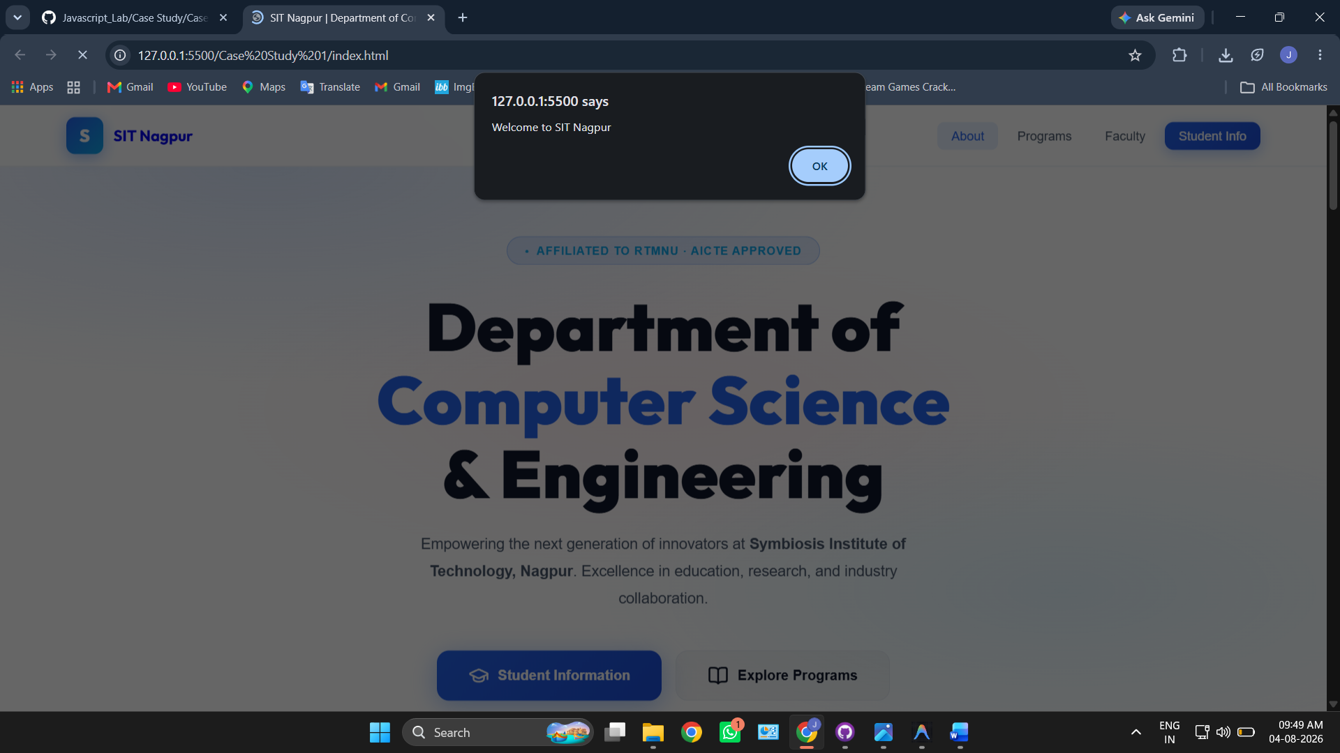

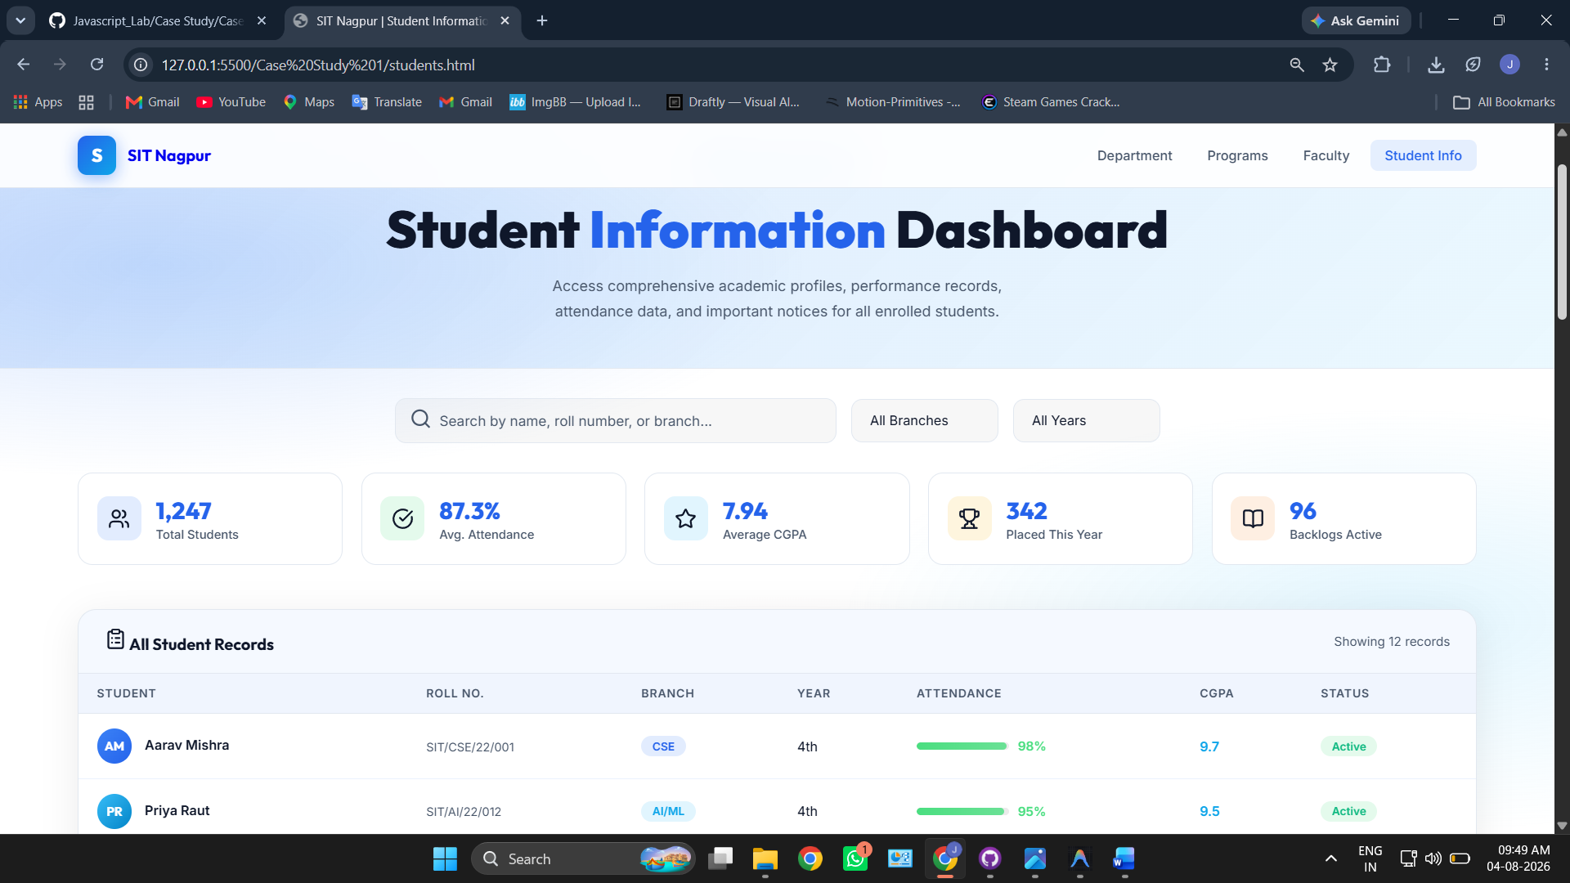

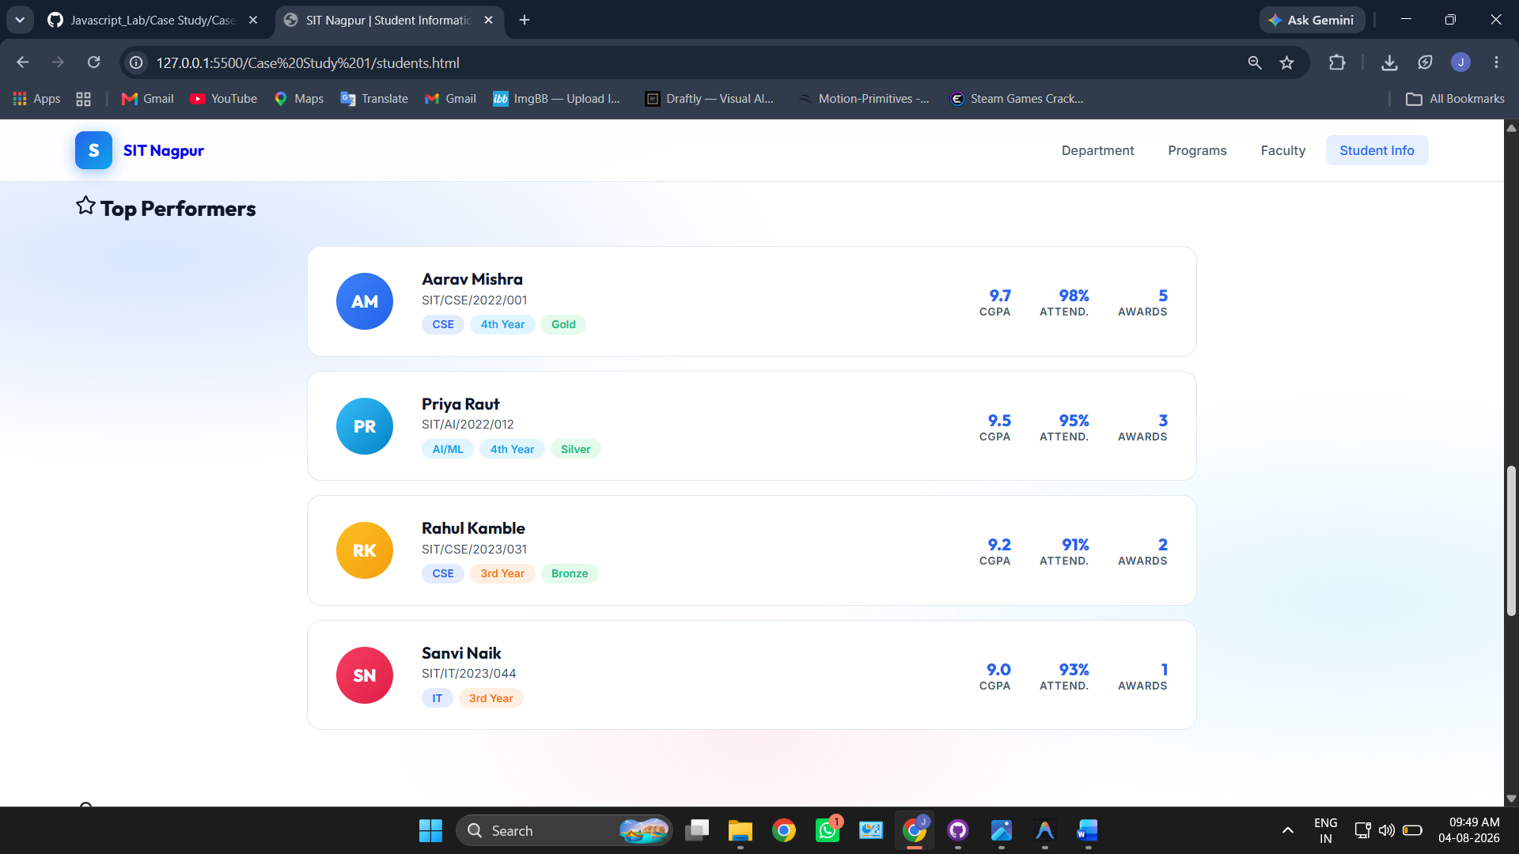

4. Result / Conclusion
The case study was successfully implemented by creating a college department webpage and linking it to a student information page. JavaScript was used to display the welcome message "Welcome to SIT Nagpur" in an alert box. The webpages were designed using HTML and CSS, while JavaScript provided the required interactivity. The objectives of the case study were successfully achieved.

Experiment 2
1. Experiment Title
Use var, let, const, and demonstrate basic features like template literals and destructuring; build a billing calculator with user input.

2. Software/Tools Required
- Visual Studio Code (VS Code)
- Google Chrome / Mozilla Firefox / Microsoft Edge
- HTML5
- CSS3
- JavaScript
- Windows Operating System

3. Experiment Program Code
The experiment consists of the following files:
- index.html
- styles.css
- script.js

index.html

<!DOCTYPE html>
<html lang="en">
<head>
<meta charset="UTF-8" />
<meta name="viewport" content="width=device-width, initial-scale=1.0" />
<meta name="description" content="Billing Calculator using var, let, const, template literals, and destructuring." />
<title>Billing Calculator</title>
<link rel="stylesheet" href="style.css" />
</head>
<body>

<div class="container">
<h1>Billing Calculator</h1>
<p class="tagline">Experiment 02 — var, let, const, template literals, destructuring</p>

<!-- Buttons -->
<div class="section">
<div class="btn-row">
<button id="btn-add" class="btn">+ Add Item</button>
<button id="btn-calculate" class="btn btn--green">Calculate Bill</button>
</div>
</div>

<!-- Items List -->
<div class="section">
<h2>Items</h2>
<table id="items-table">
<thead>
<tr>
<th>#</th>
<th>Item</th>
<th>Qty</th>
<th>Price</th>
<th>Total</th>
<th></th>
</tr>
</thead>
<tbody id="items-body"></tbody>
</table>
<p id="empty-msg" class="empty-msg">No items added yet.</p>
</div>

<!-- Invoice -->
<div class="section" id="invoice-section" style="display:none;">
<h2>Invoice Summary</h2>
<div id="invoice-output"></div>
<details id="code-details">
<summary>View JS Concepts Used</summary>
<pre id="code-block"></pre>
</details>
</div>

<!-- Console -->
<div class="section">
<h2>Console Output</h2>
<div id="console-log" class="console-log">
<p class="log log--muted">// Logs appear here as you interact...</p>
</div>
</div>

<!-- Concepts Reference -->
<div class="section concepts-ref">
<h2>JS Concepts Used</h2>
<table class="concepts-table">
<tr>
<td><code>var</code></td>
<td>Function-scoped, hoisted — used for tax rate</td>
</tr>
<tr>
<td><code>let</code></td>
<td>Block-scoped, reassignable — used for subtotal & items array</td>
</tr>
<tr>
<td><code>const</code></td>
<td>Block-scoped, immutable binding — used for DOM refs & computed values</td>
</tr>
<tr>
<td><code>`${}`</code></td>
<td>Template literals — used to build invoice HTML & log messages</td>
</tr>
<tr>
<td><code>{ }</code></td>
<td>Destructuring — unpacks item & billing result objects</td>
</tr>
</table>
</div>
</div>

<script src="script.js"></script>
</body>
</html>

Styles.css

/* Billing Calculator*/

* {
margin: 0;
padding: 0;
box-sizing: border-box;
}

body {
font-family: Arial, Helvetica, sans-serif;
background: #f5f5f5;
color: #222;
line-height: 1.5;
font-size: 14px;
}

.container {
max-width: 720px;
margin: 30px auto;
padding: 0 15px;
}

h1 {
font-size: 22px;
font-weight: bold;
margin-bottom: 2px;
}

.tagline {
color: #666;
font-size: 13px;
margin-bottom: 25px;
}

/* Sections */
.section {
background: #fff;
border: 1px solid #ddd;
border-radius: 6px;
padding: 18px;
margin-bottom: 14px;
}

.section h2 {
font-size: 15px;
font-weight: 600;
margin-bottom: 12px;
color: #333;
}

/* Button row */
.btn-row {
display: flex;
gap: 10px;
flex-wrap: wrap;
}

/* Buttons */
.btn {
padding: 7px 16px;
border: none;
border-radius: 4px;
font-size: 13px;
font-weight: 600;
font-family: inherit;
cursor: pointer;
background: #4a7fff;
color: #fff;
white-space: nowrap;
align-self: flex-end;
}

.btn:hover {
background: #3a6ae0;
}

.btn--green {
background: #27a86b;
}

.btn--green:hover {
background: #1f8c58;
}

.btn--delete {
background: none;
color: #c44;
padding: 4px 8px;
font-size: 12px;
border: 1px solid #ddd;
}

.btn--delete:hover {
background: #fde8e8;
}

/* Table */
table {
width: 100%;
border-collapse: collapse;
}

#items-table {
display: none;
}

#items-table.has-items {
display: table;
}

th, td {
padding: 8px 10px;
text-align: left;
font-size: 13px;
border-bottom: 1px solid #eee;
}

th {
font-size: 11px;
font-weight: 600;
color: #777;
text-transform: uppercase;
letter-spacing: 0.3px;
border-bottom: 2px solid #e5e5e5;
}

.empty-msg {
color: #999;
font-size: 13px;
text-align: center;
padding: 20px 0;
}

.empty-msg.hidden {
display: none;
}

/* Invoice */
.inv-row {
display: flex;
justify-content: space-between;
padding: 5px 0;
font-size: 13px;
border-bottom: 1px solid #f0f0f0;
}

.inv-row:last-child {
border-bottom: none;
}

.inv-label {
color: #666;
}

.inv-row--total {
font-weight: 700;
font-size: 15px;
margin-top: 6px;
padding-top: 8px;
border-top: 2px solid #e5e5e5;
border-bottom: none;
color: #1a8a52;
}

.inv-row--total .inv-label {
color: #222;
}

/* Code block */
details {
margin-top: 12px;
}

details summary {
cursor: pointer;
font-size: 12px;
font-weight: 600;
color: #4a7fff;
}

pre {
margin-top: 8px;
background: #f8f8f8;
border: 1px solid #e0e0e0;
border-radius: 4px;
padding: 12px;
font-family: Consolas, "Courier New", monospace;
font-size: 12px;
line-height: 1.6;
overflow-x: auto;
color: #444;
white-space: pre;
}

/* Console */
.console-log {
background: #1e1e1e;
border-radius: 4px;
padding: 12px;
max-height: 200px;
overflow-y: auto;
font-family: Consolas, "Courier New", monospace;
font-size: 12px;
line-height: 1.55;
}

.log {
padding: 1px 0;
}

.log--muted { color: #777; }
.log--var { color: #dca34e; }
.log--let { color: #5cc4db; }
.log--const { color: #5cb87a; }
.log--template { color: #b39ddb; }
.log--destruct { color: #e06c75; }
.log--result { color: #fff; font-weight: bold; }
.log--info { color: #999; }

/* Concepts Reference */
.concepts-table {
border: none;
}

.concepts-table td {
border-bottom: 1px solid #f0f0f0;
padding: 6px 10px;
font-size: 13px;
}

.concepts-table td:first-child {
width: 70px;
font-family: Consolas, "Courier New", monospace;
font-weight: bold;
color: #4a7fff;
}

/* Responsive */
@media (max-width: 550px) {
.form-row { flex-direction: column; }
.field, .field--short { flex: 1 1 100%; }
.btn { width: 100%; }
}

Script.js

/* ═══════════════════════════════════════════════════════
Billing Calculator — JavaScript
Demonstrates: var, let, const, template literals,
destructuring, and user input via prompt()
═══════════════════════════════════════════════════════ */

// ──────────────────────────────────────────────────────
// 1. `var` — function-scoped, hoisted, re-declarable
// Used here for the tax rate (legacy-style declaration)
// ──────────────────────────────────────────────────────
var taxRate = 18; // default GST percentage

// ──────────────────────────────────────────────────────
// 2. `let` — block-scoped, reassignable
// Used for the items array and the running subtotal
// ──────────────────────────────────────────────────────
let items = []; // line-item collection (will grow)
let subtotal = 0; // recalculated on every change

// ──────────────────────────────────────────────────────
// 3. `const` — block-scoped, immutable binding
// Used for DOM references and utility functions
// ──────────────────────────────────────────────────────
const btnAdd = document.getElementById("btn-add");
const btnCalculate = document.getElementById("btn-calculate");
const tableBody = document.getElementById("items-body");
const itemsTable = document.getElementById("items-table");
const emptyMsg = document.getElementById("empty-msg");
const invoiceSection = document.getElementById("invoice-section");
const invoiceOutput = document.getElementById("invoice-output");
const codeBlock = document.getElementById("code-block");
const consoleLog = document.getElementById("console-log");

// ── Helper: format currency ──
const formatCurrency = (amount) => `Rs.${amount.toFixed(2)}`;

// ══════════════════════════════════════════════════════
// CUSTOM CONSOLE — mirrors logs into the on-page panel
// ══════════════════════════════════════════════════════
let firstLog = true;

function logToConsole(message, type) {
if (firstLog) {
consoleLog.innerHTML = "";
firstLog = false;
}
const p = document.createElement("p");
p.className = "log log--" + type;
p.textContent = message;
consoleLog.appendChild(p);
consoleLog.scrollTop = consoleLog.scrollHeight;
}

// ══════════════════════════════════════════════════════
// ADD ITEM — uses prompt() for input
// ══════════════════════════════════════════════════════
btnAdd.addEventListener("click", function () {

// ── prompt() — ask user for item details one by one ──
const name = prompt("Enter item name:");
if (name === null || name.trim() === "") {
alert("Item name cannot be empty!");
return;
}

const qtyStr = prompt("Enter quantity for \"" + name.trim() + "\":");
if (qtyStr === null) return;
const qty = parseInt(qtyStr, 10);
if (isNaN(qty) || qty < 1) {
alert("Quantity must be a number >= 1!");
return;
}

const priceStr = prompt("Enter price per unit for \"" + name.trim() + "\":");
if (priceStr === null) return;
const price = parseFloat(priceStr);
if (isNaN(price) || price < 0) {
alert("Price must be a valid number!");
return;
}

// ── `const` for each item object (binding is immutable) ──
const lineTotal = qty * price;
const item = { name: name.trim(), qty, price, lineTotal };

// ── `let` — reassign the items array & subtotal ──
items.push(item);
subtotal += lineTotal;

// ── `var` — demonstrate function-scope hoisting ──
var currentTax = taxRate; // var is function-scoped to this handler
logToConsole("[var] currentTax hoisted in handler scope = " + currentTax + "%", "var");

// ── `let` log ──
logToConsole(`[let] subtotal reassigned = ${formatCurrency(subtotal)}`, "let");

// ── `const` log ──
logToConsole(`[const] item = { name: "${item.name}", qty: ${item.qty}, price: ${item.price}, lineTotal: ${item.lineTotal} }`, "const");

// ── Template Literal — build a readable log message ──
const logMsg = `Added "${item.name}" x ${qty} @ ${formatCurrency(price)} = ${formatCurrency(lineTotal)}`;
logToConsole("[`${}] " + logMsg, "template");

// ── Destructuring — unpack the item ──
const { name: itemName, qty: itemQty } = item;
logToConsole("[ {} ] Destructured -> itemName=\"" + itemName + "\", itemQty=" + itemQty, "destruct");

// Render table
renderTable();

// Confirm to user
alert(`Added: ${item.name} x ${qty} @ ${formatCurrency(price)} = ${formatCurrency(lineTotal)}`);
});

// ══════════════════════════════════════════════════════
// RENDER TABLE
// ══════════════════════════════════════════════════════
function renderTable() {
tableBody.innerHTML = "";

if (items.length === 0) {
itemsTable.classList.remove("has-items");
emptyMsg.classList.remove("hidden");
return;
}

itemsTable.classList.add("has-items");
emptyMsg.classList.add("hidden");

items.forEach(function (item, index) {
// ── Destructuring each item inside the loop ──
const { name, qty, price, lineTotal } = item;

const tr = document.createElement("tr");

// ── Template Literal — build the row HTML ──
tr.innerHTML = `
<td>${index + 1}</td>
<td>${name}</td>
<td>${qty}</td>
<td>${formatCurrency(price)}</td>
<td>${formatCurrency(lineTotal)}</td>
<td><button class="btn btn--delete" data-index="${index}">x</button></td>
`;

tableBody.appendChild(tr);
});

// Delete buttons
tableBody.querySelectorAll(".btn--delete").forEach(function (btn) {
btn.addEventListener("click", function () {
const idx = parseInt(this.dataset.index, 10);
const removed = items[idx];
logToConsole("Removed \"" + removed.name + "\" (" + formatCurrency(removed.lineTotal) + ")", "info");
items.splice(idx, 1);

// ── `let` — recalculate subtotal ──
subtotal = 0;
items.forEach(function (it) {
subtotal += it.lineTotal;
});

renderTable();
});
});
}

// ══════════════════════════════════════════════════════
// CALCULATE — uses prompt() for tax & discount
// ══════════════════════════════════════════════════════
btnCalculate.addEventListener("click", function () {
if (items.length === 0) {
alert("Add at least one item before calculating!");
return;
}

// ── `var` — ask tax rate via prompt ──
var taxRateStr = prompt("Enter tax rate % (default 18):", "18");
if (taxRateStr === null) return;
var taxRate = parseFloat(taxRateStr) || 0;
logToConsole("[var] taxRate re-declared in this scope = " + taxRate + "%", "var");

// ── `const` — ask discount via prompt ──
const discountStr = prompt("Enter discount % (default 0):", "0");
if (discountStr === null) return;
const discountPercent = parseFloat(discountStr) || 0;
logToConsole("[const] discountPercent = " + discountPercent + "%", "const");

// ── `let` — recalculate the subtotal ──
let calcSubtotal = 0;
for (let i = 0; i < items.length; i++) {
calcSubtotal += items[i].lineTotal;
}
logToConsole(`[let] calcSubtotal = ${formatCurrency(calcSubtotal)}`, "let");

// ── Compute billing values ──
const discountAmount = calcSubtotal * (discountPercent / 100);
const afterDiscount = calcSubtotal - discountAmount;
const taxAmount = afterDiscount * (taxRate / 100);
const grandTotal = afterDiscount + taxAmount;

// ── Bundle into an object for destructuring demo ──
const billingResult = {
subtotal: calcSubtotal,
discount: discountAmount,
discountPct: discountPercent,
taxable: afterDiscount,
tax: taxAmount,
taxPct: taxRate,
total: grandTotal,
itemCount: items.length
};

// ──────────────────────────────────────────────────
// 5. Destructuring — unpack the result object
// ──────────────────────────────────────────────────
const {
subtotal: billSubtotal,
discount: billDiscount,
discountPct,
taxable,
tax,
taxPct,
total,
itemCount
} = billingResult;

logToConsole("[ {} ] Destructured billingResult -> total = " + formatCurrency(total), "destruct");

// ──────────────────────────────────────────────────
// 4. Template Literal — build invoice HTML
// ──────────────────────────────────────────────────
let invoiceHTML = "";

items.forEach(function (item, idx) {
const { name, qty, price, lineTotal } = item;
invoiceHTML += `
<div class="inv-row">
<span class="inv-label">${idx + 1}. ${name} (x${qty} @ ${formatCurrency(price)})</span>
<span>${formatCurrency(lineTotal)}</span>
</div>
`;
});

invoiceHTML += `
<div class="inv-row">
<span class="inv-label">Subtotal (${itemCount} items)</span>
<span>${formatCurrency(billSubtotal)}</span>
</div>
<div class="inv-row">
<span class="inv-label">Discount (${discountPct}%)</span>
<span>- ${formatCurrency(billDiscount)}</span>
</div>
<div class="inv-row">
<span class="inv-label">Taxable Amount</span>
<span>${formatCurrency(taxable)}</span>
</div>
<div class="inv-row">
<span class="inv-label">Tax @ ${taxPct}%</span>
<span>+ ${formatCurrency(tax)}</span>
</div>
<div class="inv-row inv-row--total">
<span class="inv-label">Grand Total</span>
<span>${formatCurrency(total)}</span>
</div>
`;

logToConsole("[`${}] Invoice HTML built with template literals", "template");
logToConsole(">> Grand Total = " + formatCurrency(total), "result");

// Render invoice
invoiceOutput.innerHTML = invoiceHTML;
invoiceSection.style.display = "block";
invoiceSection.scrollIntoView({ behavior: "smooth", block: "start" });

// Show grand total in alert
alert("Grand Total: " + formatCurrency(total));

// ── Code explanation block ──
codeBlock.textContent = `// -- var: function-scoped, hoisted --
var taxRate = ${taxRate};
// taxRate is accessible anywhere in the function

// -- let: block-scoped, reassignable --
let subtotal = 0;
for (let i = 0; i < items.length; i++) {
subtotal += items[i].lineTotal; // reassigned each iteration
}
// subtotal = ${formatCurrency(calcSubtotal)}

// -- const: block-scoped, immutable binding --
const discountPercent = ${discountPercent};
const grandTotal = ${grandTotal.toFixed(2)};
// grandTotal cannot be reassigned

// -- Template Literal --
const message = \`Your total is \${formatCurrency(${grandTotal.toFixed(2)})}\`;
// Output: "Your total is ${formatCurrency(grandTotal)}"

// -- Destructuring --
const { subtotal, discount, tax, total } = billingResult;
// Unpacks object properties into individual variables
// subtotal = ${formatCurrency(billSubtotal)}
// discount = ${formatCurrency(billDiscount)}
// tax = ${formatCurrency(tax)}
// total = ${formatCurrency(total)}`;
});

// ══════════════════════════════════════════════════════
// INIT LOG
// ══════════════════════════════════════════════════════
logToConsole("Billing Calculator initialized.", "info");
logToConsole("[var] taxRate declared with var = 18%", "var");
logToConsole("[let] items = [], subtotal = 0", "let");
logToConsole("[const] DOM references bound with const", "const");

Output:
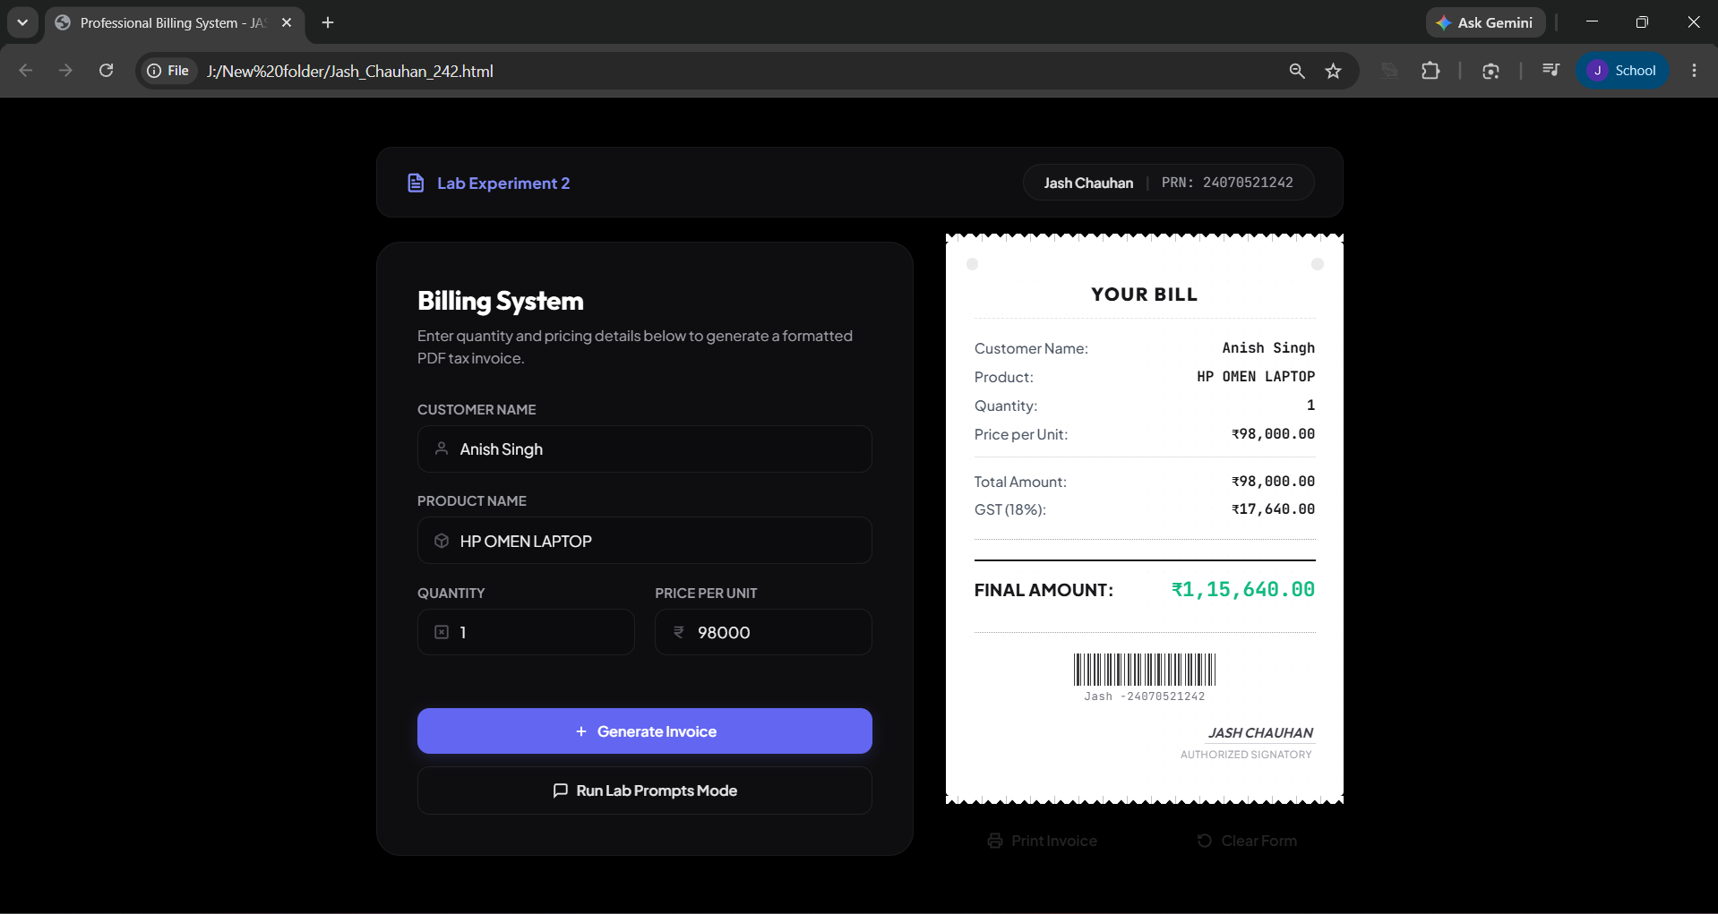
Case Study 2
1. Case Study Title
Develop the webpage for an online shopping website with using HTML CSS and HTML5 tags and calculate the bill.

2. Case Study Program Code
The case study consists of the following files:
• index.html – Displays the Premium Bill Calculator webpage containing a form to input customer and product details for generating an invoice.

• script.js – Processes the form data, performs calculations (like base amount, discount, GST, and final total) by demonstrating various data types and type coercions, and dynamically updates the invoice summary on the webpage.

• style.css – Contains the styling rules for the layout, typography, and visual elements of the bill calculator application.

Index.html
<!DOCTYPE html>
<html lang="en">
<head>
<meta charset="UTF-8">
<meta name="viewport" content="width=device-width, initial-scale=1.0">
<title>Premium Bill Calculator</title>
<meta name="description" content="Online shopping bill calculator">
<link rel="preconnect" href="https://fonts.googleapis.com">
<link rel="preconnect" href="https://fonts.gstatic.com" crossorigin>
<link href="https://fonts.googleapis.com/css2?family=Inter:wght@300;400;500;600;700&display=swap" rel="stylesheet">
<link rel="stylesheet" href="style.css">
</head>
<body>
<div class="background-shapes">
<div class="shape shape-1"></div>
<div class="shape shape-2"></div>
<div class="shape shape-3"></div>
</div>

<main class="container">
<header>
<h1>Generate Invoice</h1>
<p>Enter the details below to calculate the final bill</p>
</header>

<div class="content-wrapper">
<section class="form-section">
<form id="billForm">
<div class="form-grid">
<div class="input-group">
<label for="customerName">Customer Name</label>
<input type="text" id="customerName" required placeholder="John Doe">
</div>
<div class="input-group">
<label for="mobileNumber">Mobile Number</label>
<input type="tel" id="mobileNumber" required placeholder="+91 9876543210">
</div>
<div class="input-group">
<label for="invoiceNumber">Invoice Number</label>
<input type="text" id="invoiceNumber" required placeholder="INV-2023-001">
</div>
<div class="input-group">
<label for="productName">Product Name</label>
<input type="text" id="productName" required placeholder="Premium Coffee Beans">
</div>

<div class="input-group">
<label for="quantity">Quantity (in Kg)</label>
<input type="number" id="quantity" step="0.01" min="0" required placeholder="2.5">
</div>
<div class="input-group">
<label for="rate">Rate per Kg (₹)</label>
<input type="number" id="rate" step="0.01" min="0" required placeholder="850">
</div>

<div class="input-group">
<label for="discount">Discount (%)</label>
<input type="number" id="discount" step="0.1" min="0" max="100" required placeholder="10">
</div>
<div class="input-group">
<label for="gst">GST (%)</label>
<input type="number" id="gst" step="0.1" min="0" max="100" required placeholder="18">
</div>

<div class="input-group">
<label for="packingCharges">Packing Charges (₹)</label>
<input type="number" id="packingCharges" step="0.01" min="0" required placeholder="50">
</div>

<div class="input-group">
<label for="paymentMode">Payment Mode</label>
<select id="paymentMode" required>
<option value="UPI">UPI</option>
<option value="Card">Card</option>
<option value="Cash">Cash</option>
</select>
</div>
</div>

<div class="checkbox-group">
<label class="custom-checkbox">
<input type="checkbox" id="membership">
<span class="checkmark"></span>
Pro Member (Extra 5% off)
</label>
</div>

<button type="submit" class="submit-btn">Calculate Bill</button>
</form>
</section>

<section class="invoice-section">
<div class="invoice-card glass-panel" id="invoiceCard">
<div class="invoice-header">
<h2>Invoice Summary</h2>
<span class="badge" id="displayInvoiceNum">#INV-XXXX</span>
</div>

<div class="customer-info">
<p><strong>To:</strong> <span id="displayCustomer">N/A</span></p>
<p><strong>Phone:</strong> <span id="displayMobile">N/A</span></p>
</div>

<div class="divider"></div>

<div class="bill-details">
<div class="bill-row">
<span>Item</span>
<span id="displayProduct" class="value">N/A</span>
</div>
<div class="bill-row">
<span>Quantity</span>
<span id="displayQty" class="value">0 Kg</span>
</div>
<div class="bill-row">
<span>Rate</span>
<span id="displayRate" class="value">₹0.00</span>
</div>

<div class="divider dashed"></div>

<div class="bill-row">
<span>Base Amount</span>
<span id="displayBaseAmount" class="value">₹0.00</span>
</div>
<div class="bill-row discount">
<span>Discount <span id="displayDiscountPercent"></span></span>
<span id="displayDiscountAmount" class="value">- ₹0.00</span>
</div>
<div class="bill-row discount" id="membershipDiscountRow" style="display: none;">
<span>Member Discount (5%)</span>
<span id="displayMemberDiscount" class="value">- ₹0.00</span>
</div>

<div class="divider dashed"></div>

<div class="bill-row">
<span>Taxable Value</span>
<span id="displayTaxableValue" class="value">₹0.00</span>
</div>
<div class="bill-row">
<span>GST <span id="displayGstPercent"></span></span>
<span id="displayGstAmount" class="value">+ ₹0.00</span>
</div>
<div class="bill-row">
<span>Packing Charges</span>
<span id="displayPacking" class="value">+ ₹0.00</span>
</div>
</div>

<div class="divider"></div>

<div class="total-section">
<div class="total-row">
<h3>Total Amount</h3>
<h3 id="displayTotal">₹0.00</h3>
</div>
<p class="payment-mode-label">Paid via <span id="displayPaymentMode">UPI</span></p>
</div>
</div>

<div class="empty-state" id="emptyState">
<div class="icon">🧾</div>
<p>Fill out the form to generate the invoice</p>
</div>
</section>
</div>
</main>

<script src="script.js"></script>
</body>
</html>

Styles.css

:root {
--bg-dark: #0f172a;
--panel-bg: rgba(30, 41, 59, 0.7);
--panel-border: rgba(255, 255, 255, 0.1);
--primary: #3b82f6;
--primary-hover: #2563eb;
--text-main: #f8fafc;
--text-muted: #94a3b8;
--success: #10b981;
--accent: #8b5cf6;
}

* {
margin: 0;
padding: 0;
box-sizing: border-box;
font-family: 'Inter', sans-serif;
}

body {
background-color: var(--bg-dark);
color: var(--text-main);
min-height: 100vh;
display: flex;
justify-content: center;
align-items: center;
padding: 2rem;
position: relative;
overflow-x: hidden;
}

/* Background Shapes for Glassmorphism */
.background-shapes {
position: absolute;
top: 0;
left: 0;
width: 100%;
height: 100%;
z-index: -1;
overflow: hidden;
}

.shape {
position: absolute;
border-radius: 50%;
filter: blur(80px);
}

.shape-1 {
width: 400px;
height: 400px;
background: rgba(59, 130, 246, 0.3);
top: -100px;
left: -100px;
}

.shape-2 {
width: 300px;
height: 300px;
background: rgba(139, 92, 246, 0.3);
bottom: 50px;
right: -50px;
}

.shape-3 {
width: 250px;
height: 250px;
background: rgba(16, 185, 129, 0.2);
top: 50%;
left: 50%;
transform: translate(-50%, -50%);
}

.container {
width: 100%;
max-width: 1100px;
z-index: 1;
}

header {
text-align: center;
margin-bottom: 3rem;
}

header h1 {
font-size: 2.5rem;
font-weight: 700;
margin-bottom: 0.5rem;
background: linear-gradient(to right, #60a5fa, #a78bfa);
-webkit-background-clip: text;
-webkit-text-fill-color: transparent;
}

header p {
color: var(--text-muted);
font-size: 1.1rem;
}

.content-wrapper {
display: grid;
grid-template-columns: 1fr 1fr;
gap: 2rem;
}

@media (max-width: 900px) {
.content-wrapper {
grid-template-columns: 1fr;
}
}

/* Form Styles */
.form-section {
background: var(--panel-bg);
backdrop-filter: blur(12px);
border: 1px solid var(--panel-border);
border-radius: 1.5rem;
padding: 2rem;
box-shadow: 0 25px 50px -12px rgba(0, 0, 0, 0.5);
}

.form-grid {
display: grid;
grid-template-columns: 1fr 1fr;
gap: 1.25rem;
}

@media (max-width: 600px) {
.form-grid {
grid-template-columns: 1fr;
}
}

.input-group {
display: flex;
flex-direction: column;
gap: 0.5rem;
}

.input-group label {
font-size: 0.875rem;
font-weight: 500;
color: var(--text-muted);
}

.input-group input, .input-group select {
background: rgba(15, 23, 42, 0.6);
border: 1px solid var(--panel-border);
border-radius: 0.5rem;
padding: 0.75rem 1rem;
color: var(--text-main);
font-size: 1rem;
transition: all 0.2s ease;
}

.input-group input:focus, .input-group select:focus {
outline: none;
border-color: var(--primary);
box-shadow: 0 0 0 2px rgba(59, 130, 246, 0.25);
}

.checkbox-group {
margin: 1.5rem 0;
}

.custom-checkbox {
display: flex;
align-items: center;
gap: 0.75rem;
cursor: pointer;
font-weight: 500;
user-select: none;
}

.custom-checkbox input {
display: none;
}

.checkmark {
width: 20px;
height: 20px;
background: rgba(15, 23, 42, 0.6);
border: 1px solid var(--panel-border);
border-radius: 4px;
position: relative;
transition: all 0.2s;
}

.custom-checkbox input:checked ~ .checkmark {
background: var(--accent);
border-color: var(--accent);
}

.checkmark:after {
content: "";
position: absolute;
display: none;
left: 6px;
top: 2px;
width: 5px;
height: 10px;
border: solid white;
border-width: 0 2px 2px 0;
transform: rotate(45deg);
}

.custom-checkbox input:checked ~ .checkmark:after {
display: block;
}

.submit-btn {
width: 100%;
background: linear-gradient(135deg, var(--primary), var(--accent));
color: white;
border: none;
padding: 1rem;
border-radius: 0.5rem;
font-size: 1.1rem;
font-weight: 600;
cursor: pointer;
transition: transform 0.2s, box-shadow 0.2s;
}

.submit-btn:hover {
transform: translateY(-2px);
box-shadow: 0 10px 20px -10px rgba(59, 130, 246, 0.5);
}

.submit-btn:active {
transform: translateY(0);
}

/* Invoice Styles */
.invoice-section {
display: flex;
flex-direction: column;
}

.glass-panel {
background: var(--panel-bg);
backdrop-filter: blur(12px);
border: 1px solid var(--panel-border);
border-radius: 1.5rem;
padding: 2rem;
box-shadow: 0 25px 50px -12px rgba(0, 0, 0, 0.5);
height: 100%;
display: none;
animation: fadeIn 0.4s ease-out;
}

@keyframes fadeIn {
from { opacity: 0; transform: translateY(10px); }
to { opacity: 1; transform: translateY(0); }
}

.empty-state {
background: var(--panel-bg);
backdrop-filter: blur(12px);
border: 1px dashed var(--panel-border);
border-radius: 1.5rem;
height: 100%;
display: flex;
flex-direction: column;
justify-content: center;
align-items: center;
color: var(--text-muted);
min-height: 400px;
}

.empty-state .icon {
font-size: 4rem;
margin-bottom: 1rem;
opacity: 0.5;
}

.invoice-header {
display: flex;
justify-content: space-between;
align-items: center;
margin-bottom: 1.5rem;
}

.invoice-header h2 {
font-size: 1.5rem;
font-weight: 600;
}

.badge {
background: rgba(16, 185, 129, 0.2);
color: var(--success);
padding: 0.25rem 0.75rem;
border-radius: 9999px;
font-size: 0.875rem;
font-weight: 500;
}

.customer-info p {
color: var(--text-muted);
margin-bottom: 0.5rem;
}

.customer-info span {
color: var(--text-main);
}

.divider {
height: 1px;
background: var(--panel-border);
margin: 1.5rem 0;
}

.divider.dashed {
background: none;
border-top: 1px dashed var(--panel-border);
}

.bill-details {
display: flex;
flex-direction: column;
gap: 0.875rem;
}

.bill-row {
display: flex;
justify-content: space-between;
font-size: 0.95rem;
color: var(--text-muted);
}

.bill-row .value {
color: var(--text-main);
font-weight: 500;
}

.bill-row.discount .value {
color: #ef4444;
}

.total-section {
margin-top: 1rem;
}

.total-row {
display: flex;
justify-content: space-between;
align-items: center;
}

.total-row h3 {
font-size: 1.5rem;
color: var(--text-main);
}

.payment-mode-label {
text-align: right;
font-size: 0.875rem;
color: var(--text-muted);
margin-top: 0.5rem;
}

.payment-mode-label span {
font-weight: 600;
color: var(--accent);
}

script.js

// Wait for DOM to load
document.addEventListener('DOMContentLoaded', () => {

// Select the form element
const billForm = document.getElementById('billForm');

// UI Elements for Invoice Display
const invoiceCard = document.getElementById('invoiceCard');
const emptyState = document.getElementById('emptyState');

billForm.addEventListener('submit', function(event) {
event.preventDefault(); // Prevent page reload

// --- a) Learn primitive data types: string, number, boolean, undefined, null. ---
// --- b) Declare variables using var, let, and const ---

// 1. Strings (Using const as these won't change)
const customerName = document.getElementById('customerName').value;
const mobileNumber = document.getElementById('mobileNumber').value;
const invoiceNumber = document.getElementById('invoiceNumber').value;
const productName = document.getElementById('productName').value;
const paymentMode = document.getElementById('paymentMode').value;

// 2. Numbers (Using let as we will read them as strings and convert)
let quantityStr = document.getElementById('quantity').value;
let rateStr = document.getElementById('rate').value;
let discountStr = document.getElementById('discount').value;
let gstStr = document.getElementById('gst').value;
let packingChargesStr = document.getElementById('packingCharges').value;

// 3. Boolean
const isMember = document.getElementById('membership').checked; // returns boolean

// 4. Undefined / Null (just to demonstrate for the case study)
let optionalNotes; // This is undefined by default
let discountCode = null; // Explicitly null for now

// --- c) Understand type coercion and type conversion ---

// Explicit Type Conversion (String to Number)
const quantity = Number(quantityStr);
const rate = parseFloat(rateStr);
const discountPercent = Number(discountStr);
const gstPercent = Number(gstStr);
const packingCharges = Number(packingChargesStr);

// --- Calculations ---

// Base Amount
// Implicit Type Coercion could happen if we used *, but we explicitly converted them to numbers above for safety.
// E.g., "5" * "10" = 50 (JS coerces strings to numbers for multiplication)
// Let's use var just to fulfill the case study requirement (var, let, const)
var baseAmount = quantity * rate;

// Discount Calculation
let discountAmount = baseAmount * (discountPercent / 100);
let amountAfterDiscount = baseAmount - discountAmount;

// Member Discount (Additional 5% if true)
let memberDiscountAmount = 0;
if (isMember) {
// true will be coerced to 1 if used in math, but we use it as a boolean condition
memberDiscountAmount = amountAfterDiscount * 0.05;
amountAfterDiscount -= memberDiscountAmount;
}

// GST Calculation
let gstAmount = amountAfterDiscount * (gstPercent / 100);

// Final Total
let finalTotal = amountAfterDiscount + gstAmount + packingCharges;

// --- Update UI ---

// Show invoice, hide empty state
emptyState.style.display = 'none';
invoiceCard.style.display = 'block';

// Populate fields
document.getElementById('displayInvoiceNum').textContent = `#${invoiceNumber}`;
document.getElementById('displayCustomer').textContent = customerName;
document.getElementById('displayMobile').textContent = mobileNumber;
document.getElementById('displayProduct').textContent = productName;
document.getElementById('displayQty').textContent = `${quantity} Kg`;
document.getElementById('displayRate').textContent = `₹${rate.toFixed(2)}`;

document.getElementById('displayBaseAmount').textContent = `₹${baseAmount.toFixed(2)}`;

document.getElementById('displayDiscountPercent').textContent = `(${discountPercent}%)`;
document.getElementById('displayDiscountAmount').textContent = `- ₹${discountAmount.toFixed(2)}`;

const membershipDiscountRow = document.getElementById('membershipDiscountRow');
if (isMember) {
membershipDiscountRow.style.display = 'flex';
document.getElementById('displayMemberDiscount').textContent = `- ₹${memberDiscountAmount.toFixed(2)}`;
} else {
membershipDiscountRow.style.display = 'none';
}

document.getElementById('displayTaxableValue').textContent = `₹${amountAfterDiscount.toFixed(2)}`;

document.getElementById('displayGstPercent').textContent = `(${gstPercent}%)`;
document.getElementById('displayGstAmount').textContent = `+ ₹${gstAmount.toFixed(2)}`;
document.getElementById('displayPacking').textContent = `+ ₹${packingCharges.toFixed(2)}`;

document.getElementById('displayTotal').textContent = `₹${finalTotal.toFixed(2)}`;
document.getElementById('displayPaymentMode').textContent = paymentMode;

// Note: Demonstrating implicit coercion just for console log
console.log("Total is: " + finalTotal); // Number is coerced into a String for concatenation
});
});

Output:

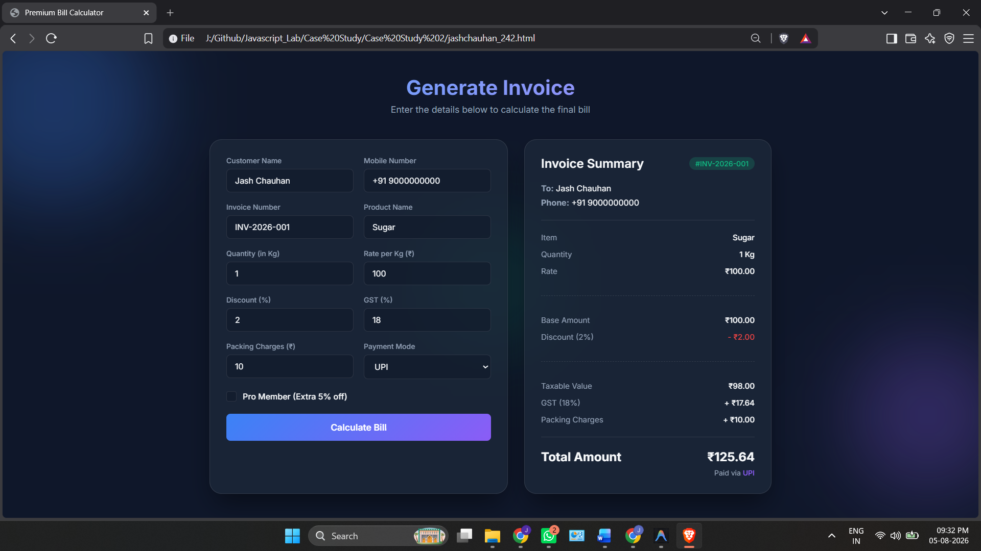

Result/Conclusion:
Hence, we have successfully developed the Premium Bill Calculator webpage. Through this case study, we practically learned how to declare variables using var, let, and const, utilize various primitive data types (such as strings, numbers, and booleans), and perform type coercion and explicit type conversions in JavaScript to compute the final bill amount and dynamically display the generated invoice.

Experiment 3
1. Experiment Title
Implement control structures and form validation; create a grading system based on user-entered marks.

2. Software/Tools Required
- Visual Studio Code (VS Code)
- Google Chrome / Mozilla Firefox / Microsoft Edge
- HTML5
- CSS3
- JavaScript
- Windows Operating System

3. Experiment Program Code
The experiment consists of the following files:
- jashchauhan_242.html
- styles.css
- script.js

jashchauhan_242.html

<!DOCTYPE html>
<html lang="en">

<head>
<meta charset="UTF-8" />
<meta name="viewport" content="width=device-width, initial-scale=1.0" />
<meta name="description"
content="Student Grading System using control structures and form validation — if/else, switch, ternary, for, while, do-while." />
<title>Student Grading System</title>
<link rel="stylesheet" href="style.css" />
</head>

<body>

<div class="container">
<h1>Student Grading System</h1>
<p class="tagline">Experiment 03 — Control structures &amp; form validation</p>

<!-- Input Form -->
<div class="section">
<h2>Enter Student Details</h2>
<form id="grade-form" novalidate>

<div class="form-row">
<div class="field">
<label for="student-name">Student Name</label>
<input type="text" id="student-name" placeholder="e.g. Jash Chauhan" autocomplete="off" />
<span class="error-msg" id="err-name"></span>
</div>
<div class="field field--short">
<label for="student-roll">Roll No.</label>
<input type="text" id="student-roll" placeholder="e.g. 101" autocomplete="off" />
<span class="error-msg" id="err-roll"></span>
</div>
</div>

<div class="form-row">
<div class="field field--short">
<label for="marks-1">English</label>
<input type="number" id="marks-1" placeholder="0 – 100" min="0" max="100" />
<span class="error-msg" id="err-m1"></span>
</div>
<div class="field field--short">
<label for="marks-2">Maths</label>
<input type="number" id="marks-2" placeholder="0 – 100" min="0" max="100" />
<span class="error-msg" id="err-m2"></span>
</div>
<div class="field field--short">
<label for="marks-3">Science</label>
<input type="number" id="marks-3" placeholder="0 – 100" min="0" max="100" />
<span class="error-msg" id="err-m3"></span>
</div>
<div class="field field--short">
<label for="marks-4">Physics</label>
<input type="number" id="marks-4" placeholder="0 – 100" min="0" max="100" />
<span class="error-msg" id="err-m4"></span>
</div>
<div class="field field--short">
<label for="marks-5">Chemistry</label>
<input type="number" id="marks-5" placeholder="0 – 100" min="0" max="100" />
<span class="error-msg" id="err-m5"></span>
</div>
</div>

<div class="btn-row">
<button type="submit" id="btn-submit" class="btn btn--green">Calculate Grade</button>
<button type="reset" id="btn-reset" class="btn">Reset</button>
</div>
</form>
</div>

<!-- Results Table -->
<div class="section" id="results-section" style="display:none;">
<h2>Results</h2>
<table id="results-table">
<thead>
<tr>
<th>#</th>
<th>Name</th>
<th>Roll</th>
<th>Total</th>
<th>%</th>
<th>Grade</th>
<th>Status</th>
</tr>
</thead>
<tbody id="results-body"></tbody>
</table>
</div>

<!-- Report Card -->
<div class="section" id="report-section" style="display:none;">
<h2>Report Card</h2>
<div id="report-output"></div>
</div>

<!-- Concepts Reference -->
<div class="section concepts-ref">
<h2>JS Concepts Used</h2>
<table class="concepts-table">
<tr>
<td><code>if / else</code></td>
<td>Form validation — checks empty fields, numeric range, and pass/fail status</td>
</tr>
<tr>
<td><code>switch</code></td>
<td>Maps percentage ranges to letter grades (A+, A, B+, B, …)</td>
</tr>
<tr>
<td><code>for</code></td>
<td>Iterates over the 5 subject mark inputs for validation &amp; totalling</td>
</tr>
<tr>
<td><code>while</code></td>
<td>Scans marks to count subjects scoring above 75</td>
</tr>
<tr>
<td><code>do…while</code></td>
<td>Builds the subject breakdown rows (at least one subject always exists)</td>
</tr>
<tr>
<td><code>? :</code></td>
<td>Ternary operator — concise pass/fail &amp; CSS class assignment</td>
</tr>
</table>
</div>
</div>

<script src="script.js"></script>
</body>

</html>

Styles.css
/* Student Grading System — Simple Light Theme */

* {
margin: 0;
padding: 0;
box-sizing: border-box;
}

body {
font-family: Arial, Helvetica, sans-serif;
background: #f5f5f5;
color: #222;
line-height: 1.5;
font-size: 14px;
}

.container {
max-width: 720px;
margin: 30px auto;
padding: 0 15px;
}

h1 {
font-size: 22px;
font-weight: bold;
margin-bottom: 2px;
}

.tagline {
color: #666;
font-size: 13px;
margin-bottom: 25px;
}

/* Sections */
.section {
background: #fff;
border: 1px solid #ddd;
border-radius: 6px;
padding: 18px;
margin-bottom: 14px;
}

.section h2 {
font-size: 15px;
font-weight: 600;
margin-bottom: 12px;
color: #333;
}

/* Form layout */
.form-row {
display: flex;
gap: 10px;
margin-bottom: 12px;
flex-wrap: wrap;
}

.field {
flex: 1 1 200px;
display: flex;
flex-direction: column;
}

.field--short {
flex: 1 1 100px;
}

label {
font-size: 12px;
font-weight: 600;
color: #555;
margin-bottom: 4px;
}

input {
padding: 7px 10px;
border: 1px solid #ccc;
border-radius: 4px;
font-size: 13px;
font-family: inherit;
outline: none;
transition: border-color 0.2s;
}

input:focus {
border-color: #4a7fff;
}

input.invalid {
border-color: #d44;
}

.error-msg {
font-size: 11px;
color: #d44;
min-height: 16px;
margin-top: 2px;
}

/* Buttons */
.btn-row {
display: flex;
gap: 10px;
flex-wrap: wrap;
margin-top: 4px;
}

.btn {
padding: 7px 16px;
border: none;
border-radius: 4px;
font-size: 13px;
font-weight: 600;
font-family: inherit;
cursor: pointer;
background: #4a7fff;
color: #fff;
white-space: nowrap;
}

.btn:hover {
background: #3a6ae0;
}

.btn--green {
background: #27a86b;
}

.btn--green:hover {
background: #1f8c58;
}

/* Table */
table {
width: 100%;
border-collapse: collapse;
}

th, td {
padding: 8px 10px;
text-align: left;
font-size: 13px;
border-bottom: 1px solid #eee;
}

th {
font-size: 11px;
font-weight: 600;
color: #777;
text-transform: uppercase;
letter-spacing: 0.3px;
border-bottom: 2px solid #e5e5e5;
}

/* Grade badge */
.badge {
display: inline-block;
padding: 2px 10px;
border-radius: 3px;
font-size: 12px;
font-weight: 700;
}

.badge--pass {
background: #e6f7ee;
color: #1a8a52;
}

.badge--fail {
background: #fde8e8;
color: #c44;
}

.badge--grade {
background: #eef2ff;
color: #4a7fff;
font-size: 13px;
}

/* Report Card */
.report-card {
border: 1px solid #e0e0e0;
border-radius: 6px;
overflow: hidden;
}

.report-header {
background: #f8f8f8;
padding: 14px 16px;
border-bottom: 1px solid #e0e0e0;
}

.report-header h3 {
font-size: 15px;
margin-bottom: 2px;
}

.report-header p {
font-size: 12px;
color: #666;
}

.report-body {
padding: 0;
}

.report-body table {
margin: 0;
}

.report-body th,
.report-body td {
padding: 8px 16px;
}

.report-footer {
background: #f8f8f8;
padding: 12px 16px;
border-top: 1px solid #e0e0e0;
display: flex;
justify-content: space-between;
align-items: center;
flex-wrap: wrap;
gap: 8px;
}

.report-footer .stat {
font-size: 13px;
color: #444;
}

.report-footer .stat strong {
font-weight: 700;
}

/* Console */
.console-log {
background: #1e1e1e;
border-radius: 4px;
padding: 12px;
max-height: 200px;
overflow-y: auto;
font-family: Consolas, "Courier New", monospace;
font-size: 12px;
line-height: 1.55;
}

.log {
padding: 1px 0;
}

.log--muted { color: #777; }
.log--if { color: #e06c75; }
.log--switch { color: #dca34e; }
.log--for { color: #5cc4db; }
.log--while { color: #b39ddb; }
.log--dowhile { color: #c678dd; }
.log--ternary { color: #e5c07b; }
.log--result { color: #fff; font-weight: bold; }
.log--info { color: #999; }
.log--error { color: #e06c75; }

/* Concepts Reference */
.concepts-table {
border: none;
}

.concepts-table td {
border-bottom: 1px solid #f0f0f0;
padding: 6px 10px;
font-size: 13px;
}

.concepts-table td:first-child {
width: 90px;
font-family: Consolas, "Courier New", monospace;
font-weight: bold;
color: #4a7fff;
}

/* Responsive */
@media (max-width: 550px) {
.form-row { flex-direction: column; }
.field, .field--short { flex: 1 1 100%; }
.btn { width: 100%; }
}

Script.js
/* ═══════════════════════════════════════════════════════
Student Grading System — JavaScript
Demonstrates: if/else, switch, for, while, do…while,
ternary operator, and form validation
═══════════════════════════════════════════════════════ */

// ──────────────────────────────────────────────────────
// DOM References
// ──────────────────────────────────────────────────────
const form = document.getElementById("grade-form");
const studentName = document.getElementById("student-name");
const studentRoll = document.getElementById("student-roll");
const resultsSection = document.getElementById("results-section");
const resultsBody = document.getElementById("results-body");
const reportSection = document.getElementById("report-section");
const reportOutput = document.getElementById("report-output");

const SUBJECT_COUNT = 5;
const PASS_MARK = 40;

// Collect all mark inputs and their error spans
const markInputs = [];
const markErrors = [];
for (let i = 1; i <= SUBJECT_COUNT; i++) {
markInputs.push(document.getElementById("marks-" + i));
markErrors.push(document.getElementById("err-m" + i));
}

// Results history
let results = [];

// ══════════════════════════════════════════════════════
// FORM VALIDATION — uses if / else
// ══════════════════════════════════════════════════════
function validateForm() {
let isValid = true;
const errName = document.getElementById("err-name");
const errRoll = document.getElementById("err-roll");

// ── if / else — validate student name ──
if (studentName.value.trim() === "") {
errName.textContent = "Name is required.";
studentName.classList.add("invalid");
isValid = false;
} else if (!/^[a-zA-Z\s]+$/.test(studentName.value.trim())) {
errName.textContent = "Name must contain only letters.";
studentName.classList.add("invalid");
isValid = false;
} else {
errName.textContent = "";
studentName.classList.remove("invalid");
}

// ── if / else — validate roll number ──
if (studentRoll.value.trim() === "") {
errRoll.textContent = "Roll No. is required.";
studentRoll.classList.add("invalid");
isValid = false;
} else if (isNaN(studentRoll.value.trim()) || parseInt(studentRoll.value) < 1) {
errRoll.textContent = "Enter a valid roll number.";
studentRoll.classList.add("invalid");
isValid = false;
} else {
errRoll.textContent = "";
studentRoll.classList.remove("invalid");
}

// ── for loop — validate each subject mark ──
for (let i = 0; i < SUBJECT_COUNT; i++) {
const value = markInputs[i].value.trim();

if (value === "") {
markErrors[i].textContent = "Required.";
markInputs[i].classList.add("invalid");
isValid = false;
} else if (isNaN(value)) {
markErrors[i].textContent = "Must be a number.";
markInputs[i].classList.add("invalid");
isValid = false;
} else if (parseFloat(value) < 0 || parseFloat(value) > 100) {
markErrors[i].textContent = "0 – 100 only.";
markInputs[i].classList.add("invalid");
isValid = false;
} else {
markErrors[i].textContent = "";
markInputs[i].classList.remove("invalid");
}
}

return isValid;
}

// ══════════════════════════════════════════════════════
// GRADE DETERMINATION — uses switch
// ══════════════════════════════════════════════════════
function getGrade(percentage) {
// ── switch — map percentage brackets to letter grades ──
// Math.floor(percentage / 10) gives us a bracket: 10, 9, 8, 7, ...
const bracket = Math.floor(percentage / 10);

let grade;
switch (bracket) {
case 10:
grade = "A+";
break;
case 9:
grade = "A+";
break;
case 8:
grade = "A";
break;
case 7:
grade = "B+";
break;
case 6:
grade = "B";
break;
case 5:
grade = "C";
break;
case 4:
grade = "D";
break;
default:
grade = "F";
break;
}

return grade;
}

// ══════════════════════════════════════════════════════
// FORM SUBMISSION — brings it all together
// ══════════════════════════════════════════════════════
form.addEventListener("submit", function (e) {
e.preventDefault();

// ── Step 1: Validate using if / else ──
if (!validateForm()) {
return;
}

// ── Step 2: Collect marks using for loop ──
const marks = [];
let total = 0;

for (let i = 0; i < SUBJECT_COUNT; i++) {
const mark = parseFloat(markInputs[i].value);
marks.push(mark);
total += mark;
}

const percentage = total / SUBJECT_COUNT;

// ── Step 3: Determine grade using switch ──
const grade = getGrade(percentage);

// ── Step 4: Check pass / fail ──
// Using a while loop to check if any subject is below pass mark
let failedSubjects = 0;
let idx = 0;

while (idx < marks.length) {
if (marks[idx] < PASS_MARK) {
failedSubjects++;
}
idx++;
}

// ── Ternary operator — determine pass/fail status ──
const status = failedSubjects === 0 ? "PASS" : "FAIL";

// ── Count subjects above 75 using while loop ──
let highScorers = 0;
let j = 0;
while (j < marks.length) {
if (marks[j] >= 75) {
highScorers++;
}
j++;
}

// ── Find highest and lowest marks ──
let highest = marks[0];
let lowest = marks[0];
for (let i = 1; i < marks.length; i++) {
if (marks[i] > highest) highest = marks[i];
if (marks[i] < lowest) lowest = marks[i];
}

// ── Store result ──
const result = {
name: studentName.value.trim(),
roll: studentRoll.value.trim(),
marks: marks,
total: total,
percentage: percentage,
grade: grade,
status: status,
failedSubjects: failedSubjects,
highScorers: highScorers,
highest: highest,
lowest: lowest
};

results.push(result);

// ── Render results table and report card ──
renderResults();
renderReport(result);
});

// ══════════════════════════════════════════════════════
// RENDER RESULTS TABLE
// ══════════════════════════════════════════════════════
function renderResults() {
resultsBody.innerHTML = "";
resultsSection.style.display = "block";

// ── for loop — build table rows for all results ──
for (let i = 0; i < results.length; i++) {
const r = results[i];
const tr = document.createElement("tr");

// ── Ternary — pick the CSS class for status badge ──
const statusClass = r.status === "PASS" ? "badge--pass" : "badge--fail";

tr.innerHTML =
"<td>" + (i + 1) + "</td>" +
"<td>" + r.name + "</td>" +
"<td>" + r.roll + "</td>" +
"<td>" + r.total + " / " + (SUBJECT_COUNT * 100) + "</td>" +
"<td>" + r.percentage.toFixed(2) + "%</td>" +
"<td><span class='badge badge--grade'>" + r.grade + "</span></td>" +
"<td><span class='badge " + statusClass + "'>" + r.status + "</span></td>";

resultsBody.appendChild(tr);
}
}

// ══════════════════════════════════════════════════════
// RENDER REPORT CARD — uses do…while
// ══════════════════════════════════════════════════════
function renderReport(result) {
reportSection.style.display = "block";

// ── Build subject rows using do…while ──
// (At least one subject always exists, so do…while is appropriate)
let subjectRows = "";
let k = 0;

do {
// ── Ternary — mark subjects below pass mark ──
const markClass = result.marks[k] < PASS_MARK ? "badge--fail" : "badge--pass";
const markLabel = result.marks[k] < PASS_MARK ? "Fail" : "Pass";

subjectRows +=
"<tr>" +
"<td>Subject " + (k + 1) + "</td>" +
"<td>" + result.marks[k] + " / 100</td>" +
"<td><span class='badge " + markClass + "'>" + markLabel + "</span></td>" +
"</tr>";

k++;
} while (k < result.marks.length);

// ── Build the full report card HTML ──
const statusClass = result.status === "PASS" ? "badge--pass" : "badge--fail";

reportOutput.innerHTML =
"<div class='report-card'>" +
"<div class='report-header'>" +
"<h3>" + result.name + "</h3>" +
"<p>Roll No. " + result.roll + "</p>" +
"</div>" +
"<div class='report-body'>" +
"<table>" +
"<thead><tr><th>Subject</th><th>Marks</th><th>Status</th></tr></thead>" +
"<tbody>" + subjectRows + "</tbody>" +
"</table>" +
"</div>" +
"<div class='report-footer'>" +
"<span class='stat'>Total: <strong>" + result.total + " / " + (SUBJECT_COUNT * 100) + "</strong></span>" +
"<span class='stat'>Percentage: <strong>" + result.percentage.toFixed(2) + "%</strong></span>" +
"<span class='stat'>Grade: <span class='badge badge--grade'>" + result.grade + "</span></span>" +
"<span class='stat'><span class='badge " + statusClass + "'>" + result.status + "</span></span>" +
"</div>" +
"</div>";

reportSection.scrollIntoView({ behavior: "smooth", block: "start" });
}

// ══════════════════════════════════════════════════════
// RESET — clear errors on form reset
// ══════════════════════════════════════════════════════
form.addEventListener("reset", function () {
// Clear all error messages and invalid styles
document.getElementById("err-name").textContent = "";
document.getElementById("err-roll").textContent = "";
studentName.classList.remove("invalid");
studentRoll.classList.remove("invalid");

for (let i = 0; i < SUBJECT_COUNT; i++) {
markErrors[i].textContent = "";
markInputs[i].classList.remove("invalid");
}

});

Output:
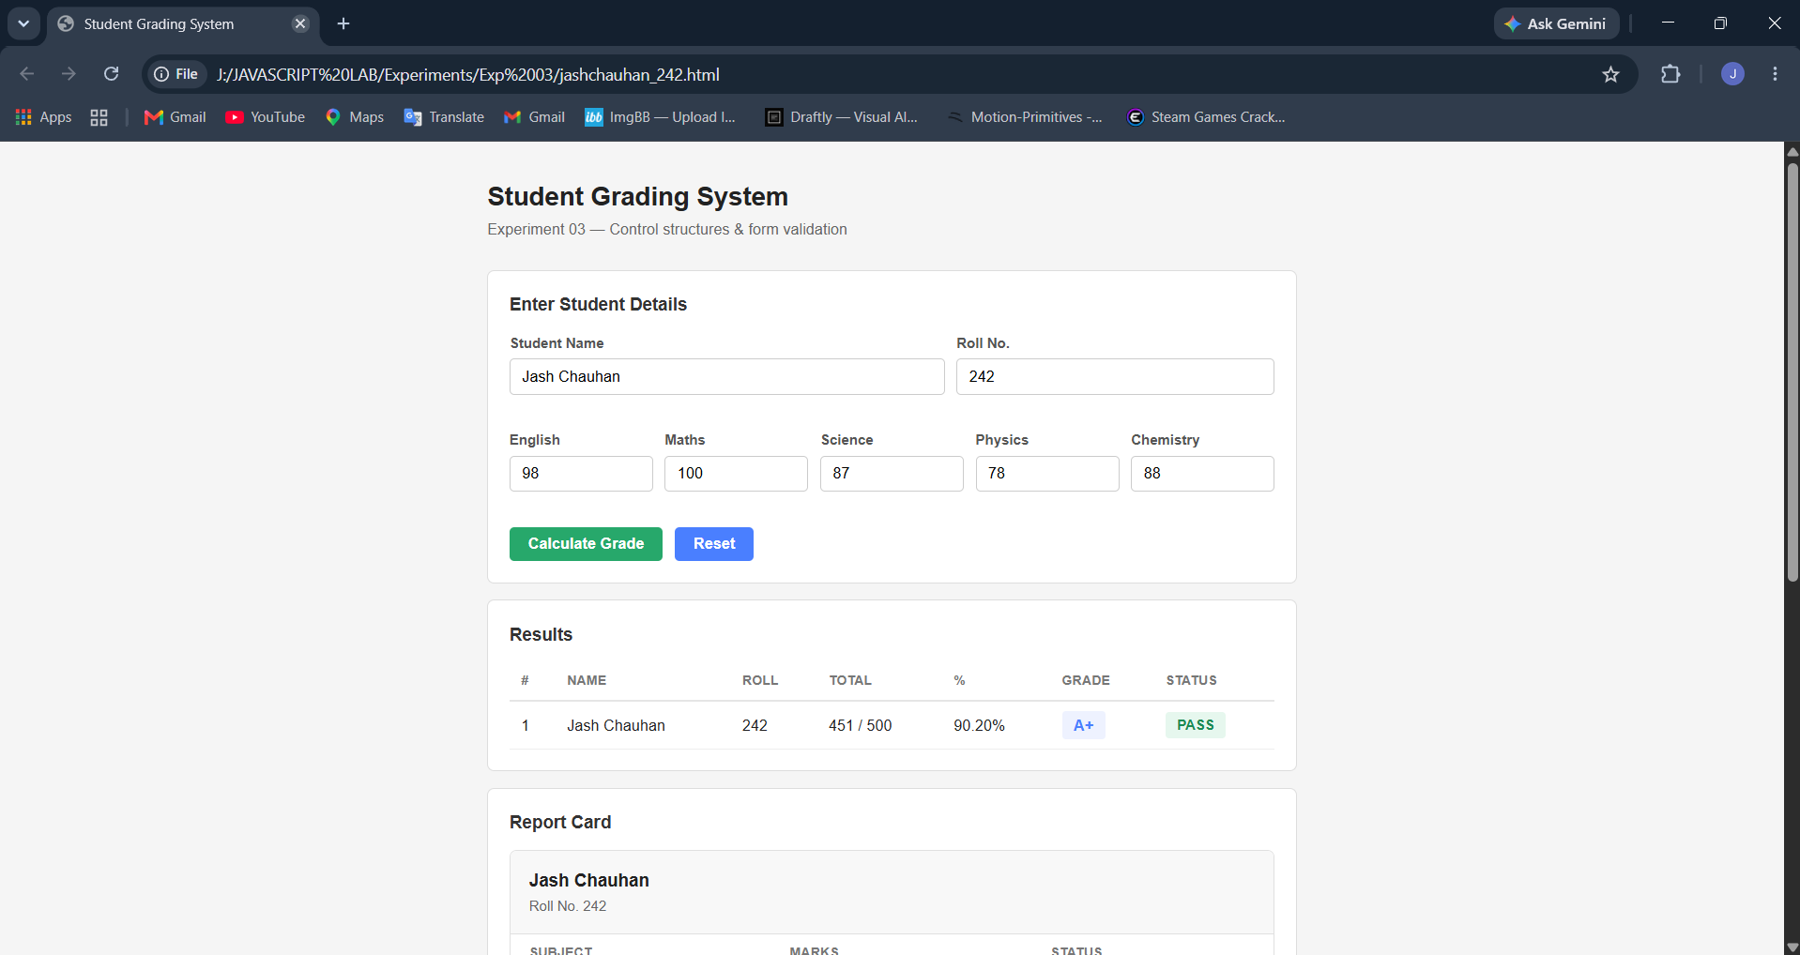
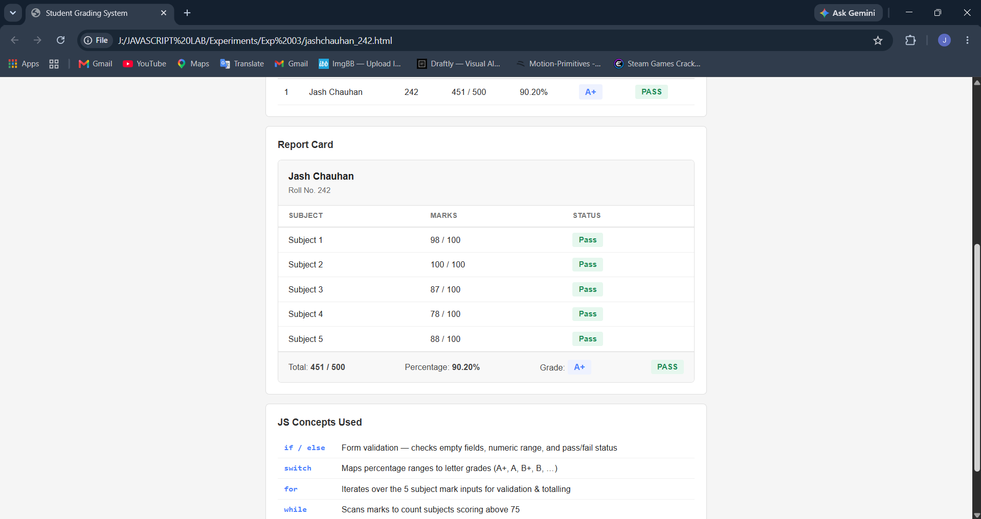
Case Study 3
1. Case Study Title
Write a Javascript program that accepts students marks and displays the scholarship category.

2. Case Study Program Code
The case study consists of the following files:

• jashchauhan_242.html – Displays the Scholarship Eligibility Checker webpage, containing an input form for students to enter their marks and a section outlining the various scholarship criteria.

• script.js – Processes the entered marks, validates the input, and utilizes if-else conditional statements to determine the corresponding scholarship category (Not Eligible, Bronze, Silver, Gold, Platinum). It dynamically updates the UI to show the correct result and corresponding custom SVG icon.

• style.css – Contains the styling rules for the layout, typography, animations, and overall visual presentation of the eligibility checker application.

Jashchauhan_242.html
<!DOCTYPE html>
<html lang="en">
<head>
<meta charset="UTF-8">
<meta name="viewport" content="width=device-width, initial-scale=1.0">
<meta name="description" content="Scholarship Eligibility Checker - Enter your marks to find your scholarship category">
<title>Scholarship Eligibility Checker</title>
<link rel="stylesheet" href="style.css">
<link href="https://fonts.googleapis.com/css2?family=Inter:wght@400;500;600;700;800&display=swap" rel="stylesheet">
</head>
<body>
<div class="background-orbs">
<div class="orb orb-1"></div>
<div class="orb orb-2"></div>
<div class="orb orb-3"></div>
</div>

<div class="container">
<header class="header">
<div class="logo">
<span class="logo-icon">
<!-- Graduation Cap -->
<svg viewBox="0 0 48 48" fill="none" xmlns="http://www.w3.org/2000/svg">
<path d="M24 6L2 18L24 30L46 18L24 6Z" fill="#e8e8ed" stroke="#ffffff" stroke-width="1"/>
<path d="M12 24V36L24 42L36 36V24L24 30L12 24Z" fill="#b0b0be" stroke="#d0d0d8" stroke-width="0.5"/>
<line x1="40" y1="18" x2="40" y2="38" stroke="#d0d0d8" stroke-width="1.5" stroke-linecap="round"/>
<path d="M37 38C37 36.3 38.3 35 40 35C41.7 35 43 36.3 43 38C43 39.7 41.7 42 40 42C38.3 42 37 39.7 37 38Z" fill="#d0d0d8"/>
</svg>
</span>
<h1>Scholarship Eligibility</h1>
</div>
<p class="subtitle">Enter your marks to discover your scholarship category</p>
</header>

<main class="main-card" id="mainCard">
<div class="input-section">
<label for="marksInput" class="input-label">Enter Your Marks</label>
<div class="input-wrapper">
<input
type="number"
id="marksInput"
min="0"
max="100"
placeholder="0 – 100"
autocomplete="off"
>
<span class="input-suffix">/ 100</span>
</div>
<button id="checkBtn" onclick="checkScholarship()">
<span>Check Eligibility</span>
<svg width="20" height="20" viewBox="0 0 24 24" fill="none" stroke="currentColor" stroke-width="2.5" stroke-linecap="round" stroke-linejoin="round">
<path d="M5 12h14M12 5l7 7-7 7"/>
</svg>
</button>
</div>

<div class="result-section" id="resultSection">
<div class="result-card" id="resultCard">
<div class="result-icon" id="resultIcon"></div>
<h2 class="result-title" id="resultTitle"></h2>
<p class="result-marks" id="resultMarks"></p>
<p class="result-message" id="resultMessage"></p>
</div>
</div>
</main>

<section class="criteria-section">
<h2 class="criteria-heading">Scholarship Criteria</h2>
<div class="criteria-grid">
<div class="criteria-item not-eligible">
<div class="criteria-bar"></div>
<div class="criteria-icon">
<!-- Shield with X -->
<svg viewBox="0 0 24 24" fill="none" xmlns="http://www.w3.org/2000/svg">
<path d="M12 2L4 6V12C4 16.42 7.4 20.56 12 22C16.6 20.56 20 16.42 20 12V6L12 2Z" fill="#2a1215" stroke="#ef4444" stroke-width="1.5"/>
<path d="M9.5 9.5L14.5 14.5M14.5 9.5L9.5 14.5" stroke="#ef4444" stroke-width="2" stroke-linecap="round"/>
</svg>
</div>
<div class="criteria-range">Below 50</div>
<div class="criteria-label">Not Eligible</div>
</div>
<div class="criteria-item bronze">
<div class="criteria-bar"></div>
<div class="criteria-icon">
<!-- Bronze Medal -->
<svg viewBox="0 0 24 24" fill="none" xmlns="http://www.w3.org/2000/svg">
<path d="M8 2H16L14.5 7H9.5L8 2Z" fill="#a0522d"/>
<path d="M10 2L8 7" stroke="#8b4513" stroke-width="0.5"/>
<path d="M14 2L16 7" stroke="#8b4513" stroke-width="0.5"/>
<circle cx="12" cy="14.5" r="7" fill="#cd7f32" stroke="#a0622a" stroke-width="0.8"/>
<circle cx="12" cy="14.5" r="5.2" fill="none" stroke="#daa06d" stroke-width="0.6"/>
<path d="M10 13L11.5 15L14.5 11.5" stroke="#fff" stroke-width="1.5" stroke-linecap="round" stroke-linejoin="round"/>
</svg>
</div>
<div class="criteria-range">50 – 69</div>
<div class="criteria-label">Bronze</div>
</div>
<div class="criteria-item silver">
<div class="criteria-bar"></div>
<div class="criteria-icon">
<!-- Silver Medal -->
<svg viewBox="0 0 24 24" fill="none" xmlns="http://www.w3.org/2000/svg">
<path d="M8 2H16L14.5 7H9.5L8 2Z" fill="#8a8a98"/>
<path d="M10 2L8 7" stroke="#707080" stroke-width="0.5"/>
<path d="M14 2L16 7" stroke="#707080" stroke-width="0.5"/>
<circle cx="12" cy="14.5" r="7" fill="#c0c0c0" stroke="#a8a8b0" stroke-width="0.8"/>
<circle cx="12" cy="14.5" r="5.2" fill="none" stroke="#d8d8e0" stroke-width="0.6"/>
<path d="M10 13L11.5 15L14.5 11.5" stroke="#fff" stroke-width="1.5" stroke-linecap="round" stroke-linejoin="round"/>
</svg>
</div>
<div class="criteria-range">70 – 84</div>
<div class="criteria-label">Silver</div>
</div>
<div class="criteria-item gold">
<div class="criteria-bar"></div>
<div class="criteria-icon">
<!-- Gold Medal -->
<svg viewBox="0 0 24 24" fill="none" xmlns="http://www.w3.org/2000/svg">
<path d="M8 2H16L14.5 7H9.5L8 2Z" fill="#daa520"/>
<path d="M10 2L8 7" stroke="#b8860b" stroke-width="0.5"/>
<path d="M14 2L16 7" stroke="#b8860b" stroke-width="0.5"/>
<circle cx="12" cy="14.5" r="7" fill="#ffd700" stroke="#daa520" stroke-width="0.8"/>
<circle cx="12" cy="14.5" r="5.2" fill="none" stroke="#ffe44d" stroke-width="0.6"/>
<path d="M10 13L11.5 15L14.5 11.5" stroke="#fff" stroke-width="1.5" stroke-linecap="round" stroke-linejoin="round"/>
</svg>
</div>
<div class="criteria-range">85 – 94</div>
<div class="criteria-label">Gold</div>
</div>
<div class="criteria-item platinum">
<div class="criteria-bar"></div>
<div class="criteria-icon">
<!-- Diamond/Trophy -->
<svg viewBox="0 0 24 24" fill="none" xmlns="http://www.w3.org/2000/svg">
<path d="M5 4H19L21 8L12 20L3 8L5 4Z" fill="#e5e4e2" stroke="#c8c8c6" stroke-width="0.8"/>
<path d="M3 8H21" stroke="#d0d0ce" stroke-width="0.6"/>
<path d="M12 20L8.5 8L10 4" stroke="#c8c8c6" stroke-width="0.5"/>
<path d="M12 20L15.5 8L14 4" stroke="#c8c8c6" stroke-width="0.5"/>
<path d="M8.5 8L10 4H14L15.5 8" fill="#f0efed" stroke="none"/>
</svg>
</div>
<div class="criteria-range">95 – 100</div>
<div class="criteria-label">Platinum</div>
</div>
</div>
</section>
</div>

<script src="script.js"></script>
</body>
</html>

Styles.css
/* ===== Reset & Base ===== */
*,
*::before,
*::after {
margin: 0;
padding: 0;
box-sizing: border-box;
}

:root {
--bg-primary: #0e0e12;
--bg-card: rgba(255, 255, 255, 0.03);
--bg-card-hover: rgba(255, 255, 255, 0.06);
--text-primary: #e8e8ed;
--text-secondary: #6e6e82;
--border-color: rgba(255, 255, 255, 0.07);
--white: #ffffff;
--shadow-glow: 0 0 80px rgba(255, 255, 255, 0.03);

/* Scholarship tier colors — used only on results */
--not-eligible: #ef4444;
--bronze: #cd7f32;
--silver: #c0c0c0;
--gold: #ffd700;
--platinum: #e5e4e2;
}

body {
font-family: 'Inter', system-ui, -apple-system, sans-serif;
background-color: var(--bg-primary);
color: var(--text-primary);
min-height: 100vh;
display: flex;
justify-content: center;
align-items: flex-start;
padding: 40px 20px;
overflow-x: hidden;
position: relative;
}

/* ===== Subtle Background Glow ===== */
.background-orbs {
position: fixed;
inset: 0;
overflow: hidden;
pointer-events: none;
z-index: 0;
}

.orb {
position: absolute;
border-radius: 50%;
filter: blur(120px);
opacity: 0.08;
background: #ffffff;
animation: float 24s ease-in-out infinite;
}

.orb-1 {
width: 500px;
height: 500px;
top: -10%;
right: -10%;
}

.orb-2 {
width: 400px;
height: 400px;
bottom: -5%;
left: -5%;
animation-delay: -8s;
}

.orb-3 {
width: 300px;
height: 300px;
top: 40%;
left: 50%;
animation-delay: -16s;
}

@keyframes float {
0%, 100% { transform: translate(0, 0) scale(1); }
25% { transform: translate(40px, -30px) scale(1.05); }
50% { transform: translate(-20px, 20px) scale(0.95); }
75% { transform: translate(30px, 40px) scale(1.03); }
}

/* ===== Container ===== */
.container {
position: relative;
z-index: 1;
width: 100%;
max-width: 600px;
}

/* ===== Header ===== */
.header {
text-align: center;
margin-bottom: 32px;
}

.logo {
display: flex;
align-items: center;
justify-content: center;
gap: 14px;
margin-bottom: 10px;
}

.logo-icon {
display: flex;
align-items: center;
animation: bounce 2.5s ease-in-out infinite;
}

.logo-icon svg {
width: 42px;
height: 42px;
}

@keyframes bounce {
0%, 100% { transform: translateY(0); }
50% { transform: translateY(-5px); }
}

.header h1 {
font-size: 2rem;
font-weight: 800;
color: var(--white);
letter-spacing: -0.03em;
}

.subtitle {
color: var(--text-secondary);
font-size: 0.95rem;
font-weight: 400;
}

/* ===== Main Card ===== */
.main-card {
background: var(--bg-card);
border: 1px solid var(--border-color);
border-radius: 20px;
padding: 36px 32px;
backdrop-filter: blur(20px);
-webkit-backdrop-filter: blur(20px);
box-shadow: var(--shadow-glow);
margin-bottom: 28px;
}

/* ===== Input Section ===== */
.input-section {
display: flex;
flex-direction: column;
gap: 16px;
}

.input-label {
font-size: 0.8rem;
font-weight: 600;
text-transform: uppercase;
letter-spacing: 0.1em;
color: var(--text-secondary);
}

.input-wrapper {
position: relative;
display: flex;
align-items: center;
}

.input-wrapper input {
width: 100%;
padding: 16px 80px 16px 20px;
font-size: 1.6rem;
font-weight: 700;
font-family: 'Inter', sans-serif;
color: var(--text-primary);
background: rgba(255, 255, 255, 0.04);
border: 2px solid var(--border-color);
border-radius: 14px;
outline: none;
transition: border-color 0.3s ease, box-shadow 0.3s ease;
-moz-appearance: textfield;
}

.input-wrapper input::-webkit-outer-spin-button,
.input-wrapper input::-webkit-inner-spin-button {
-webkit-appearance: none;
margin: 0;
}

.input-wrapper input::placeholder {
color: rgba(255, 255, 255, 0.12);
font-weight: 500;
}

.input-wrapper input:focus {
border-color: rgba(255, 255, 255, 0.25);
box-shadow: 0 0 0 4px rgba(255, 255, 255, 0.05);
}

.input-suffix {
position: absolute;
right: 20px;
color: var(--text-secondary);
font-size: 1rem;
font-weight: 500;
pointer-events: none;
}

/* ===== Button ===== */
#checkBtn {
display: flex;
align-items: center;
justify-content: center;
gap: 10px;
width: 100%;
padding: 16px;
font-size: 1rem;
font-weight: 600;
font-family: 'Inter', sans-serif;
color: #0e0e12;
background: var(--white);
border: none;
border-radius: 14px;
cursor: pointer;
transition: transform 0.2s ease, box-shadow 0.2s ease, background 0.2s ease;
}

#checkBtn:hover {
transform: translateY(-2px);
box-shadow: 0 8px 30px rgba(255, 255, 255, 0.12);
background: #e8e8ed;
}

#checkBtn:active {
transform: translateY(0);
}

/* ===== Result Section ===== */
.result-section {
margin-top: 28px;
display: none;
}

.result-section.visible {
display: block;
animation: slideUp 0.5s cubic-bezier(0.16, 1, 0.3, 1);
}

@keyframes slideUp {
from { opacity: 0; transform: translateY(20px); }
to { opacity: 1; transform: translateY(0); }
}

.result-card {
text-align: center;
padding: 32px 24px;
border-radius: 16px;
border: 1px solid var(--border-color);
background: rgba(255, 255, 255, 0.02);
position: relative;
overflow: hidden;
}

.result-card::before {
content: '';
position: absolute;
top: 0;
left: 0;
right: 0;
height: 3px;
}

.result-card.not-eligible::before { background: var(--not-eligible); }
.result-card.bronze::before { background: var(--bronze); }
.result-card.silver::before { background: var(--silver); }
.result-card.gold::before { background: var(--gold); }
.result-card.platinum::before { background: var(--platinum); }

.result-icon {
margin-bottom: 16px;
display: flex;
justify-content: center;
animation: popIn 0.4s cubic-bezier(0.16, 1, 0.3, 1) 0.15s both;
}

.result-icon svg {
width: 64px;
height: 64px;
}

@keyframes popIn {
from { opacity: 0; transform: scale(0.5); }
to { opacity: 1; transform: scale(1); }
}

.result-title {
font-size: 1.5rem;
font-weight: 800;
margin-bottom: 6px;
letter-spacing: -0.01em;
}

.result-card.not-eligible .result-title { color: var(--not-eligible); }
.result-card.bronze .result-title { color: var(--bronze); }
.result-card.silver .result-title { color: var(--silver); }
.result-card.gold .result-title { color: var(--gold); }
.result-card.platinum .result-title { color: var(--platinum); }

.result-marks {
font-size: 0.9rem;
color: var(--text-secondary);
margin-bottom: 8px;
font-weight: 500;
}

.result-message {
font-size: 0.95rem;
color: var(--text-secondary);
line-height: 1.5;
}

/* ===== Criteria Section ===== */
.criteria-section {
margin-bottom: 40px;
}

.criteria-heading {
font-size: 0.8rem;
font-weight: 600;
text-transform: uppercase;
letter-spacing: 0.1em;
color: var(--text-secondary);
margin-bottom: 16px;
text-align: center;
}

.criteria-grid {
display: flex;
flex-direction: column;
gap: 8px;
}

.criteria-item {
display: flex;
align-items: center;
gap: 14px;
padding: 14px 20px;
background: var(--bg-card);
border: 1px solid var(--border-color);
border-radius: 12px;
backdrop-filter: blur(10px);
transition: transform 0.2s ease, background 0.2s ease;
position: relative;
overflow: hidden;
}

.criteria-item:hover {
transform: translateX(4px);
background: var(--bg-card-hover);
}

.criteria-bar {
position: absolute;
left: 0;
top: 0;
bottom: 0;
width: 3px;
}

.criteria-item.not-eligible .criteria-bar { background: var(--not-eligible); }
.criteria-item.bronze .criteria-bar { background: var(--bronze); }
.criteria-item.silver .criteria-bar { background: var(--silver); }
.criteria-item.gold .criteria-bar { background: var(--gold); }
.criteria-item.platinum .criteria-bar { background: var(--platinum); }

.criteria-icon {
display: flex;
align-items: center;
flex-shrink: 0;
}

.criteria-icon svg {
width: 24px;
height: 24px;
}

.criteria-range {
font-size: 0.9rem;
font-weight: 600;
color: var(--text-primary);
min-width: 80px;
}

.criteria-label {
font-size: 0.85rem;
font-weight: 500;
}

.criteria-item.not-eligible .criteria-label { color: var(--not-eligible); }
.criteria-item.bronze .criteria-label { color: var(--bronze); }
.criteria-item.silver .criteria-label { color: var(--silver); }
.criteria-item.gold .criteria-label { color: var(--gold); }
.criteria-item.platinum .criteria-label { color: var(--platinum); }

/* ===== Shake Animation ===== */
@keyframes shake {
0%, 100% { transform: translateX(0); }
20% { transform: translateX(-8px); }
40% { transform: translateX(8px); }
60% { transform: translateX(-4px); }
80% { transform: translateX(4px); }
}

.shake {
animation: shake 0.4s ease;
}

/* ===== Responsive ===== */
@media (max-width: 480px) {
body { padding: 24px 16px; }
.header h1 { font-size: 1.5rem; }
.main-card { padding: 28px 20px; border-radius: 16px; }
.input-wrapper input { font-size: 1.3rem; padding: 14px 70px 14px 16px; }
.result-icon svg { width: 48px; height: 48px; }
.result-title { font-size: 1.3rem; }
}

Script.js
// Scholarship Eligibility Checker
// Case Study: A college awards scholarships based on marks

// Detailed custom SVG icons for each scholarship tier
const ICONS = {
'not-eligible': `
<svg viewBox="0 0 64 64" fill="none" xmlns="http://www.w3.org/2000/svg">
<!-- Shield body -->
<path d="M32 4L8 16V32C8 44.84 18.8 56.12 32 60C45.2 56.12 56 44.84 56 32V16L32 4Z" fill="#2a1215" stroke="#ef4444" stroke-width="2.5"/>
<!-- Inner shield highlight -->
<path d="M32 10L14 19V32C14 42.2 22.4 51.2 32 54.4C41.6 51.2 50 42.2 50 32V19L32 10Z" fill="#1f0a0d" stroke="#ef4444" stroke-width="0.5" opacity="0.4"/>
<!-- X mark -->
<path d="M23 23L41 41" stroke="#ef4444" stroke-width="4.5" stroke-linecap="round"/>
<path d="M41 23L23 41" stroke="#ef4444" stroke-width="4.5" stroke-linecap="round"/>
<!-- Corner accents -->
<circle cx="32" cy="14" r="1.5" fill="#ef4444" opacity="0.5"/>
</svg>`,

'bronze': `
<svg viewBox="0 0 64 64" fill="none" xmlns="http://www.w3.org/2000/svg">
<!-- Ribbon -->
<path d="M22 4H42L38 18H26L22 4Z" fill="#a0522d"/>
<path d="M26 4L22 18" stroke="#8b4513" stroke-width="0.8"/>
<path d="M32 4V18" stroke="#8b4513" stroke-width="0.5" opacity="0.4"/>
<path d="M38 4L42 18" stroke="#8b4513" stroke-width="0.8"/>
<!-- Medal body -->
<circle cx="32" cy="38" r="20" fill="#cd7f32" stroke="#a0622a" stroke-width="2"/>
<!-- Inner ring -->
<circle cx="32" cy="38" r="15" fill="none" stroke="#daa06d" stroke-width="1.2"/>
<!-- Star in center -->
<polygon points="32,25 35,33 43,33 37,38 39,46 32,42 25,46 27,38 21,33 29,33" fill="#e8a848" stroke="#b8762a" stroke-width="0.5"/>
<!-- Shine -->
<path d="M22 28C24 24 28 22 32 22" stroke="#e8c088" stroke-width="1" stroke-linecap="round" opacity="0.6"/>
</svg>`,

'silver': `
<svg viewBox="0 0 64 64" fill="none" xmlns="http://www.w3.org/2000/svg">
<!-- Ribbon -->
<path d="M22 4H42L38 18H26L22 4Z" fill="#8a8a98"/>
<path d="M26 4L22 18" stroke="#707080" stroke-width="0.8"/>
<path d="M32 4V18" stroke="#707080" stroke-width="0.5" opacity="0.4"/>
<path d="M38 4L42 18" stroke="#707080" stroke-width="0.8"/>
<!-- Medal body -->
<circle cx="32" cy="38" r="20" fill="#c0c0c0" stroke="#a8a8b0" stroke-width="2"/>
<!-- Inner ring -->
<circle cx="32" cy="38" r="15" fill="none" stroke="#d8d8e0" stroke-width="1.2"/>
<!-- Star in center -->
<polygon points="32,25 35,33 43,33 37,38 39,46 32,42 25,46 27,38 21,33 29,33" fill="#d8d8e0" stroke="#a0a0a8" stroke-width="0.5"/>
<!-- Shine -->
<path d="M22 28C24 24 28 22 32 22" stroke="#e8e8f0" stroke-width="1" stroke-linecap="round" opacity="0.7"/>
</svg>`,

'gold': `
<svg viewBox="0 0 64 64" fill="none" xmlns="http://www.w3.org/2000/svg">
<!-- Ribbon -->
<path d="M22 4H42L38 18H26L22 4Z" fill="#daa520"/>
<path d="M26 4L22 18" stroke="#b8860b" stroke-width="0.8"/>
<path d="M32 4V18" stroke="#b8860b" stroke-width="0.5" opacity="0.4"/>
<path d="M38 4L42 18" stroke="#b8860b" stroke-width="0.8"/>
<!-- Medal body -->
<circle cx="32" cy="38" r="20" fill="#ffd700" stroke="#daa520" stroke-width="2"/>
<!-- Inner ring -->
<circle cx="32" cy="38" r="15" fill="none" stroke="#ffe44d" stroke-width="1.2"/>
<!-- Star in center -->
<polygon points="32,25 35,33 43,33 37,38 39,46 32,42 25,46 27,38 21,33 29,33" fill="#ffe866" stroke="#d4a800" stroke-width="0.5"/>
<!-- Shine -->
<path d="M22 28C24 24 28 22 32 22" stroke="#fff4a0" stroke-width="1" stroke-linecap="round" opacity="0.8"/>
</svg>`,

'platinum': `
<svg viewBox="0 0 64 64" fill="none" xmlns="http://www.w3.org/2000/svg">
<!-- Diamond top facets -->
<path d="M12 20H52L32 56L12 20Z" fill="#e5e4e2" stroke="#c8c8c6" stroke-width="1.5"/>
<!-- Top edge -->
<path d="M8 20L16 8H48L56 20H8Z" fill="#f0efed" stroke="#d0d0ce" stroke-width="1"/>
<!-- Center facets -->
<path d="M8 20L32 56L24 20Z" fill="#d8d7d5"/>
<path d="M56 20L32 56L40 20Z" fill="#d8d7d5"/>
<!-- Top inner facets -->
<path d="M16 8L24 20H8Z" fill="#e0dfdd"/>
<path d="M48 8L40 20H56Z" fill="#e0dfdd"/>
<path d="M16 8H48L40 20H24Z" fill="#f5f4f2"/>
<!-- Center vertical line -->
<path d="M32 56L32 20" stroke="#c8c8c6" stroke-width="0.6"/>
<path d="M32 20L16 8" stroke="#c8c8c6" stroke-width="0.5"/>
<path d="M32 20L48 8" stroke="#c8c8c6" stroke-width="0.5"/>
<!-- Sparkle highlights -->
<circle cx="28" cy="16" r="1" fill="#fff" opacity="0.8"/>
<circle cx="38" cy="14" r="0.7" fill="#fff" opacity="0.6"/>
<path d="M20 26L22 24" stroke="#fff" stroke-width="0.8" stroke-linecap="round" opacity="0.5"/>
</svg>`
};

function checkScholarship() {
const input = document.getElementById('marksInput');
const resultSection = document.getElementById('resultSection');
const resultCard = document.getElementById('resultCard');
const resultIcon = document.getElementById('resultIcon');
const resultTitle = document.getElementById('resultTitle');
const resultMarks = document.getElementById('resultMarks');
const resultMessage = document.getElementById('resultMessage');

const marks = parseFloat(input.value);

// Validate input
if (isNaN(marks) || marks < 0 || marks > 100) {
input.classList.add('shake');
setTimeout(() => input.classList.remove('shake'), 400);
resultSection.classList.remove('visible');
alert('Please enter valid marks between 0 and 100.');
return;
}

let category, message, cssClass;

if (marks < 50) {
category = 'Not Eligible';
message = 'Score below 50. Keep working hard — you can improve!';
cssClass = 'not-eligible';
} else if (marks >= 50 && marks <= 69) {
category = 'Bronze Scholarship';
message = 'Great start! You\'ve earned a Bronze Scholarship.';
cssClass = 'bronze';
} else if (marks >= 70 && marks <= 84) {
category = 'Silver Scholarship';
message = 'Impressive performance! You\'ve earned a Silver Scholarship.';
cssClass = 'silver';
} else if (marks >= 85 && marks <= 94) {
category = 'Gold Scholarship';
message = 'Outstanding! You\'ve earned a Gold Scholarship.';
cssClass = 'gold';
} else if (marks >= 95 && marks <= 100) {
category = 'Platinum Scholarship';
message = 'Exceptional! You\'ve earned the prestigious Platinum Scholarship!';
cssClass = 'platinum';
}

// Update the result card
resultCard.className = 'result-card ' + cssClass;
resultIcon.innerHTML = ICONS[cssClass];
resultTitle.textContent = category;
resultMarks.textContent = 'Your Marks: ' + marks + ' / 100';
resultMessage.textContent = message;

// Show result with animation
resultSection.classList.remove('visible');
// Force reflow to restart animation
void resultSection.offsetWidth;
resultSection.classList.add('visible');
}

// Allow pressing Enter to check
document.getElementById('marksInput').addEventListener('keydown', function (e) {
if (e.key === 'Enter') {
checkScholarship();
}
});

Output:
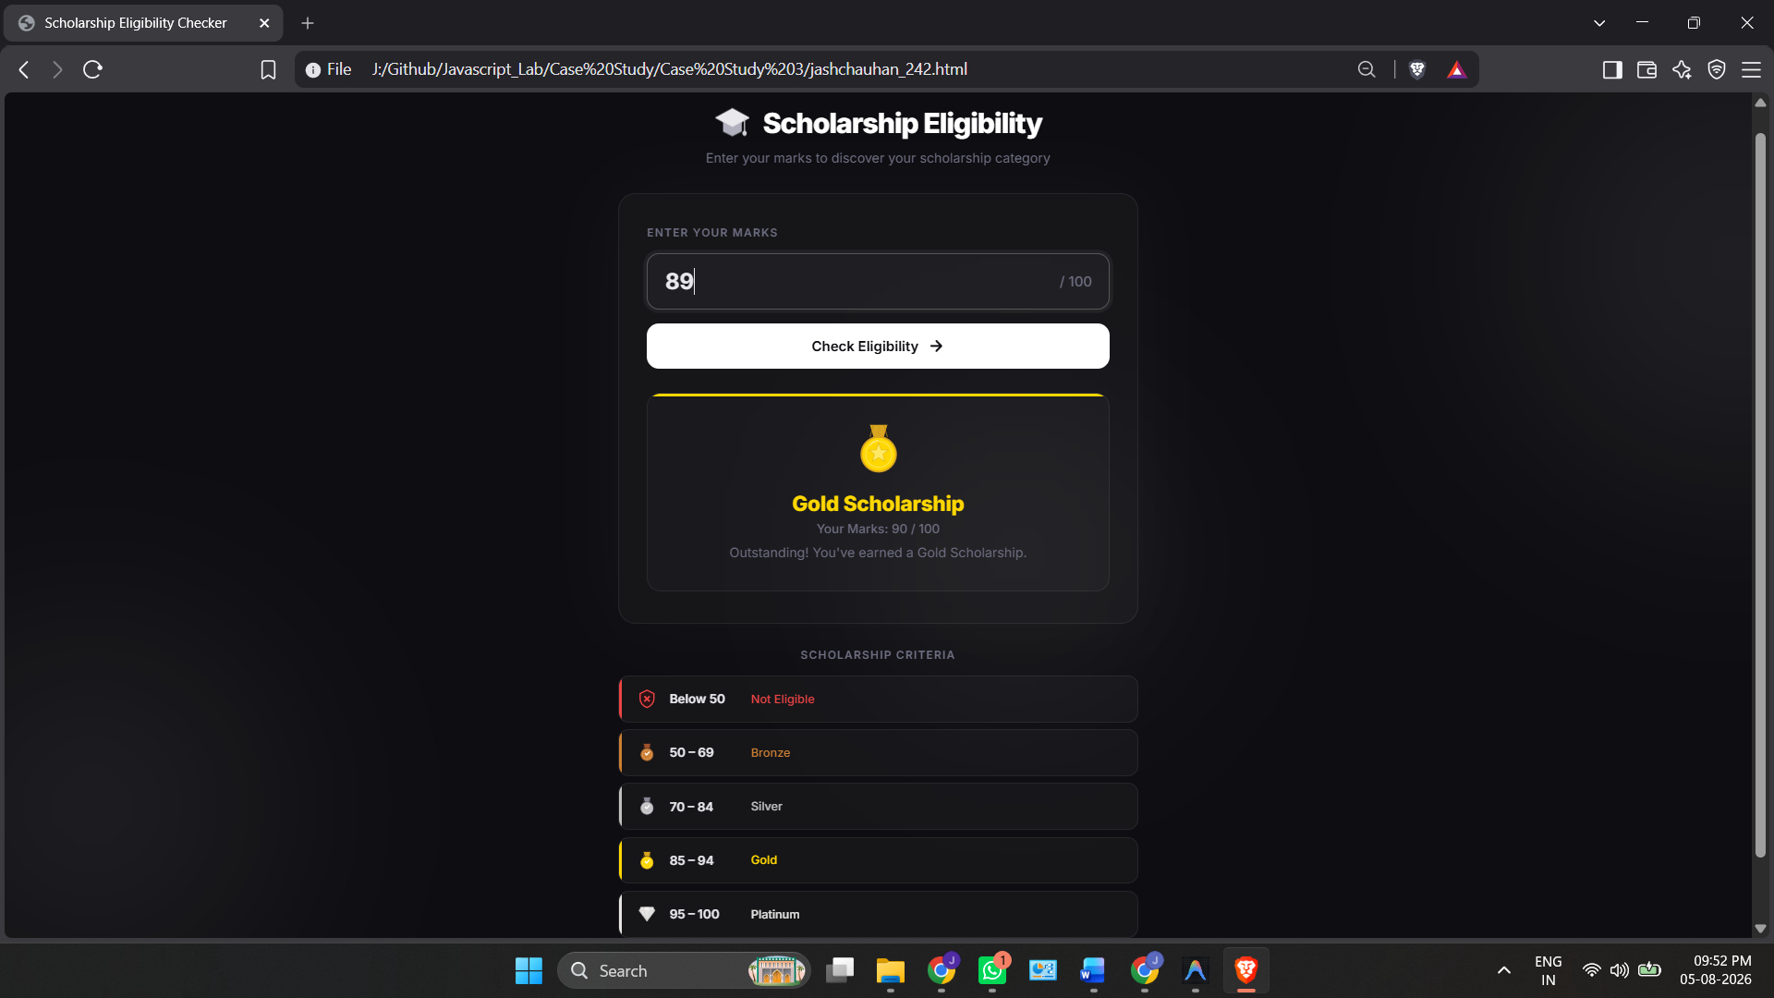

Result / Conclusion:
Hence, we have successfully developed the Scholarship Eligibility Checker webpage. Through this case study, we practically learned how to implement control structures, specifically if-else conditional statements in JavaScript, to evaluate user input, make logical decisions, and dynamically update the webpage's UI to display the appropriate scholarship category based on the provided marks.

Experiment 4
1. Experiment Title
Use function types, scope, and closures; apply try-catch; build a palindrome checker.

2. Software/Tools Required
- Visual Studio Code (VS Code)
- Google Chrome / Mozilla Firefox / Microsoft Edge
- HTML5
- CSS3
- JavaScript
- Windows Operating System

3. Experiment Program Code
The experiment consists of the following files:
- jash_chauhan_242.html
- styles.css
- script.js

jash_chauhan_242.html

<!DOCTYPE html>
<html lang="en">

<head>
<meta charset="UTF-8">
<meta name="viewport" content="width=device-width, initial-scale=1.0">
<title>Palindrome Checker</title>
<link rel="stylesheet" href="style.css">

<!-- Font Awesome Icons -->
<link rel="stylesheet" href="https://cdnjs.cloudflare.com/ajax/libs/font-awesome/6.5.2/css/all.min.css">
</head>

<body>

<div class="container">
<h2>Enter text to check</h2>

<input type="text" id="text-input" placeholder="Enter text">

<div class="btn-row">
<button onclick="checkPalindrome()">
Check palindrome
</button>

<span class="info">
Ignores spaces and punctuation, and compares case-insensitively.
</span>
</div>

<div id="result" class="result">
Enter a word above.
</div>
</div>

<script src="script.js"></script>
</body>

</html>

Styles.css
* {
margin: 0;
padding: 0;
box-sizing: border-box;
font-family: Arial, Helvetica, sans-serif;
}

body {
background: #f5f5f5;
display: flex;
justify-content: center;
align-items: center;
height: 100vh;
}

.container {
width: 720px;
background: white;
padding: 22px;
border: 1px solid #ddd;
border-radius: 14px;
}

h2 {
font-size: 24px;
margin-bottom: 18px;
}

input {
width: 100%;
padding: 13px;
font-size: 18px;
border: 1px solid #ccc;
border-radius: 10px;
outline: none;
margin-bottom: 15px;
}

input:focus {
border-color: #222;
}

.btn-row {
display: flex;
align-items: center;
gap: 12px;
margin-bottom: 18px;
}

button {
background: #111;
color: white;
border: none;
padding: 12px 18px;
border-radius: 10px;
cursor: pointer;
font-size: 17px;
transition: .3s;
}

button:hover {
background: #333;
}

.info {
color: #555;
font-size: 15px;
}

.result {
border: 1px solid #ddd;
border-radius: 12px;
padding: 18px;
font-size: 24px;
}

.success {
color: #16a34a;
}

.fail {
color: #ef4444;
}

Script.js
function normalize(text) {
return text
.toLowerCase()
.replace(/[^a-z0-9]/g, "");
}

function isPalindrome(text) {

const cleaned = normalize(text);

const reversed = cleaned
.split("")
.reverse()
.join("");

return cleaned === reversed;
}

function checkPalindrome() {

try {

const input = document.getElementById("text-input").value;

if (input.trim() === "") {
throw "Please enter some text.";
}

const result = document.getElementById("result");

if (isPalindrome(input)) {

result.className = "result success";
result.innerHTML =
'<i class="fa-solid fa-circle-check"></i> Palindrome';

} else {

result.className = "result fail";
result.innerHTML =
'<i class="fa-solid fa-circle-xmark"></i> Not a palindrome';
}

}

catch(error){

alert(error);

}

}

Output:
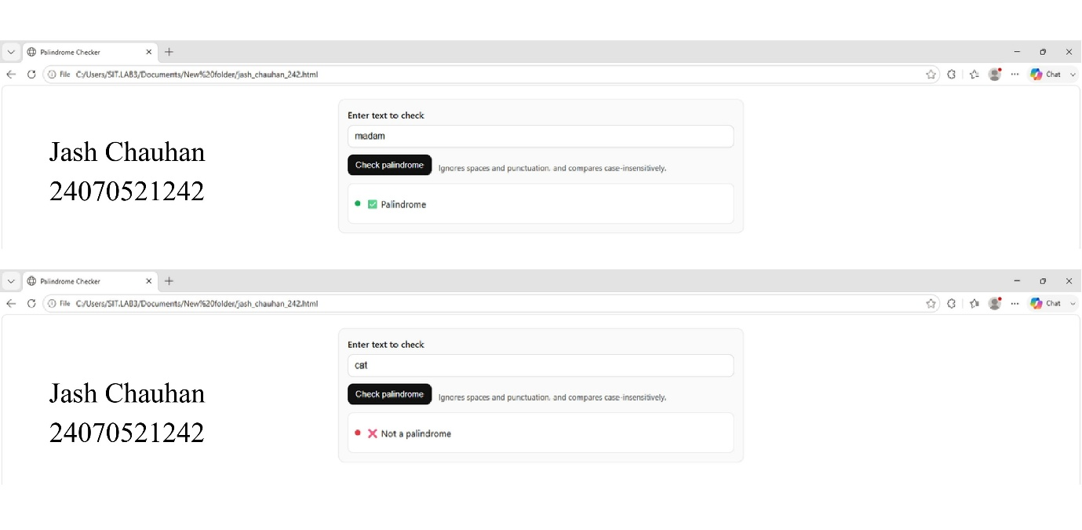

Case Study 4
1. Case Study Title
Real-Time Case Study: ATM Card PIN Verification Using JavaScript Functions to verify whether a customer's PIN is a palindrome. Use function declaration, function expression, arrow function, and demonstrate scope and closure concepts.

2. Case Study Program Code
The case study consists of the following files:

- jashchauhan_242.html – Displays the ATM interface webpage containing a digital screen and a keypad to securely enter the PIN.

• script.js – Implements the PIN verification logic using function declarations, function expressions, and arrow functions, while demonstrating scope and closures to securely track failed attempts.

• style.css – Contains the styling rules to create a realistic, responsive ATM layout with premium visual elements.

Jashchauhan_242.html
<!DOCTYPE html>
<html lang="en">
<head>
<meta charset="UTF-8">
<meta name="viewport" content="width=device-width, initial-scale=1.0">
<title>ATM PIN Verification</title>
<link href="https://fonts.googleapis.com/css2?family=Share+Tech+Mono&family=Inter:wght@400;500;600&display=swap" rel="stylesheet">
<link rel="stylesheet" href="style.css">
</head>
<body>
<div class="atm-container">
<div class="atm-machine">
<div class="atm-screen">
<div class="bank-logo">SecureBank</div>
<div id="screen-content" class="screen-content">
<p class="welcome-text">WELCOME</p>
<p class="instruction">PLEASE ENTER YOUR PIN</p>
<div class="pin-display" id="pin-display">
<!-- Dots will appear here -->
</div>
<div class="message-area" id="message-area"></div>
</div>
</div>

<div class="atm-keypad">
<button class="key num-key" data-val="1">1</button>
<button class="key num-key" data-val="2">2</button>
<button class="key num-key" data-val="3">3</button>
<button class="key action-key cancel" id="btn-cancel">CANCEL</button>

<button class="key num-key" data-val="4">4</button>
<button class="key num-key" data-val="5">5</button>
<button class="key num-key" data-val="6">6</button>
<button class="key action-key clear" id="btn-clear">CLEAR</button>

<button class="key num-key" data-val="7">7</button>
<button class="key num-key" data-val="8">8</button>
<button class="key num-key" data-val="9">9</button>
<button class="key action-key enter" id="btn-enter">ENTER</button>

<button class="key empty-key"></button>
<button class="key num-key" data-val="0">0</button>
<button class="key empty-key"></button>
<button class="key empty-key"></button>
</div>

<div class="card-slot">
<div class="slot-opening"></div>
<div class="card-indicator"></div>
</div>
</div>
</div>

<script src="script.js"></script>
</body>
</html>

Styles.css

:root {
--atm-bg: #e0e5ec;
--atm-shadow: #a3b1c6;
--atm-highlight: #ffffff;
--screen-bg: #1a2f33;
--screen-text: #64ffda;
--screen-text-error: #ff5252;
--screen-text-success: #69f0ae;
--key-bg: #d1d9e6;
--btn-cancel: #ef5350;
--btn-clear: #ffa726;
--btn-enter: #66bb6a;
}

* {
margin: 0;
padding: 0;
box-sizing: border-box;
}

body {
font-family: 'Inter', sans-serif;
background-color: #2c3e50;
display: flex;
justify-content: center;
align-items: center;
min-height: 100vh;
padding: 20px;
}

.atm-container {
background: var(--atm-bg);
padding: 40px;
border-radius: 30px;
box-shadow:
15px 15px 30px #1a252f,
-15px -15px 30px #3e5771;
width: 100%;
max-width: 500px;
}

.atm-machine {
display: flex;
flex-direction: column;
gap: 30px;
}

/* --- Screen Styling --- */
.atm-screen {
background: #0f1c1f;
padding: 20px;
border-radius: 15px;
border: 8px solid #2a2a2a;
box-shadow: inset 0 0 20px rgba(0,0,0,0.8);
position: relative;
height: 250px;
display: flex;
flex-direction: column;
overflow: hidden;
}

/* Scanline effect */
.atm-screen::after {
content: " ";
display: block;
position: absolute;
top: 0;
left: 0;
bottom: 0;
right: 0;
background: linear-gradient(rgba(18, 16, 16, 0) 50%, rgba(0, 0, 0, 0.25) 50%), linear-gradient(90deg, rgba(255, 0, 0, 0.06), rgba(0, 255, 0, 0.02), rgba(0, 0, 255, 0.06));
z-index: 2;
background-size: 100% 2px, 3px 100%;
pointer-events: none;
}

.bank-logo {
font-family: 'Share Tech Mono', monospace;
color: #4a6c72;
font-size: 1.2rem;
text-transform: uppercase;
letter-spacing: 2px;
text-align: center;
margin-bottom: 20px;
}

.screen-content {
font-family: 'Share Tech Mono', monospace;
color: var(--screen-text);
flex-grow: 1;
display: flex;
flex-direction: column;
align-items: center;
justify-content: center;
text-align: center;
text-shadow: 0 0 5px rgba(100, 255, 218, 0.5);
z-index: 1;
}

.welcome-text {
font-size: 1.5rem;
margin-bottom: 10px;
}

.instruction {
font-size: 1rem;
margin-bottom: 20px;
opacity: 0.9;
}

.pin-display {
display: flex;
gap: 10px;
height: 30px;
margin-bottom: 20px;
}

.pin-dot {
width: 20px;
height: 20px;
background-color: var(--screen-text);
border-radius: 50%;
box-shadow: 0 0 10px var(--screen-text);
animation: blink 1s infinite alternate;
}

@keyframes blink {
0% { opacity: 0.5; }
100% { opacity: 1; }
}

.message-area {
font-size: 0.9rem;
min-height: 40px;
line-height: 1.4;
transition: color 0.3s ease;
}

.msg-error {
color: var(--screen-text-error);
text-shadow: 0 0 5px rgba(255, 82, 82, 0.5);
}

.msg-success {
color: var(--screen-text-success);
text-shadow: 0 0 5px rgba(105, 240, 174, 0.5);
}

/* --- Keypad Styling --- */
.atm-keypad {
display: grid;
grid-template-columns: repeat(4, 1fr);
gap: 15px;
background: #c3cfdf;
padding: 20px;
border-radius: 15px;
border: 1px solid #b0bec5;
box-shadow: inset 0 0 10px rgba(0,0,0,0.1);
}

.key {
background: var(--key-bg);
border: none;
border-radius: 8px;
height: 60px;
font-size: 1.5rem;
font-weight: 600;
color: #333;
cursor: pointer;
box-shadow:
5px 5px 10px var(--atm-shadow),
-5px -5px 10px var(--atm-highlight);
transition: all 0.1s ease;
display: flex;
justify-content: center;
align-items: center;
}

.key:active {
box-shadow:
inset 5px 5px 10px var(--atm-shadow),
inset -5px -5px 10px var(--atm-highlight);
transform: scale(0.95);
}

.action-key {
font-size: 0.85rem;
font-weight: 700;
color: white;
text-shadow: 1px 1px 2px rgba(0,0,0,0.5);
}

.cancel { background: var(--btn-cancel); }
.clear { background: var(--btn-clear); }
.enter { background: var(--btn-enter); }

.cancel:active { box-shadow: inset 3px 3px 8px rgba(0,0,0,0.2); }
.clear:active { box-shadow: inset 3px 3px 8px rgba(0,0,0,0.2); }
.enter:active { box-shadow: inset 3px 3px 8px rgba(0,0,0,0.2); }

.empty-key {
visibility: hidden;
}

/* --- Card Slot --- */
.card-slot {
align-self: flex-end;
width: 150px;
height: 40px;
background: #cfd8e3;
border-radius: 10px;
display: flex;
flex-direction: column;
align-items: center;
justify-content: center;
gap: 5px;
box-shadow:
inset 2px 2px 5px var(--atm-shadow),
inset -2px -2px 5px var(--atm-highlight);
position: relative;
}

.slot-opening {
width: 120px;
height: 6px;
background: #111;
border-radius: 3px;
box-shadow: inset 0 2px 4px rgba(0,0,0,0.8);
}

.card-indicator {
width: 40px;
height: 4px;
background: #00e676;
border-radius: 2px;
box-shadow: 0 0 8px #00e676;
animation: pulse 1.5s infinite;
}

@keyframes pulse {
0% { opacity: 0.3; }
50% { opacity: 1; }
100% { opacity: 0.3; }
}

/* Responsive */
@media (max-width: 480px) {
.atm-container {
padding: 20px;
}
.key {
height: 50px;
font-size: 1.2rem;
}
.action-key {
font-size: 0.7rem;
}
.atm-screen {
height: 220px;
}
}

Script.js

// ==========================================
// Case Study 4: ATM Card PIN Verification
// Demonstrating: Functions, Scope, Closure
// ==========================================

// --- 1. Function Declaration (Scope: Global) ---
// Reverses a string
function reverseString(str) {
return str.split('').reverse().join('');
}

// --- 2. Function Expression (Scope: Global) ---
// Checks if original and reversed strings are identical
const isPalindrome = function(original, reversed) {
return original === reversed;
};

// --- 3. Arrow Function & 4. Closure (Scope: Global & Local) ---
// Factory function demonstrating closure to keep track of secure attempts
const createATMSystem = () => {
// Scope: Local variables to createATMSystem
let attempts = 0;
const MAX_ATTEMPTS = 3;

// The returned arrow function creates a closure, retaining access to 'attempts' and 'MAX_ATTEMPTS'
return (pin) => {
attempts++;

if (attempts > MAX_ATTEMPTS) {
return {
status: 'BLOCKED',
message: 'CARD BLOCKED. TOO MANY FAILED ATTEMPTS.'
};
}

const reversedPin = reverseString(pin);
const valid = isPalindrome(pin, reversedPin);

if (valid) {
// Reset attempts on success if we wanted a real system, but we'll leave it simple
attempts = 0;
return {
status: 'SUCCESS',
message: 'SECURITY VERIFIED: PIN IS PALINDROME. ACCESS GRANTED.'
};
} else {
return {
status: 'ERROR',
message: `INVALID PIN. ATTEMPT ${attempts} OF ${MAX_ATTEMPTS}.`
};
}
};
};

// Initialize the secure verifier instance (closure is active)
const verifyPin = createATMSystem();

// ==========================================
// UI Interaction Logic
// ==========================================
document.addEventListener("DOMContentLoaded", () => {
let currentPin = "";

// DOM Elements
const pinDisplay = document.getElementById("pin-display");
const messageArea = document.getElementById("message-area");
const numKeys = document.querySelectorAll(".num-key");
const btnClear = document.getElementById("btn-clear");
const btnCancel = document.getElementById("btn-cancel");
const btnEnter = document.getElementById("btn-enter");

// Update the visual dots on the ATM screen
function updateDisplay() {
pinDisplay.innerHTML = "";
for (let i = 0; i < currentPin.length; i++) {
const dot = document.createElement("div");
dot.className = "pin-dot";
pinDisplay.appendChild(dot);
}
}

// Display messages on the screen
function showMessage(msg, type) {
messageArea.textContent = msg;
messageArea.className = `message-area ${type === 'error' ? 'msg-error' : (type === 'success' ? 'msg-success' : '')}`;

// Clear success/error message after 3 seconds, unless it's a block message
if (!msg.includes("BLOCKED") && !msg.includes("GRANTED")) {
setTimeout(() => {
messageArea.textContent = "";
messageArea.className = "message-area";
}, 3000);
}
}

// Number pad click events
numKeys.forEach(key => {
key.addEventListener("click", () => {
// Max 6 digits PIN
if (currentPin.length < 6) {
currentPin += key.getAttribute("data-val");
updateDisplay();
}
});
});

// Clear key (removes last entered digit)
btnClear.addEventListener("click", () => {
currentPin = currentPin.slice(0, -1);
updateDisplay();
});

// Cancel key (clears entire input)
btnCancel.addEventListener("click", () => {
currentPin = "";
updateDisplay();
showMessage("OPERATION CANCELLED", "error");
});

// Enter key (Submits PIN for verification)
btnEnter.addEventListener("click", () => {
if (currentPin.length === 0) {
showMessage("PLEASE ENTER A PIN", "error");
return;
}

// Execute PIN Verification using our closure
const result = verifyPin(currentPin);

if (result.status === 'BLOCKED') {
showMessage(result.message, "error");
// Visually disable keypad
document.querySelectorAll(".key").forEach(btn => {
btn.style.opacity = "0.5";
btn.style.pointerEvents = "none";
});
currentPin = "";
updateDisplay();
} else if (result.status === 'SUCCESS') {
showMessage(result.message, "success");
currentPin = "";
updateDisplay();
} else {
showMessage(result.message, "error");
currentPin = "";
updateDisplay();
}
});
});

Output:
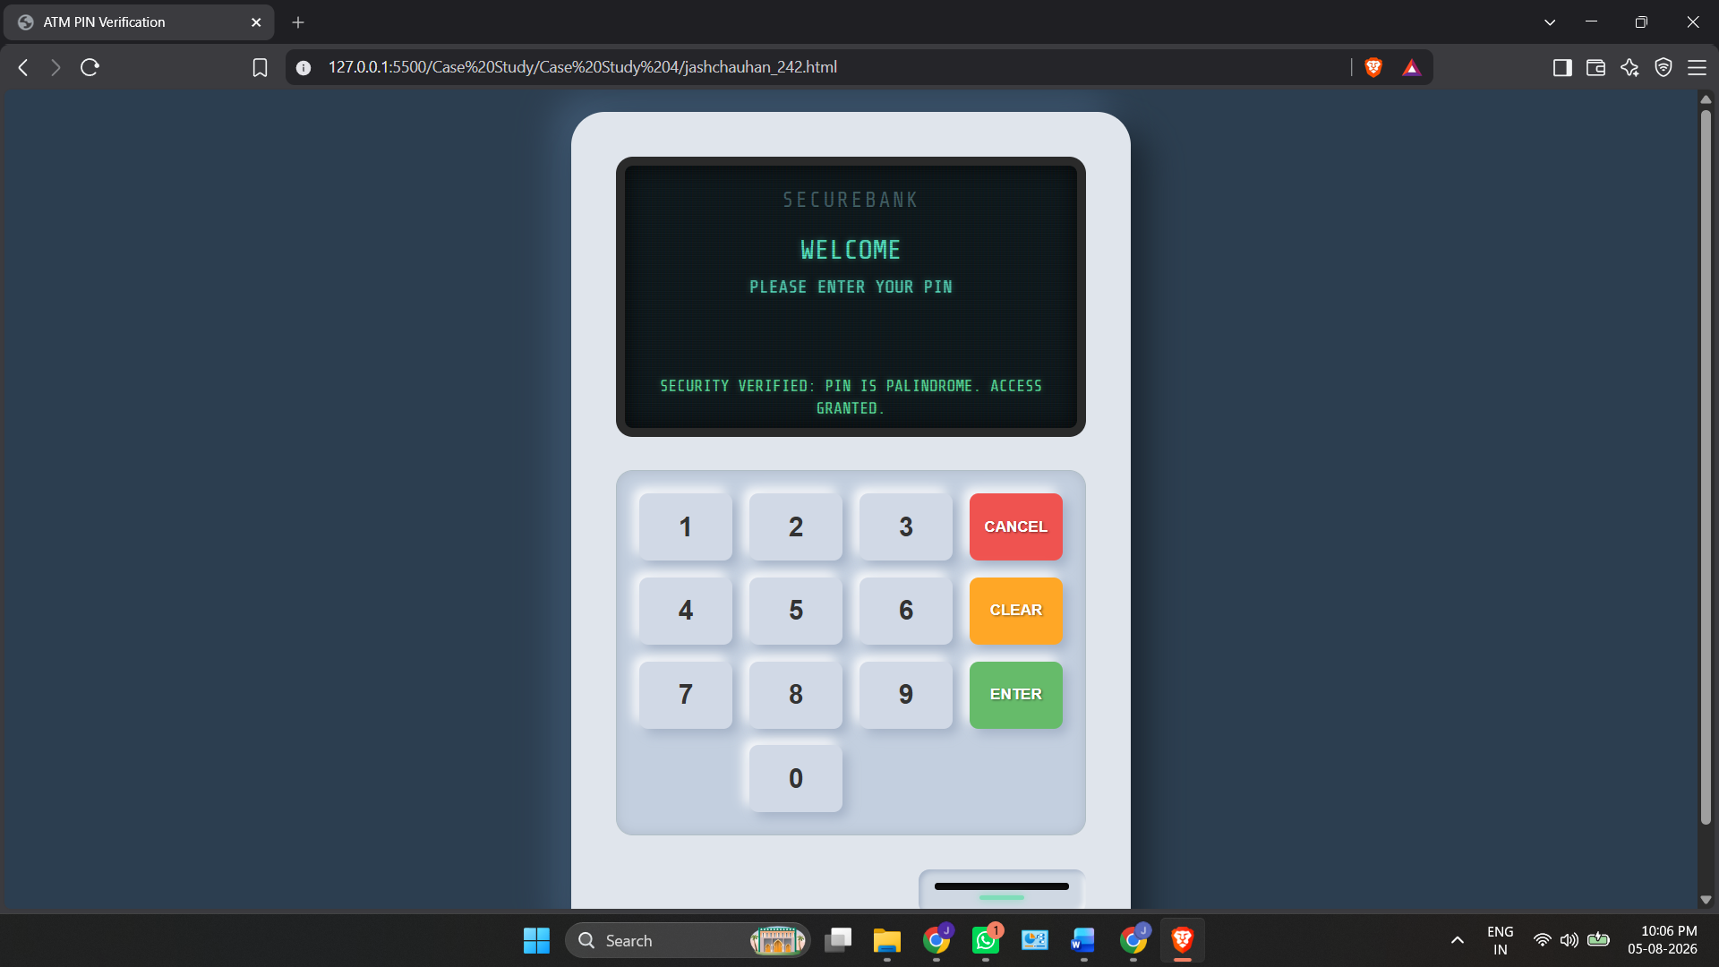

Result/Conclusion:
Case Study 4 successfully demonstrates how to use closures in JavaScript to securely maintain private data (like tracking failed PIN attempts) without exposing it to the global scope. It provides a functional ATM interface that validates palindromic PINs and securely blocks the user after 3 invalid attempts.

Experiment 5
1. Experiment Title
Apply array methods and object handling; create a cart total calculator with discount logic.

2. Software/Tools Required
- Visual Studio Code (VS Code)
- Google Chrome / Mozilla Firefox / Microsoft Edge
- HTML5
- CSS3
- JavaScript
- Windows Operating System

3. Experiment Program Code
The experiment consists of the following files:
- Jashchauhan_242.html
- styles.css
- script.js

jashchauhan_242.html
<!DOCTYPE html>
<html lang="en">

<head>
<meta charset="UTF-8">
<meta name="viewport" content="width=device-width, initial-scale=1.0">
<title>Cart Total Calculator</title>
<link rel="stylesheet" href="style.css">

<!-- Font Awesome Icons -->
<link rel="stylesheet" href="https://cdnjs.cloudflare.com/ajax/libs/font-awesome/6.5.2/css/all.min.css">
</head>

<body>

<div class="container">
<h2><i class="fa-solid fa-cart-shopping"></i> Cart Total Calculator</h2>

<!-- Add Item Form -->
<div class="form-row">
<input type="text" id="item-name" placeholder="Item name">
<input type="number" id="item-price" placeholder="Price (₹)" min="0" step="0.01">
<input type="number" id="item-qty" placeholder="Qty" min="1" value="1">
<select id="item-category">
<option value="general">General</option>
<option value="electronics">Electronics</option>
<option value="clothing">Clothing</option>
<option value="grocery">Grocery</option>
</select>
<button onclick="addItem()" id="add-btn">
<i class="fa-solid fa-plus"></i> Add
</button>
</div>

<!-- Discount Code -->
<div class="discount-row">
<input type="text" id="discount-code" placeholder="Discount code (e.g. SAVE10, FLAT50, ELEC20)">
<button onclick="applyDiscount()" id="apply-discount-btn">
<i class="fa-solid fa-tag"></i> Apply
</button>
</div>

<div id="discount-msg" class="discount-msg"></div>

<!-- Cart Table -->
<div class="table-wrap">
<table id="cart-table">
<thead>
<tr>
<th>#</th>
<th>Item</th>
<th>Category</th>
<th>Price (₹)</th>
<th>Qty</th>
<th>Subtotal (₹)</th>
<th></th>
</tr>
</thead>
<tbody id="cart-body">
<!-- Rows rendered by JS -->
</tbody>
</table>

<p id="empty-msg" class="empty-msg">
<i class="fa-solid fa-basket-shopping"></i> Your cart is empty. Add items above.
</p>
</div>

<!-- Summary -->
<div id="summary" class="summary hidden">
<div class="summary-line">
<span>Items in cart</span>
<span id="total-items">0</span>
</div>
<div class="summary-line">
<span>Total quantity</span>
<span id="total-qty">0</span>
</div>
<div class="summary-line">
<span>Subtotal</span>
<span id="subtotal">₹0.00</span>
</div>
<div class="summary-line discount-line hidden" id="discount-summary">
<span id="discount-label">Discount</span>
<span id="discount-amount">−₹0.00</span>
</div>
<div class="summary-line total-line">
<span>Grand Total</span>
<span id="grand-total">₹0.00</span>
</div>
</div>

<!-- Filter Buttons -->
<div id="filter-section" class="filter-section hidden">
<span class="filter-label">Filter by category:</span>
<button class="filter-btn active" onclick="filterByCategory('all')">All</button>
<button class="filter-btn" onclick="filterByCategory('electronics')">Electronics</button>
<button class="filter-btn" onclick="filterByCategory('clothing')">Clothing</button>
<button class="filter-btn" onclick="filterByCategory('grocery')">Grocery</button>
<button class="filter-btn" onclick="filterByCategory('general')">General</button>
</div>

<!-- Most Expensive Item -->
<div id="highlight" class="highlight hidden"></div>
</div>

<script src="script.js"></script>
</body>

</html>

Style.css

* {
margin: 0;
padding: 0;
box-sizing: border-box;
font-family: Arial, Helvetica, sans-serif;
}

body {
background: #f5f5f5;
display: flex;
justify-content: center;
align-items: flex-start;
min-height: 100vh;
padding: 40px 20px;
}

.container {
width: 800px;
background: white;
padding: 28px;
border: 1px solid #ddd;
border-radius: 14px;
}

h2 {
font-size: 24px;
margin-bottom: 20px;
}

h2 i {
margin-right: 6px;
}

/* ─── Add-Item Form ─── */

.form-row {
display: flex;
gap: 10px;
margin-bottom: 12px;
flex-wrap: wrap;
}

.form-row input,
.form-row select {
padding: 11px 13px;
font-size: 15px;
border: 1px solid #ccc;
border-radius: 10px;
outline: none;
}

.form-row input:focus,
.form-row select:focus {
border-color: #222;
}

#item-name {
flex: 2;
min-width: 140px;
}

#item-price {
flex: 1;
min-width: 100px;
}

#item-qty {
width: 70px;
}

#item-category {
flex: 1;
min-width: 120px;
cursor: pointer;
}

/* ─── Buttons ─── */

button {
background: #111;
color: white;
border: none;
padding: 11px 18px;
border-radius: 10px;
cursor: pointer;
font-size: 15px;
transition: .3s;
white-space: nowrap;
}

button:hover {
background: #333;
}

/* ─── Discount Row ─── */

.discount-row {
display: flex;
gap: 10px;
margin-bottom: 8px;
}

.discount-row input {
flex: 1;
padding: 11px 13px;
font-size: 15px;
border: 1px solid #ccc;
border-radius: 10px;
outline: none;
}

.discount-row input:focus {
border-color: #222;
}

#apply-discount-btn {
background: #7c3aed;
}

#apply-discount-btn:hover {
background: #6d28d9;
}

.discount-msg {
font-size: 14px;
min-height: 20px;
margin-bottom: 14px;
padding-left: 2px;
}

.discount-msg.success {
color: #16a34a;
}

.discount-msg.error {
color: #ef4444;
}

/* ─── Table ─── */

.table-wrap {
margin-bottom: 18px;
}

table {
width: 100%;
border-collapse: collapse;
}

thead th {
text-align: left;
padding: 10px 12px;
font-size: 14px;
color: #555;
border-bottom: 2px solid #e5e5e5;
}

tbody td {
padding: 10px 12px;
font-size: 15px;
border-bottom: 1px solid #f0f0f0;
}

tbody tr:hover {
background: #fafafa;
}

.category-badge {
display: inline-block;
padding: 3px 10px;
border-radius: 20px;
font-size: 12px;
font-weight: 600;
text-transform: uppercase;
letter-spacing: .3px;
}

.badge-electronics {
background: #dbeafe;
color: #1d4ed8;
}

.badge-clothing {
background: #fce7f3;
color: #be185d;
}

.badge-grocery {
background: #dcfce7;
color: #15803d;
}

.badge-general {
background: #f3f4f6;
color: #374151;
}

.delete-btn {
background: none;
color: #ef4444;
padding: 6px 10px;
font-size: 16px;
}

.delete-btn:hover {
background: #fef2f2;
color: #dc2626;
}

.empty-msg {
text-align: center;
color: #999;
padding: 32px 0;
font-size: 16px;
}

.empty-msg i {
margin-right: 6px;
}

/* ─── Summary ─── */

.summary {
background: #fafafa;
border: 1px solid #e5e5e5;
border-radius: 12px;
padding: 18px 22px;
margin-bottom: 18px;
}

.summary-line {
display: flex;
justify-content: space-between;
padding: 7px 0;
font-size: 15px;
color: #444;
}

.discount-line {
color: #16a34a;
}

.total-line {
border-top: 2px solid #e5e5e5;
margin-top: 6px;
padding-top: 12px;
font-size: 20px;
font-weight: 700;
color: #111;
}

/* ─── Filter Section ─── */

.filter-section {
display: flex;
align-items: center;
gap: 8px;
flex-wrap: wrap;
margin-bottom: 14px;
}

.filter-label {
font-size: 14px;
color: #555;
margin-right: 4px;
}

.filter-btn {
background: #f3f4f6;
color: #333;
padding: 7px 14px;
font-size: 13px;
border-radius: 8px;
}

.filter-btn:hover {
background: #e5e7eb;
}

.filter-btn.active {
background: #111;
color: white;
}

/* ─── Highlight Box ─── */

.highlight {
background: #fffbeb;
border: 1px solid #fbbf24;
border-radius: 12px;
padding: 14px 18px;
font-size: 15px;
color: #92400e;
}

.highlight i {
margin-right: 6px;
color: #f59e0b;
}

/* ─── Utility ─── */

.hidden {
display: none !important;
}

Script.js

// ============================================================
// Experiment 05 – Cart Total Calculator with Discount Logic
// Demonstrates: Array methods (map, filter, reduce, find,
// forEach, findIndex) and Object handling
// ============================================================

// ─── Cart state (array of item objects) ───

let cart = [];
let nextId = 1;

// Active discount object (null when none applied)
let activeDiscount = null;

// Current category filter
let activeFilter = "all";

// ─── Discount code definitions (array of objects) ───

const discountCodes = [
{
code: "SAVE10",
type: "percent",
value: 10,
label: "10% off entire cart",
},
{
code: "FLAT50",
type: "flat",
value: 50,
label: "₹50 flat off",
},
{
code: "ELEC20",
type: "category-percent",
value: 20,
category: "electronics",
label: "20% off Electronics items",
},
];

// ──────────────────────────────────────────────────────────
// Add Item (Object creation + Array.push)
// ──────────────────────────────────────────────────────────

function addItem() {

try {

const name = document.getElementById("item-name").value.trim();
const price = parseFloat(document.getElementById("item-price").value);
const qty = parseInt(document.getElementById("item-qty").value, 10);
const category = document.getElementById("item-category").value;

if (!name) throw "Please enter an item name.";
if (isNaN(price) || price <= 0) throw "Please enter a valid price.";
if (isNaN(qty) || qty < 1) throw "Quantity must be at least 1.";

// Create an item object
const item = {
id: nextId++,
name: name,
price: price,
qty: qty,
category: category,
};

// Array.push – add item to cart
cart.push(item);

// Clear inputs
document.getElementById("item-name").value = "";
document.getElementById("item-price").value = "";
document.getElementById("item-qty").value = 1;

renderCart();

} catch (error) {
alert(error);
}
}

// ──────────────────────────────────────────────────────────
// Remove Item (Array.findIndex + Array.splice)
// ──────────────────────────────────────────────────────────

function removeItem(id) {

// Array.findIndex – locate item by id
const index = cart.findIndex(function (item) {
return item.id === id;
});

if (index !== -1) {
// Array.splice – remove one element at index
cart.splice(index, 1);
renderCart();
}
}

// ──────────────────────────────────────────────────────────
// Apply Discount (Array.find on discountCodes)
// ──────────────────────────────────────────────────────────

function applyDiscount() {

const input = document.getElementById("discount-code").value.trim().toUpperCase();
const msgEl = document.getElementById("discount-msg");

if (!input) {
msgEl.className = "discount-msg error";
msgEl.textContent = "Please enter a discount code.";
return;
}

// Array.find – search for matching code object
const found = discountCodes.find(function (d) {
return d.code === input;
});

if (!found) {
activeDiscount = null;
msgEl.className = "discount-msg error";
msgEl.textContent = 'Invalid code "' + input + '". Try SAVE10, FLAT50, or ELEC20.';
} else {
activeDiscount = found;
msgEl.className = "discount-msg success";
msgEl.textContent = 'Code "' + found.code + '" applied — ' + found.label + "!";
}

renderCart();
}

// ──────────────────────────────────────────────────────────
// Calculate Discount (Array.filter + Array.reduce)
// ──────────────────────────────────────────────────────────

function calculateDiscount(subtotal) {

if (!activeDiscount) return 0;

if (activeDiscount.type === "percent") {
// Percentage off entire subtotal
return subtotal * (activeDiscount.value / 100);
}

if (activeDiscount.type === "flat") {
// Flat amount off (cannot exceed subtotal)
return Math.min(activeDiscount.value, subtotal);
}

if (activeDiscount.type === "category-percent") {

// Array.filter – pick items matching the discount category
const eligible = cart.filter(function (item) {
return item.category === activeDiscount.category;
});

// Array.reduce – sum subtotals of eligible items
const eligibleTotal = eligible.reduce(function (sum, item) {
return sum + item.price * item.qty;
}, 0);

return eligibleTotal * (activeDiscount.value / 100);
}

return 0;
}

// ──────────────────────────────────────────────────────────
// Filter by Category (Array.filter)
// ──────────────────────────────────────────────────────────

function filterByCategory(category) {

activeFilter = category;

// Update active button
var btns = document.querySelectorAll(".filter-btn");
btns.forEach(function (btn) {
btn.classList.remove("active");
});

// Find the clicked button using event-less approach
var allBtns = document.querySelectorAll(".filter-btn");
allBtns.forEach(function (btn) {
if (btn.textContent.trim().toLowerCase() === category) {
btn.classList.add("active");
}
});

renderCart();
}

// ──────────────────────────────────────────────────────────
// Render Cart (Array.forEach, Array.map, Array.filter,
// Array.reduce, Object destructuring-style
// property access)
// ──────────────────────────────────────────────────────────

function renderCart() {

var tbody = document.getElementById("cart-body");
var emptyMsg = document.getElementById("empty-msg");
var summaryEl = document.getElementById("summary");
var filterSection = document.getElementById("filter-section");
var highlightEl = document.getElementById("highlight");
var table = document.getElementById("cart-table");

// Decide which items to show (Array.filter)
var displayItems;
if (activeFilter === "all") {
displayItems = cart;
} else {
displayItems = cart.filter(function (item) {
return item.category === activeFilter;
});
}

// Empty state
if (cart.length === 0) {
table.classList.add("hidden");
emptyMsg.classList.remove("hidden");
summaryEl.classList.add("hidden");
filterSection.classList.add("hidden");
highlightEl.classList.add("hidden");
return;
}

table.classList.remove("hidden");
emptyMsg.classList.add("hidden");
summaryEl.classList.remove("hidden");
filterSection.classList.remove("hidden");

// ── Build table rows (Array.map to create HTML strings) ──

var rowsHtml = displayItems.map(function (item, index) {

var subtotal = item.price * item.qty;

return (
"<tr>" +
"<td>" + (index + 1) + "</td>" +
"<td>" + escapeHtml(item.name) + "</td>" +
'<td><span class="category-badge badge-' + item.category + '">' +
item.category +
"</span></td>" +
"<td>" + item.price.toFixed(2) + "</td>" +
"<td>" + item.qty + "</td>" +
"<td>" + subtotal.toFixed(2) + "</td>" +
'<td><button class="delete-btn" onclick="removeItem(' + item.id + ')">' +
'<i class="fa-solid fa-trash"></i></button></td>' +
"</tr>"
);

}).join("");

tbody.innerHTML = rowsHtml;

// ── Summary calculations ──

// Array.reduce – total subtotal of ALL cart items
var subtotal = cart.reduce(function (sum, item) {
return sum + item.price * item.qty;
}, 0);

// Array.reduce – total quantity
var totalQty = cart.reduce(function (sum, item) {
return sum + item.qty;
}, 0);

var discountAmt = calculateDiscount(subtotal);
var grandTotal = subtotal - discountAmt;

document.getElementById("total-items").textContent = cart.length;
document.getElementById("total-qty").textContent = totalQty;
document.getElementById("subtotal").textContent = "₹" + subtotal.toFixed(2);
document.getElementById("grand-total").textContent = "₹" + grandTotal.toFixed(2);

// Show / hide discount line
var discountSummary = document.getElementById("discount-summary");
if (discountAmt > 0) {
discountSummary.classList.remove("hidden");
document.getElementById("discount-label").textContent =
"Discount (" + activeDiscount.label + ")";
document.getElementById("discount-amount").textContent =
"−₹" + discountAmt.toFixed(2);
} else {
discountSummary.classList.add("hidden");
}

// ── Highlight most expensive item (Array.reduce as max-finder) ──

var mostExpensive = cart.reduce(function (max, item) {
return item.price * item.qty > max.price * max.qty ? item : max;
}, cart[0]);

highlightEl.classList.remove("hidden");
highlightEl.innerHTML =
'<i class="fa-solid fa-crown"></i> Most expensive item: <strong>' +
escapeHtml(mostExpensive.name) +
"</strong> — ₹" +
(mostExpensive.price * mostExpensive.qty).toFixed(2);
}

// ─── Helper: escape HTML to prevent XSS ───

function escapeHtml(text) {
var div = document.createElement("div");
div.appendChild(document.createTextNode(text));
return div.innerHTML;
}

OUTPUT:
